2 Videos

Source #1
https://www.youtube.com/watch?v=keJDEkjupdw&list=PLSXY7z-v8oPDtXt3WaKuZk7FWHmkO3LME

DFD for a Mobile List Application (11.2 Example)
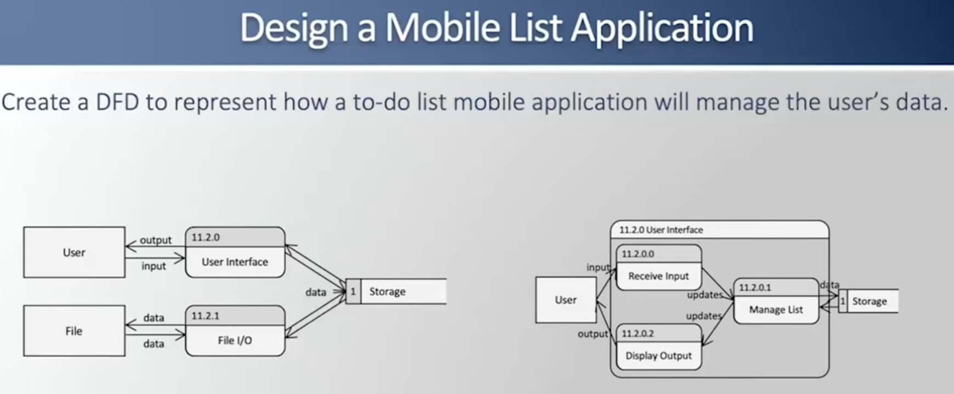

Source #2
https://www.youtube.com/watch?v=bi1UvmkoSKQ&list=PLSXY7z-v8oPDtXt3WaKuZk7FWHmkO3LME&index=2

Pseudocode to a DFD (11.1 Example)

Step 1
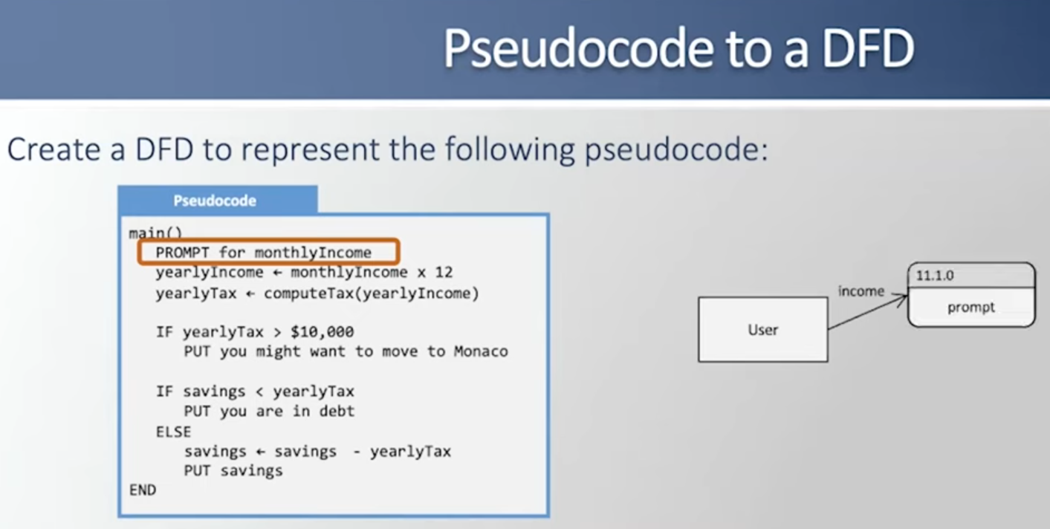

Step 2
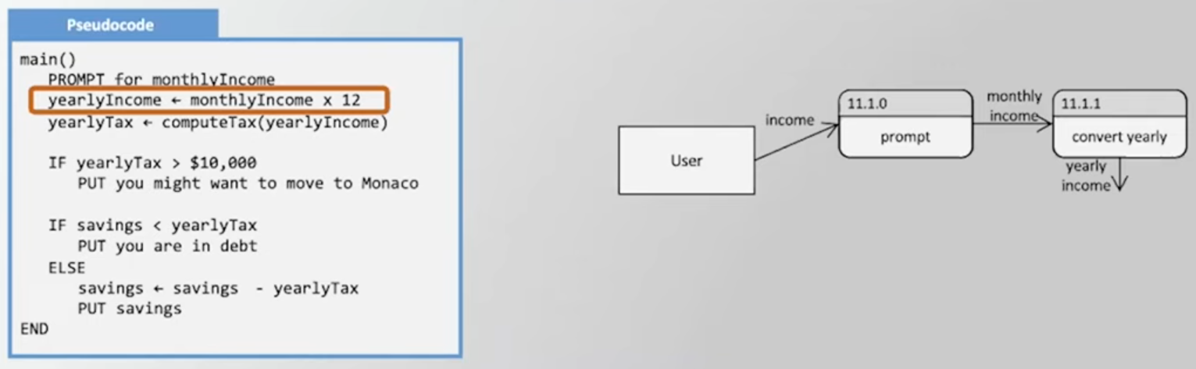

Step 3
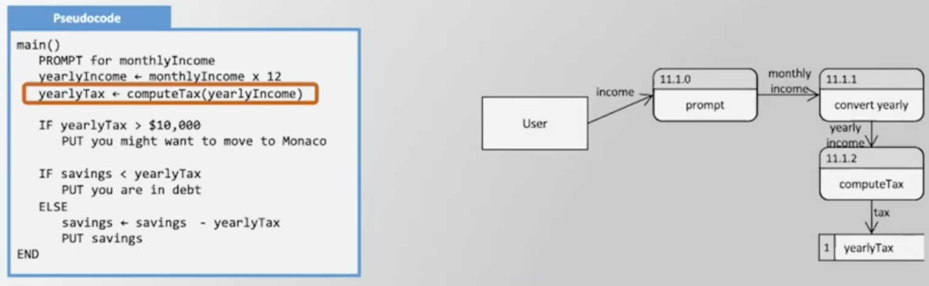

Step 4
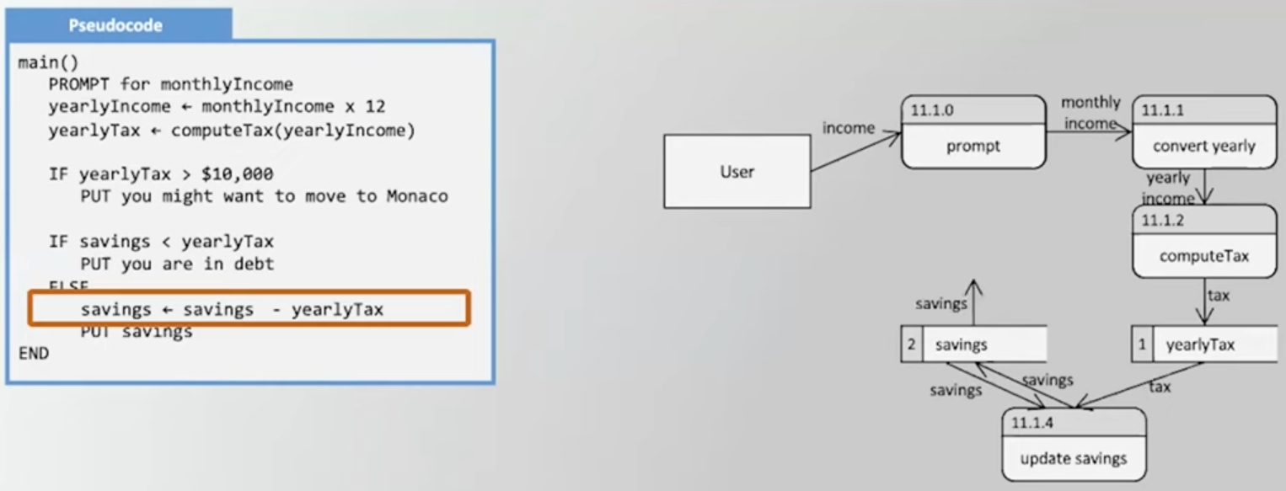

Step 5
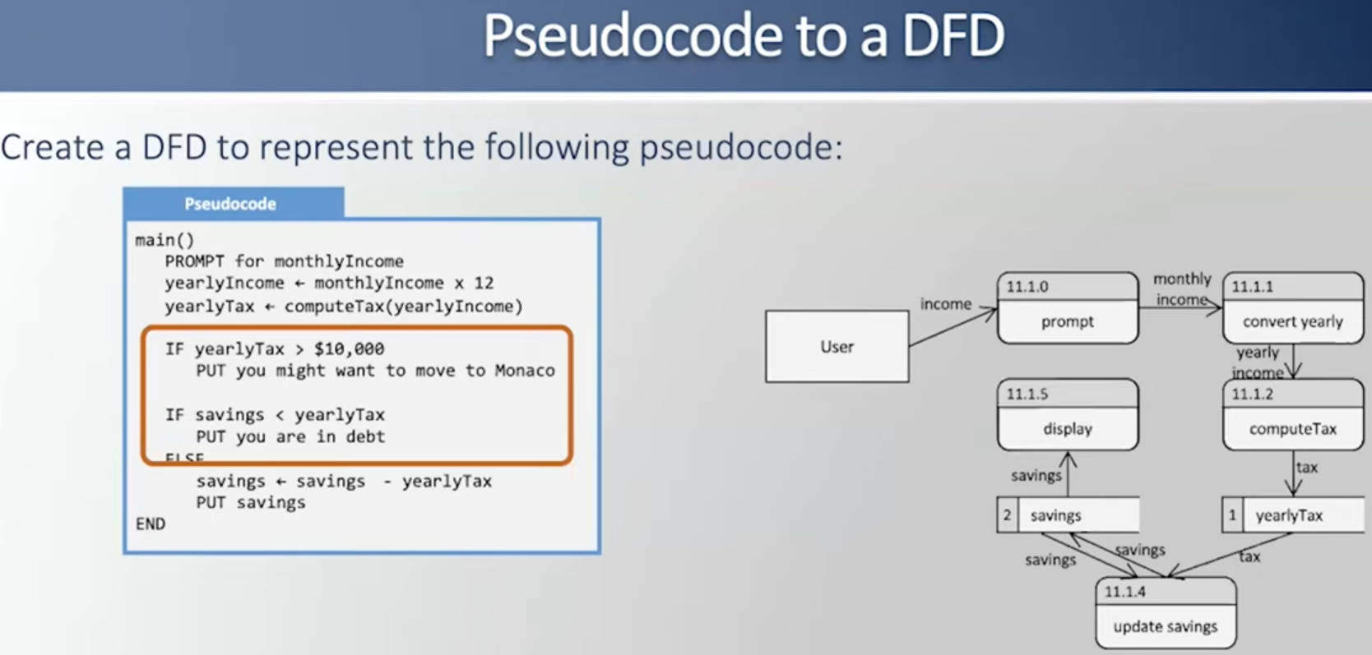

Step 6 - Finish Data Flow Diagram Loop
