2 Videos

Source #1
https://www.youtube.com/watch?v=NhNpIxwn2Bw&list=PLSXY7z-v8oPCLNIG7po8JWNehw5f95kyq&index=1

JavaScript to Structure Chart
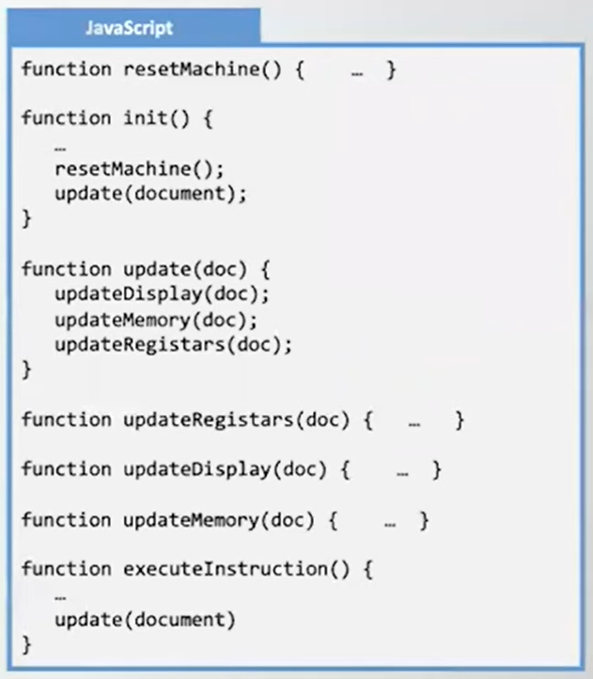
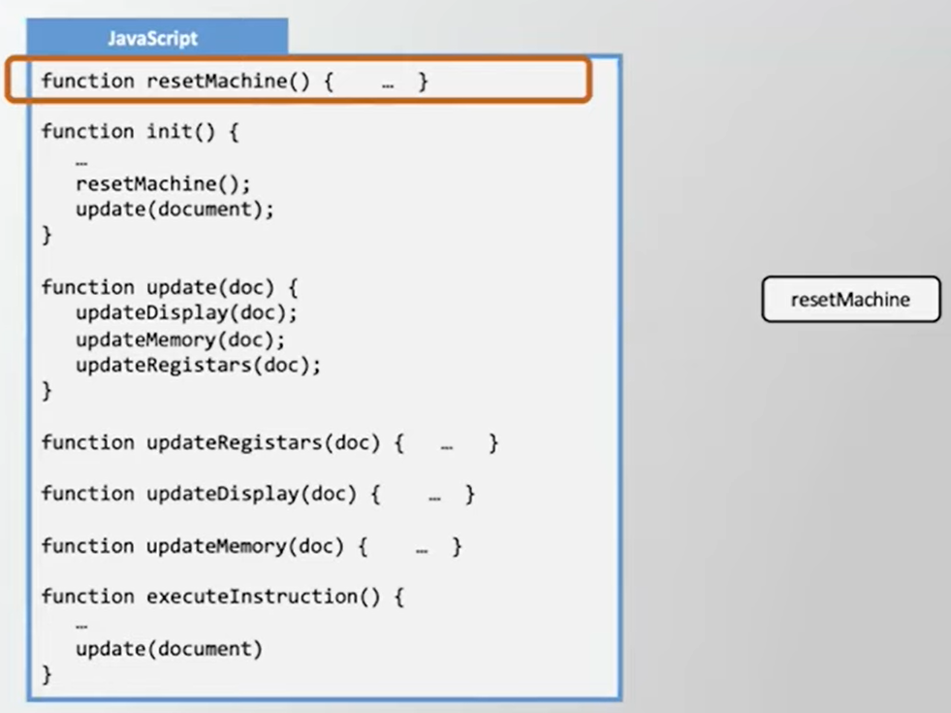
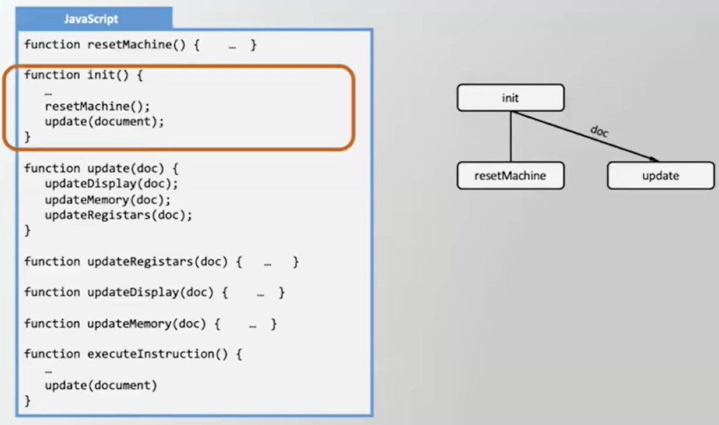
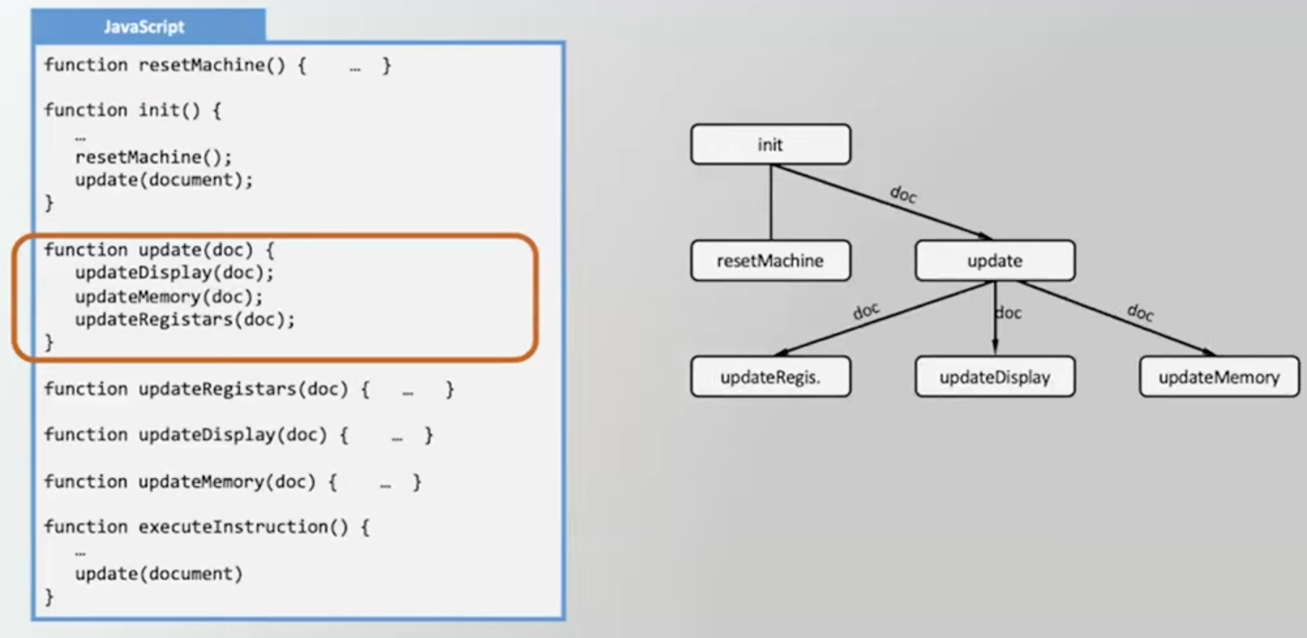
updateRegistars, updateDisplay, & updateMemory already exists from Previous Step - so there is nothing more to do for each of those.
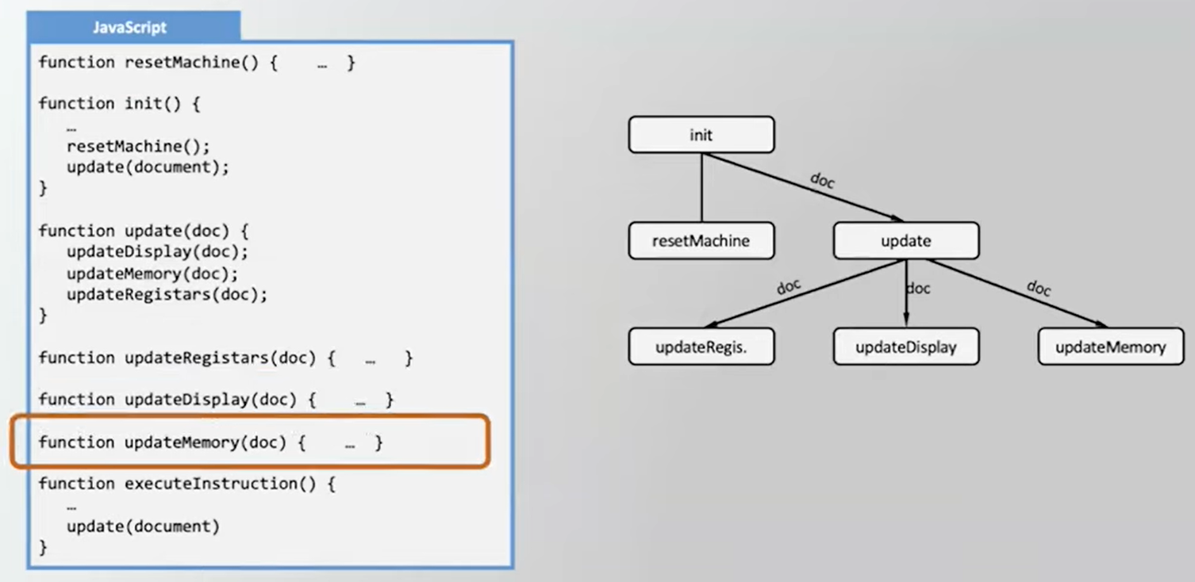
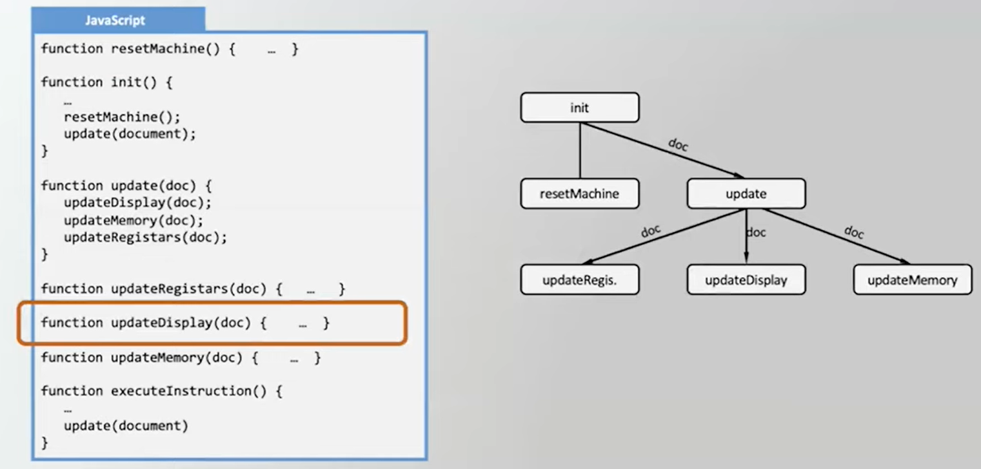
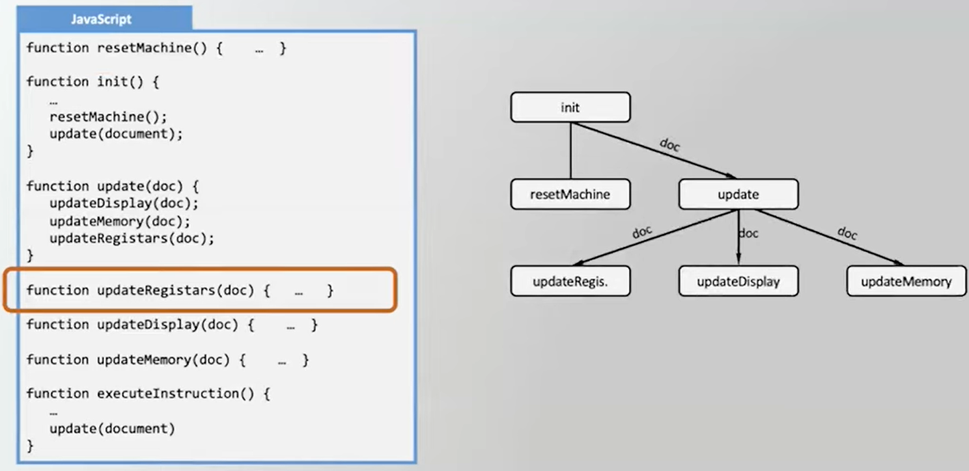
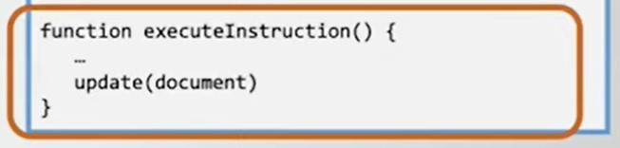
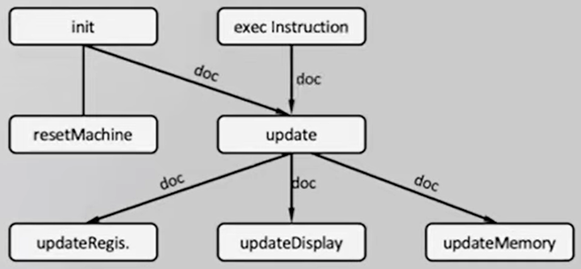

Source #1
https://www.youtube.com/watch?v=3s8HTE-JS1I&list=PLSXY7z-v8oPCLNIG7po8JWNehw5f95kyq&index=2

Designing a Program
- Start with main function & display all underneath it
- Determine needed helper functions - type of report to display- 2nd layer
- Identify the parameters for the subroutines of the 2nd layer
- Look deeper into one from the 2nd layer - displayHistogram
- Determine the parts needed for that function - 3rd layer
- Identify parameters for subroutines of 3rd layer (displayGrid) needs no parameter
- Determine if any of the 3rd layer needs supporting functions & their parameters
