Entity Identification Table Assignment Distribution
TEAM | SUBCOMPONENTS | UI View ASSIGMENT | TOTAL INNER COMPONENTS
Team 5  (Adam Sheridan) | - API Gateway/-External & Analytics Services Orchestrators  - External Services  - Analytics Service  - Combined | - Analytics Dashboard Screen  - Desktop  - Mobile  - Design Information | Figure 1.4 = 2  Figure 1.12 = 3  Figure 1.13 = 5  Total = 10

Team 5 (Adam Sheridan) - Total Entity Identification Tables Count (10)
- Entity Identification Tables — API Gateway / Orchestrator (2 Inner Components)
  - EI Table 1.4.11 — External Services Orchestrator – Adam – Reviewed by Ethan S.
    - domain-specific entities in (API Gateway / Orchestrator)
  - EI Table 1.4.12 — Analytics Orchestrator – Wesley – Reviewed by William
    - domain-specific entities in (API Gateway / Orchestrator)
- Entity Identification Tables — External Services (3 Inner Components)
  - El Table 1.12.1 — USPS Address Validation Adapter - William– Reviewed by Adam
  - El Table 1.12.2 — Autocomplete API Adapter - Wesley– Reviewed by William
  - El Table 1.12.3 — Push Notification Gateway – Ethan S. – Reviewed by Dallin
- Entity Identification Tables — Analytics Service (5 Inner Components)
  - El Table 1.13.1 — Job Posting Analytics - Dallin– Reviewed by Wesley
  - El Table 1.13.2 — Search and Candidate Analytics - Dallin– Reviewed by Wesley
  - El Table 1.13.3 — Profile and Resume Engagement - William– Reviewed by Adam
  - El Table 1.13.4 — Notification and News Feed Analytics – Ethan S. – Reviewed by Dallin
  - El Table 1.13.5 — Performance Monitor - Adam– Reviewed by Ethan S.

TEAM 5 ASSIGNMENTS
Table 1.4.11 & Table 1.4.12: see page 13 in in Milestone 2 submitted file XS_MileStone2_1stDozenViews_Corrected_Submission.docx

EI Table 1.4.11 — External Services Orchestrator:
    - domain-specific entities in (API Gateway / Orchestrator)
EI Table 1.4.12 — Analytics Orchestrator
    - domain-specific entities in (API Gateway / Orchestrator)

Figure 1.4 – API Gateway / Orchestrator Detail
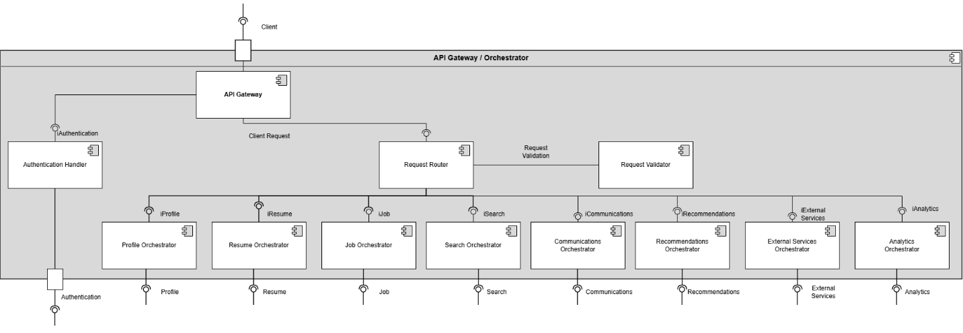
Design Information
Field | Description / Purpose
View Name & Number | 1.4 – API Gateway / Orchestrator
Purpose | Describe the API/ Orchestrator View
Description | API Gateway with authentication Handling and request routing to various component orchestration.
Requirements | Cross-cutting for all SRS sections — routes all client requests to backend services
Elements | API Gateway
 | Authentication Handler
 | Auth Service
 | Request Handler
 | Request Validator
 | Profile Orchestrator
 | Resume Orchestrator
 | Job Orchestrator
 | Search Orchestrator
 | Communications Orchestrator
 | Recommendation Orchestrator
 | External Orchestrator
 | Analytics Orchestrator
Navigation / References | 1.2 Web Client, 1.3 Mobile Client, 1.5–1.13 all backend service detail views
Viewpoint | Component Diagram

Table 1.12.1, Table 1.12.2, & Table 1.12.3: see page 24 in Milestone 2 submitted file XS_MileStone2_1stDozenViews_Corrected_Submission.docx

- Entity Identification Tables — External Services (3 Inner Components)
  - EI Table 1.12.1 — USPS Address Validation Adapter
  - EI Table 1.12.2 — Autocomplete API Adapter
  - EI Table 1.12.3 — Push Notification Gateway

Figure 1.12 – External Services Detail
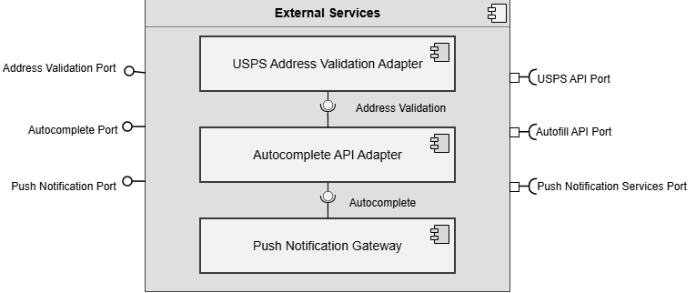
Design Information
Field | Description / Purpose
View Name & Number | 1.12 External Services
Purpose | Describe the external services.
Description | Basic service demonstrating the external services.
Requirements | SRS 2.1.3.9 (USPS address validation), 2.3.6 (Autocomplete API), 2.2.3–2.2.4 (Push notification delivery)
Elements | USPS Validation
 | Autocomplete API Adapter
 | Push Notifications Gateway
Navigation / References | 1.4 API Gateway / Orchestrator
Viewpoint | Component Diagram

Table 1.13.1, Table 1.13.2, Table 1.13.3, Table 1.13.4, Table 1.13.5: see page 25 in Milestone 2 submitted file XS_MileStone2_1stDozenViews_Corrected_Submission.docx

- Entity Identification Tables — Analytics Service (5 Inner Components)
  - El Table 1.13.1 — Job Posting Analytics
  - El Table 1.13.2 — Search and Candidate Analytics
  - El Table 1.13.3 — Profile and Resume Engagement
  - El Table 1.13.4 — Notification and News Feed Analytics
  - El Table 1.13.5 — Performance Monitor

Figure 1.13 – Analytics Service Detail
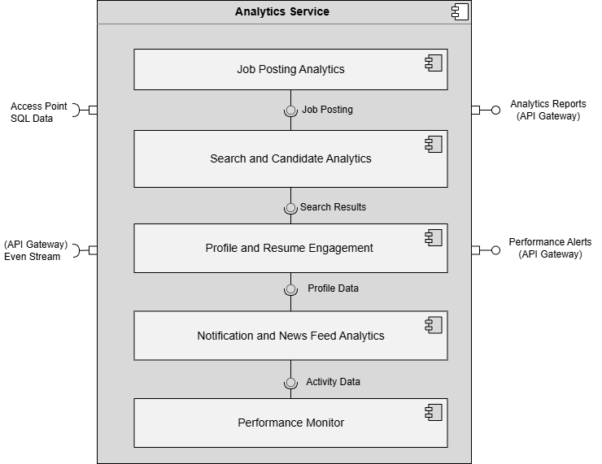

Design Information
Field | Description / Purpose
View Name & Number | 1.13 Analytics Service
Purpose | Describe the analytics service.
Description | Basic service demonstrating the analytics service.
Requirements | SRS 2.1.3.6 (Company analytics), 2.5.7 (Job posting status/performance tracking)
Elements | Job Posting Analytics
 | Search and Candidate Analytics
 | Profile and Resume Engagement
 | Notifications and News Feed Analytics
 | Performance Monitor
Navigation / References | 1.4 API Gateway / Orchestrator, 1.14 Database
Viewpoint | Component Diagram

