7 Videos

Source #1
https://www.youtube.com/watch?v=N8uPoEZwAm0&list=PLSXY7z-v8oPBChTThEsgXooT_65KKm30-&index=1

Types of Class Relations
Composition means I create and destroy the member variable or I completely own it.
Aggregation mean I don't create or destroy the member variable.
Nested Class is defined within the base class.
Association will utilize the class - not as an attribute - as a parameter or local variable.
Inheritance it is a derived class
Dependency means anything else
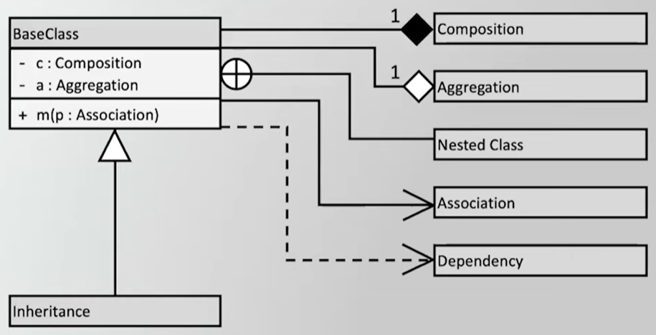

C++'s std::map Class Example
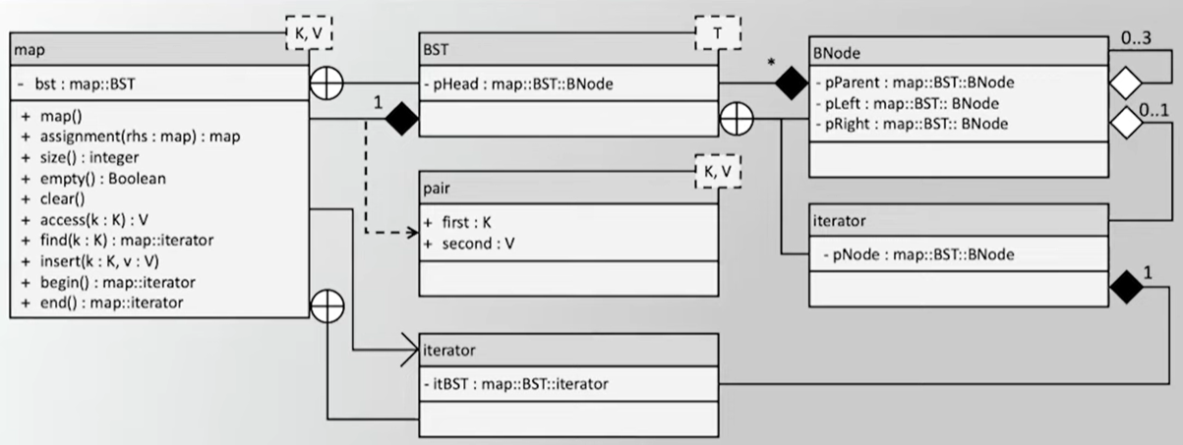

Checking Account Example
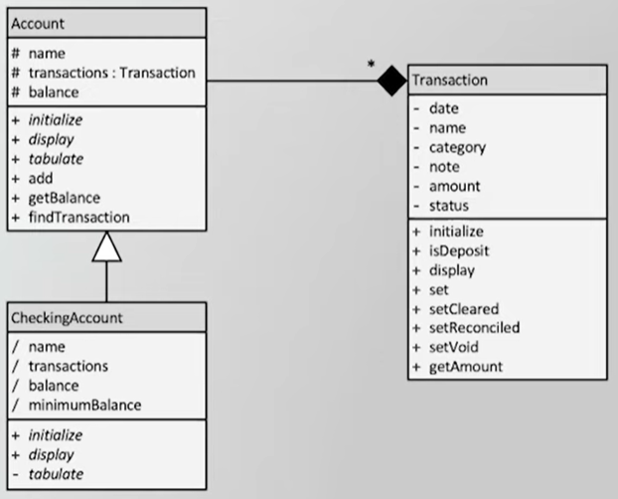

Source #2
https://www.youtube.com/watch?v=jRjwWFsk_Zo&list=PLSXY7z-v8oPBChTThEsgXooT_65KKm30-&index=2

Composition Definition
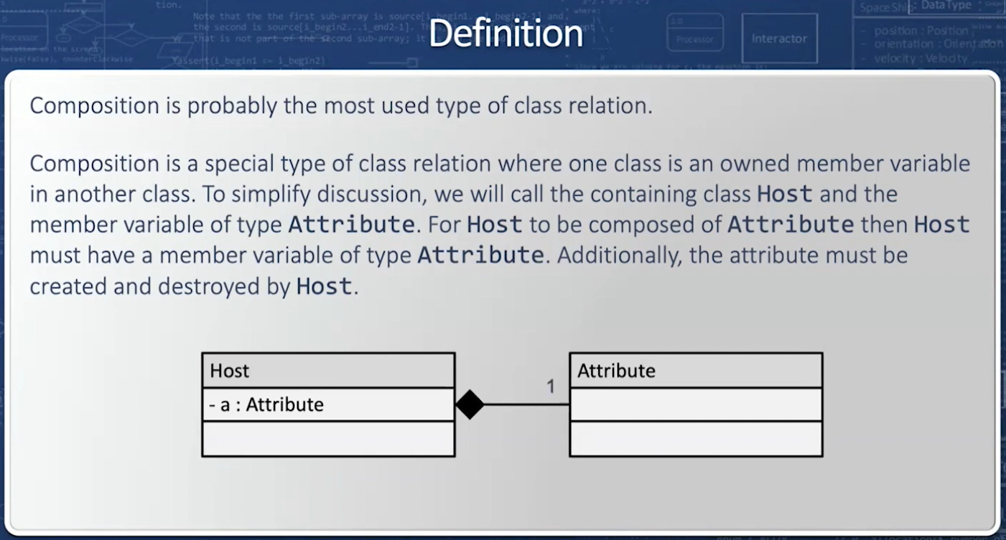



Trivial Composition Example
When it has a member variable it is the most likely case
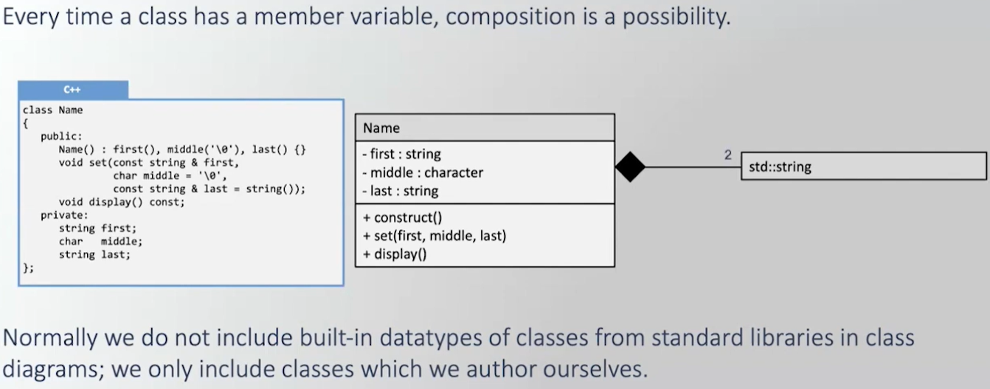
Since we didn't author the Standard Template Library String omit it.
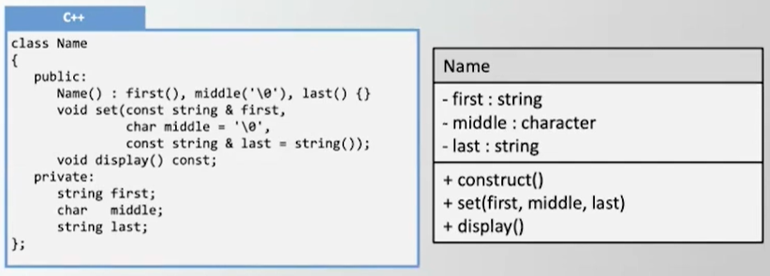

Single-Level Composition Example
No need to include numerosity or composition for the built-in data type of gpa
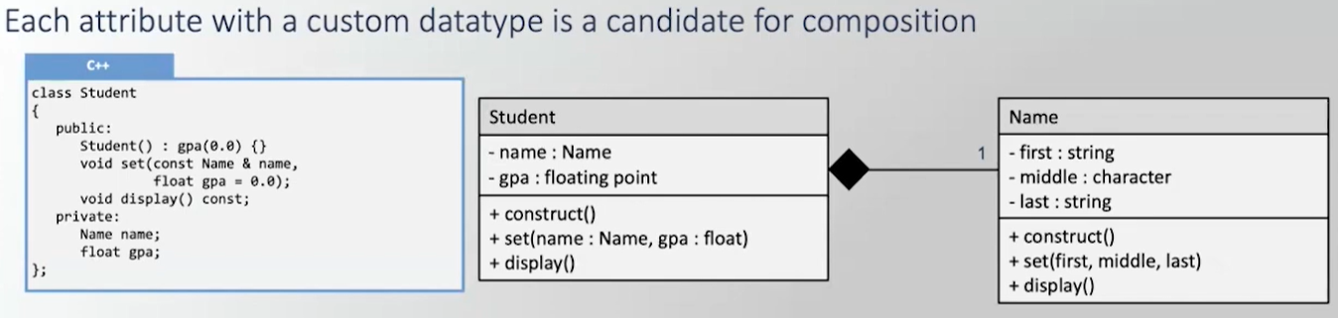

Two-Level Composition Example
coursePrefix, courseNumber, & numStudents are built-in data types so don't include
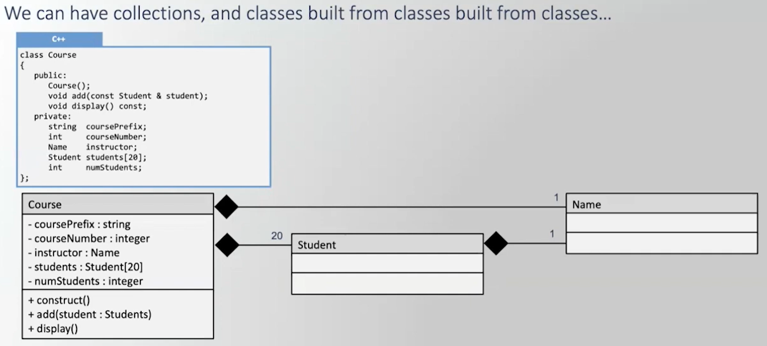

Containers Using Composition Example
T in white box with dashed lines in the corner means Template class
num_elements and num_capacity are built-in data types so don't include, T could be, but don't know for sure - so include
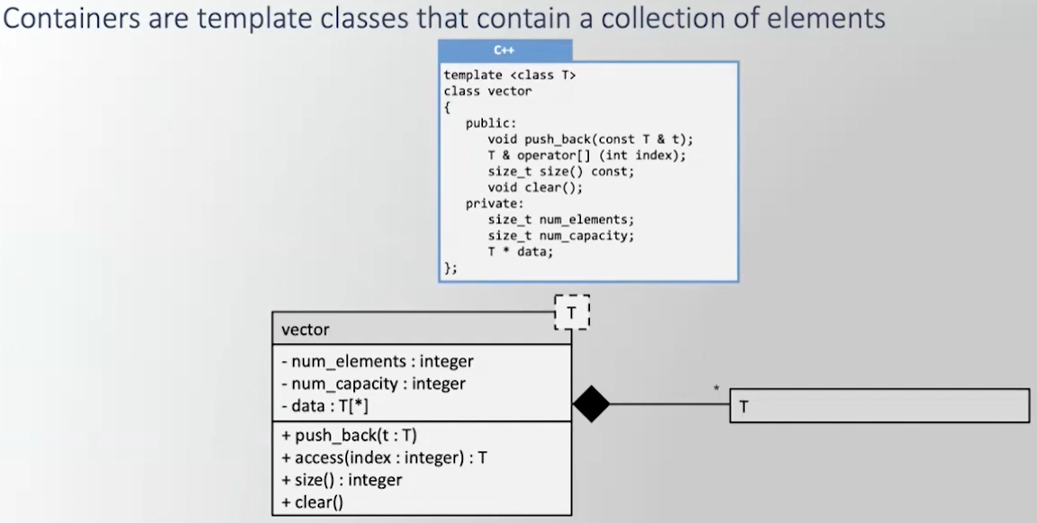

Complex Composition Example
coursePrefix & courseNumber are built-in data types so don't include. this has a Vector of Student - in other words - rather than a built-in array - use the vector used before
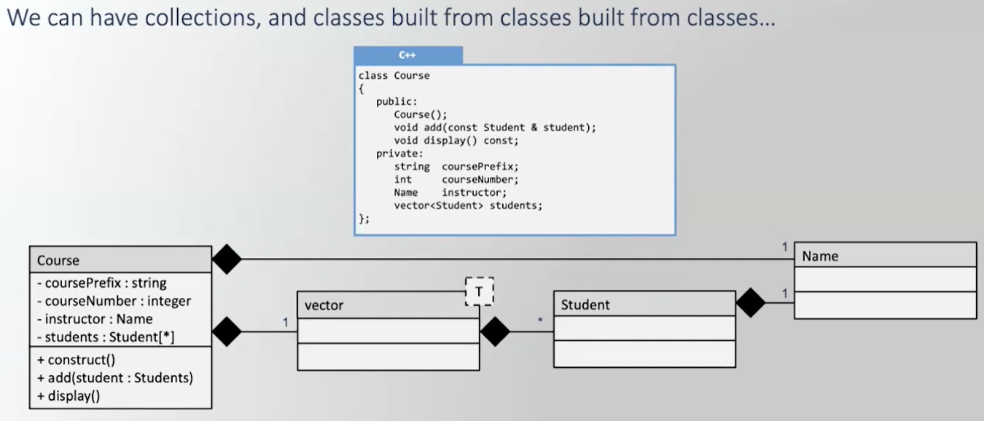

Source #3
https://www.youtube.com/watch?v=YZqXHHv15SI&list=PLSXY7z-v8oPBChTThEsgXooT_65KKm30-&index=3

Aggregation Definition
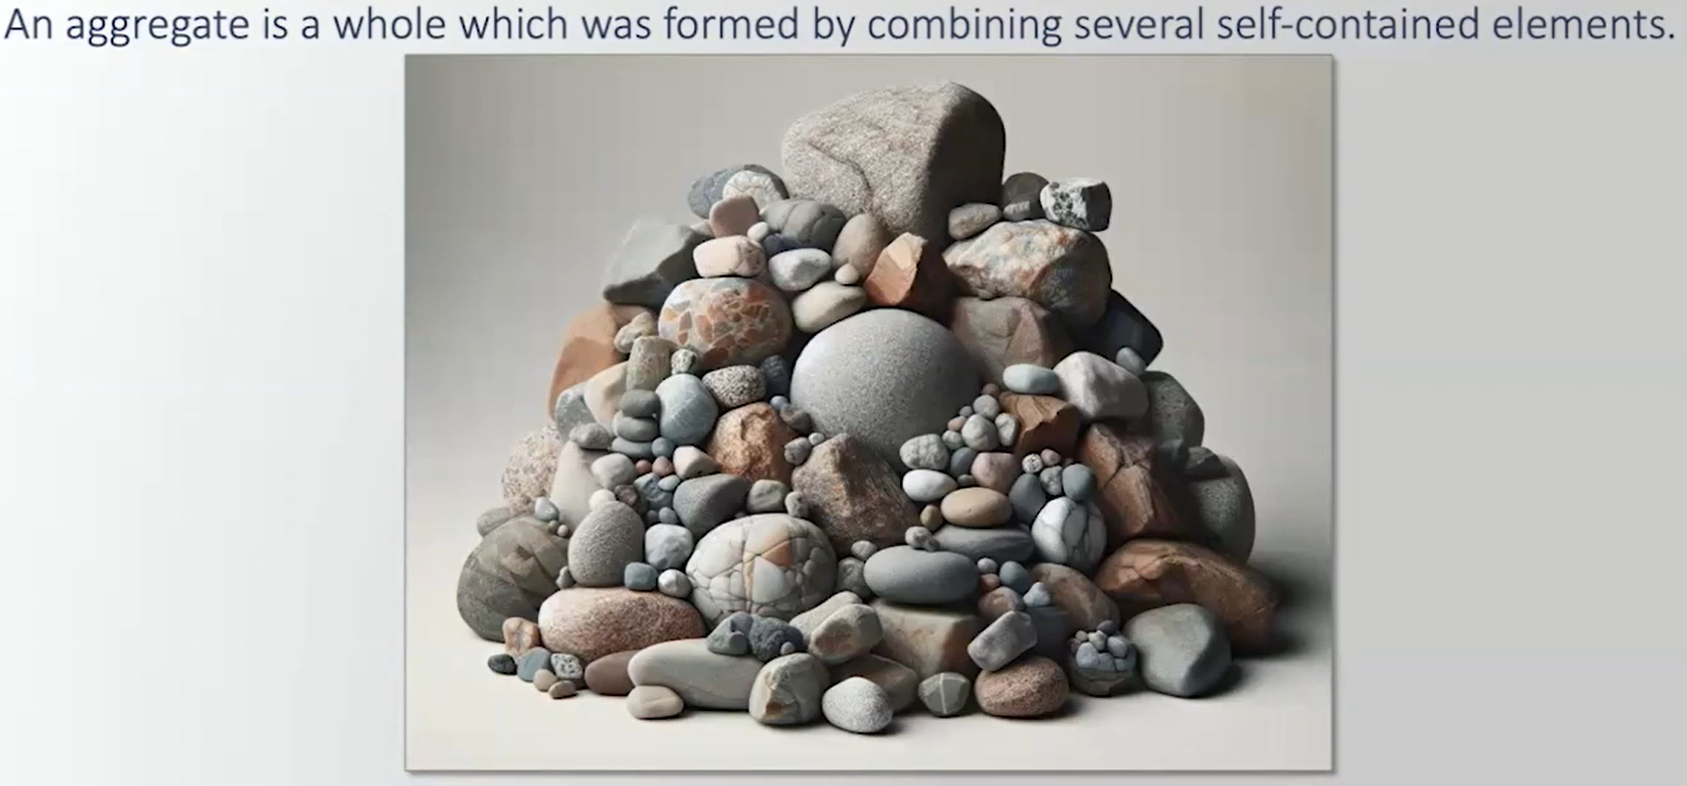

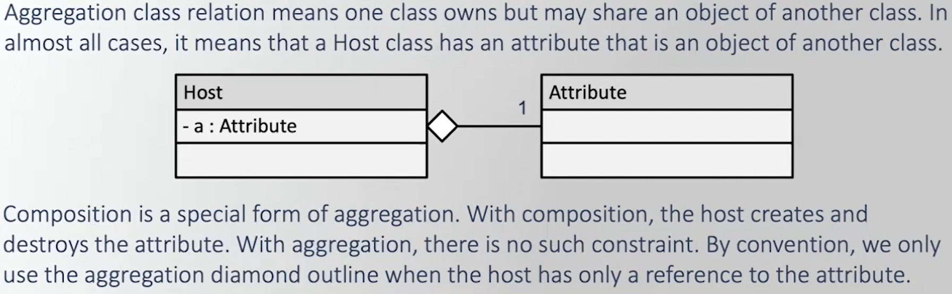

Types of Aggregation
If aggregation is from a built-in type or from a Standard Library, we don't include it.
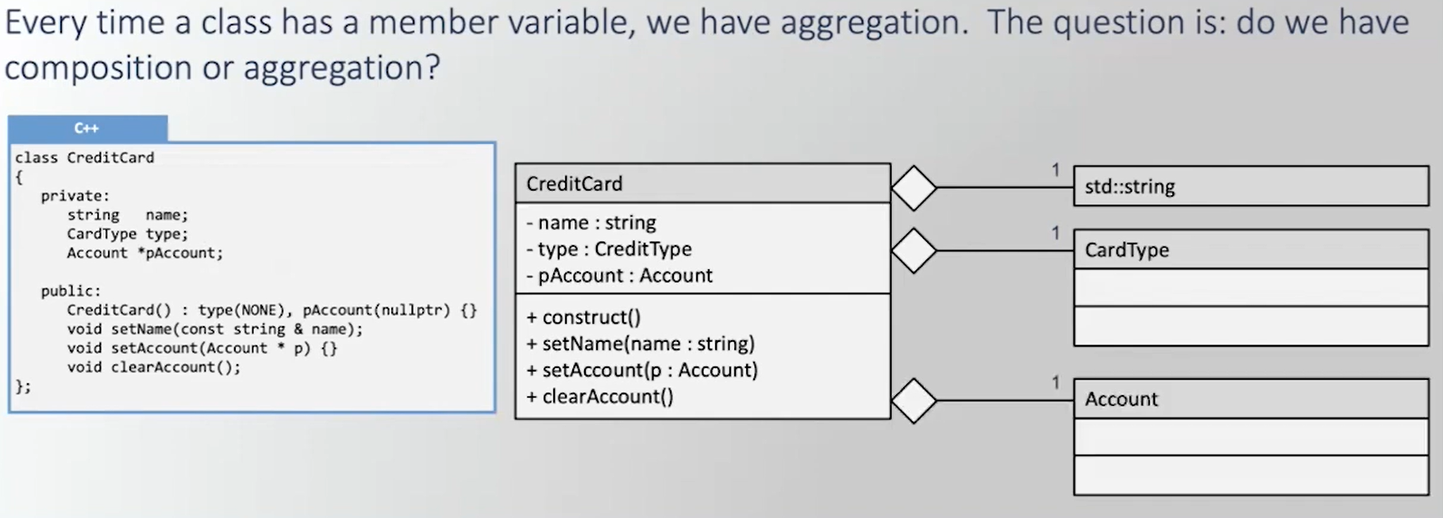
name is from a Standard Library, so we don't include it & since the type is created and destroyed it is composition
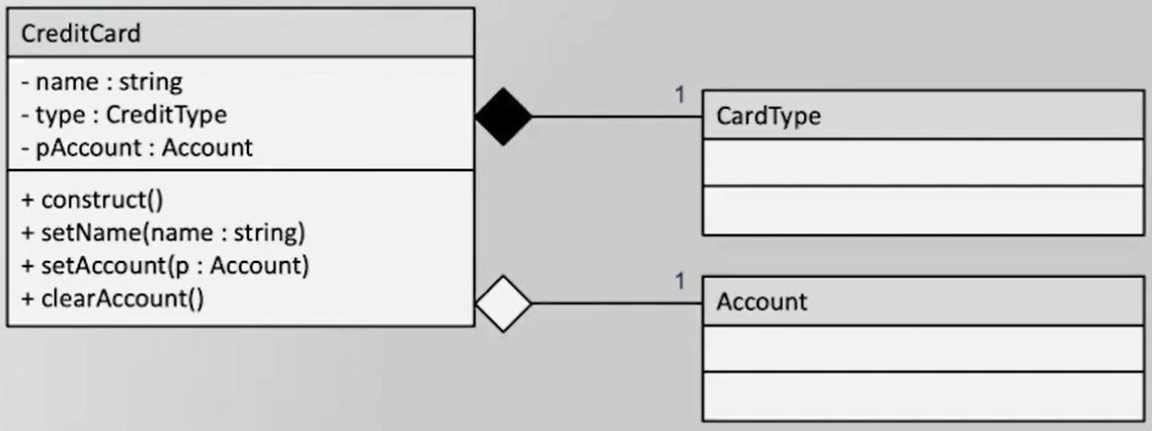

Linked List Node Class Example
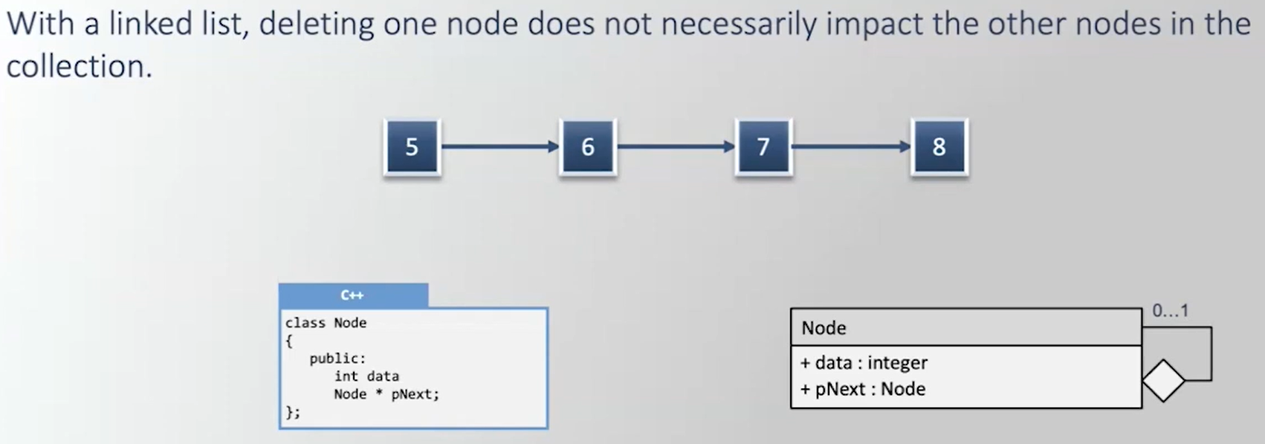

Report Class Example
title is from a Standard Library, so we don't include it
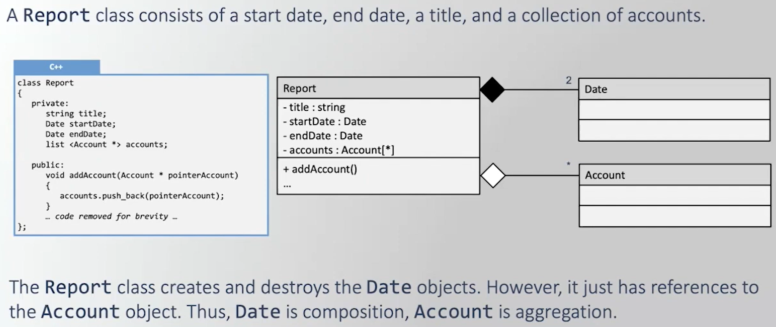

Source #4
https://www.youtube.com/watch?v=dQYb1u07hO0&list=PLSXY7z-v8oPBChTThEsgXooT_65KKm30-&index=4

Association Definition
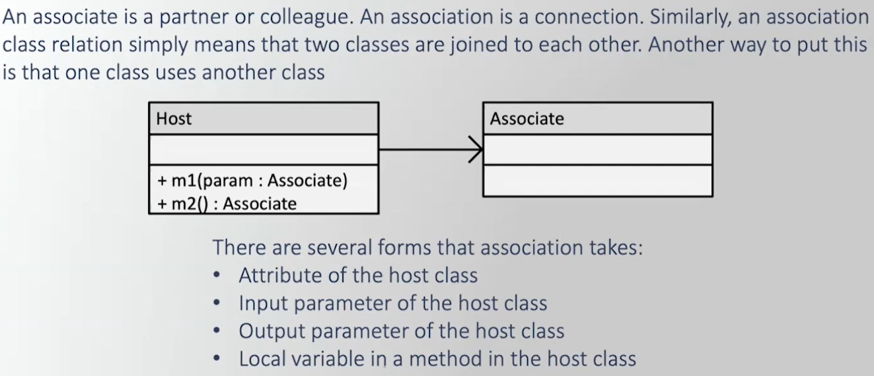

Flavors of Association
M1 has a parameter of, M2 returns it, and M3 has a local variable of type Association.
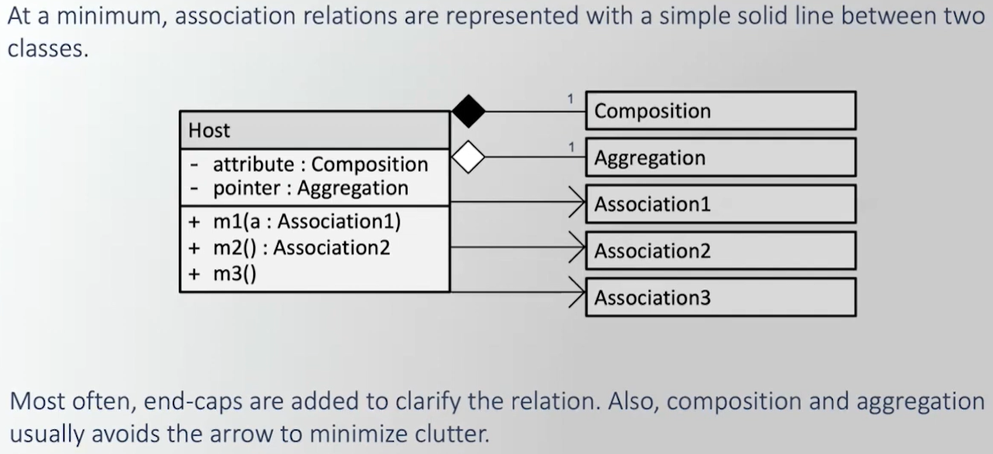



Association Notational Differences
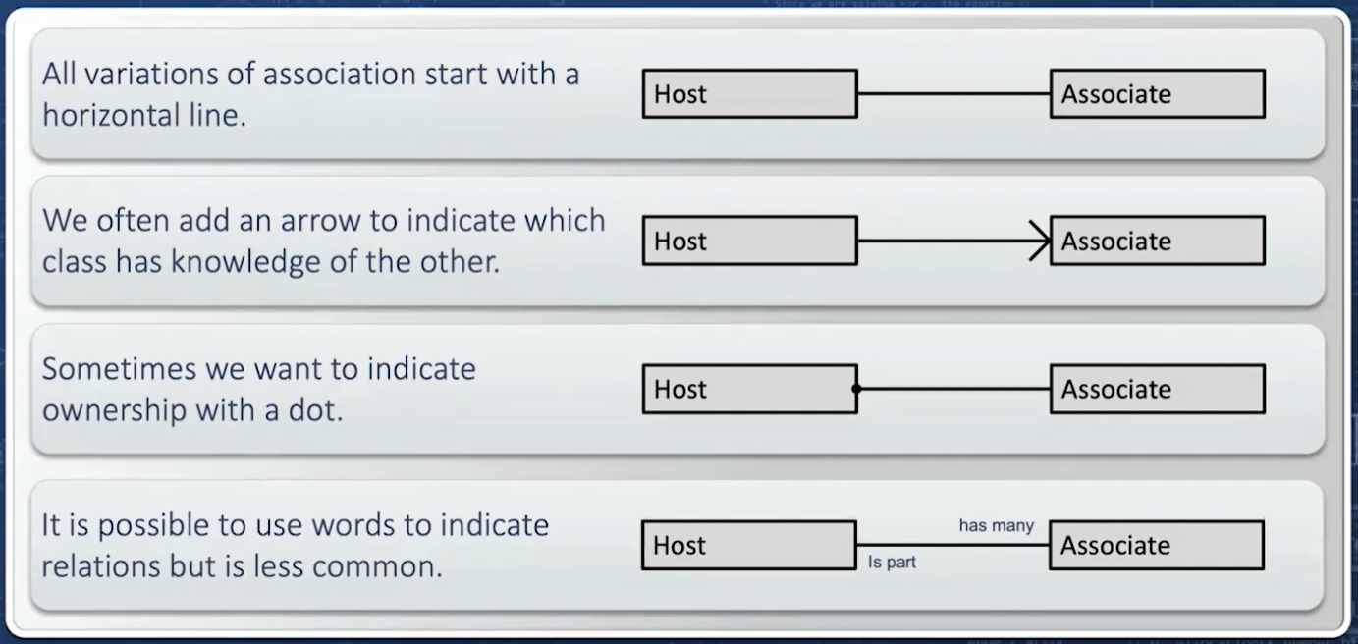

Most Common Representation of Association
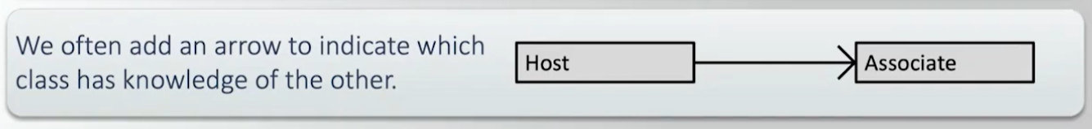

Ship Class Example
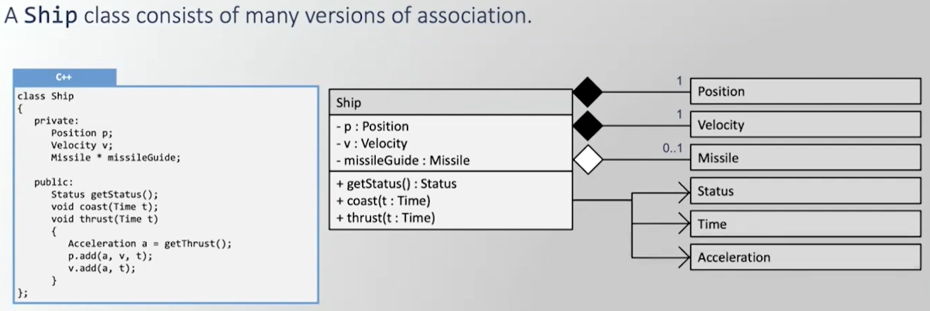

Source #5
https://www.youtube.com/watch?v=Vhky2Lo3_r4&list=PLSXY7z-v8oPBChTThEsgXooT_65KKm30-&index=5

Definition of Nested Class
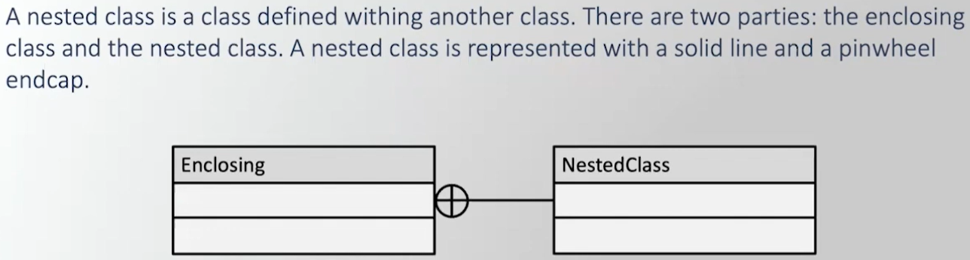

Public and Private Nested Class
- pHead and pTail of type Node - the Node class is Private - meaning only the list Class has access to it, but we can't distinguish Public from Private. Node is also related by Composition, so you need 2 horizontal lines with endcaps.
- iterator is a Nested Class within list and it is Public - meaning the client can instantiate a list iterator without even instantiating a list object.
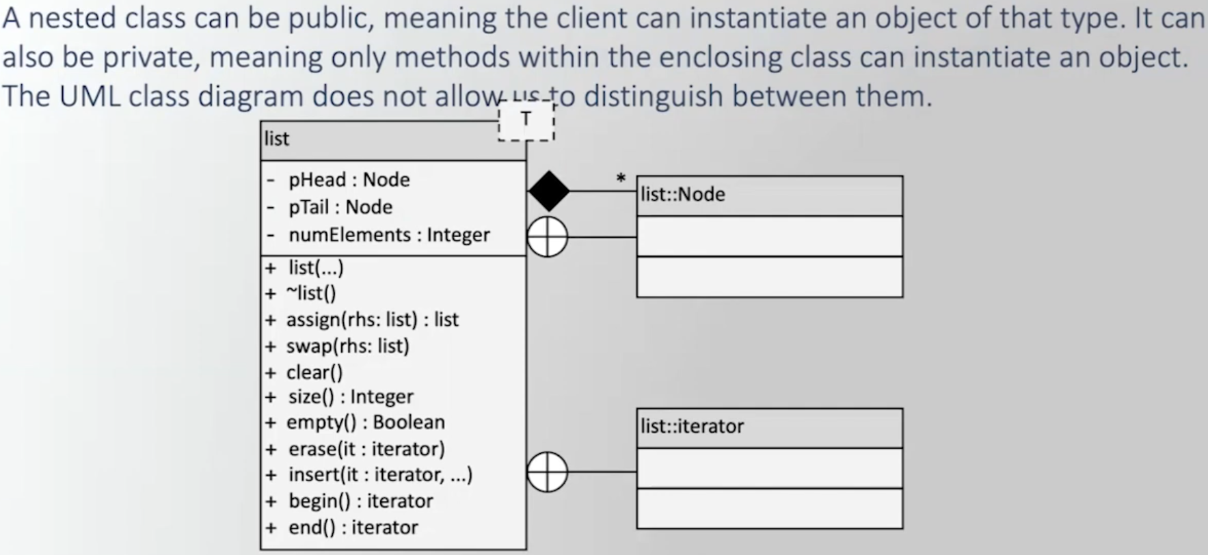

Spaceship Class Example
Type & Behavior are attributes in Spaceship so they are Composition, but they as well as Shuttle & Status are also defined within Spaceship, so they are also a Nested Class.
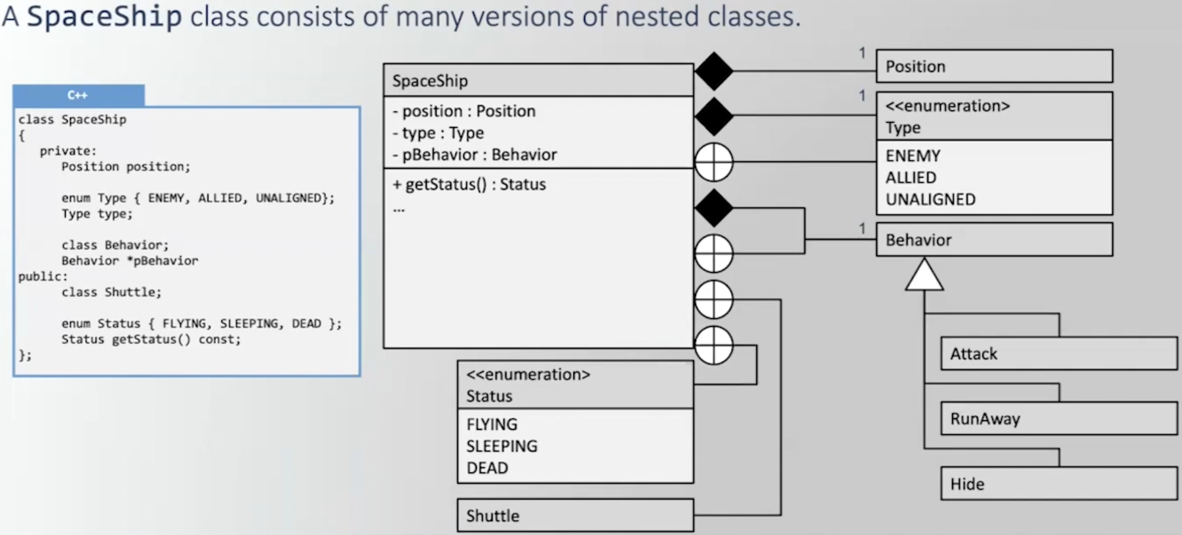

Nested Class Inheriting Template Parameters from Enclosing Class
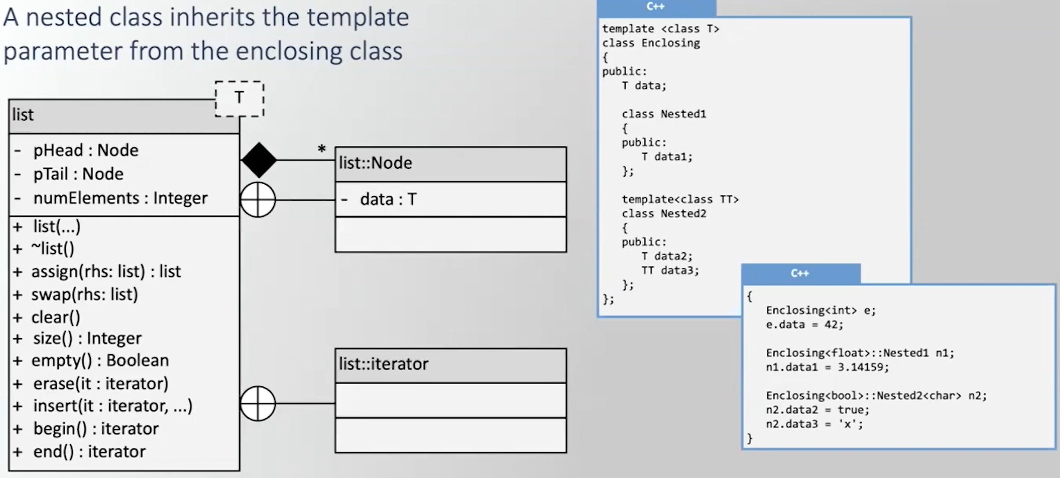

Source #6
https://www.youtube.com/watch?v=BpZs1qOVJbU&list=PLSXY7z-v8oPBChTThEsgXooT_65KKm30-&index=6

Class Diagram from Code - Example 3.0.1
You want the Class diagram to be language independent.
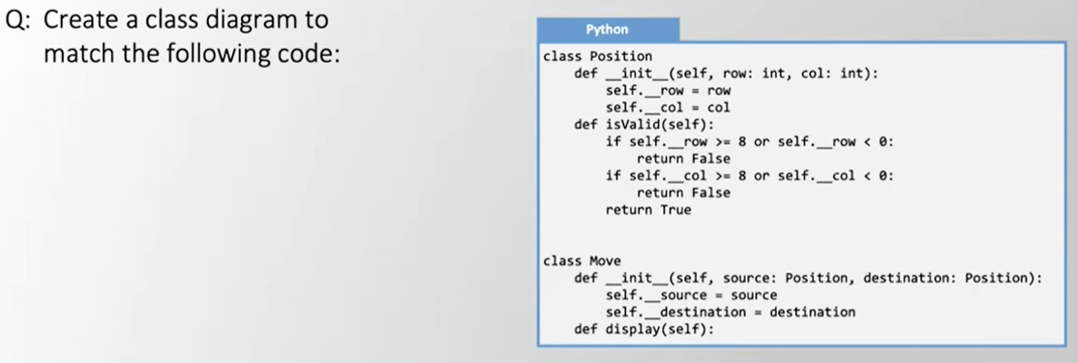


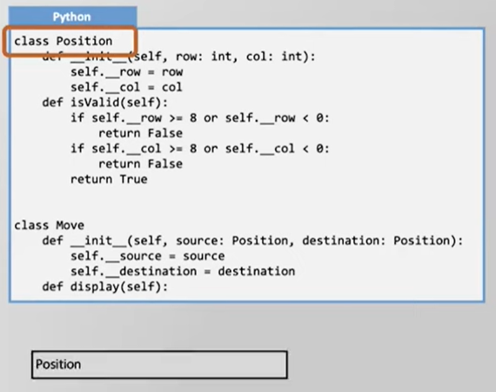


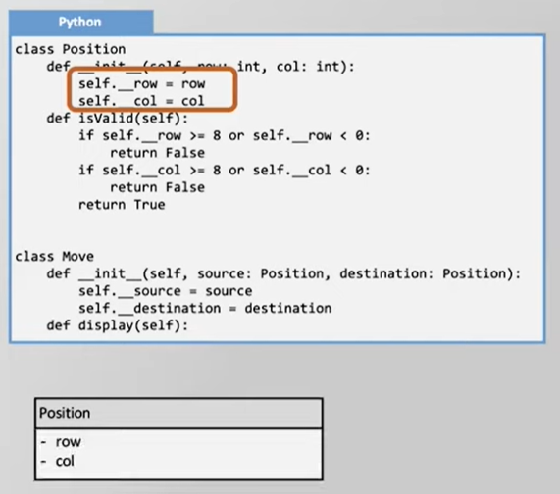


Self is a Python thing, not all languages have self as the 1st parameter - so omit it.
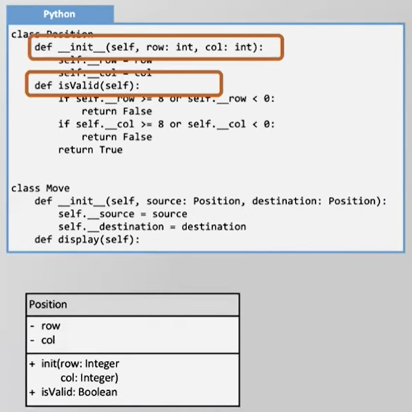

To keep the Class Diagram language independent don't represent any of the algorithms, if statements, or assignment operators.
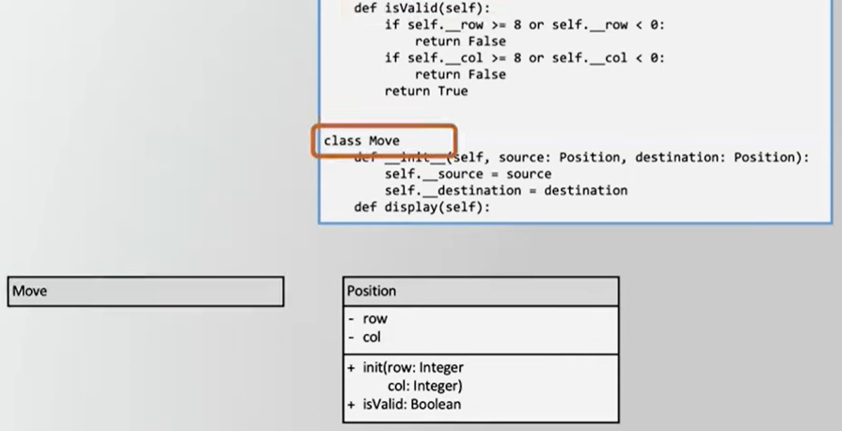

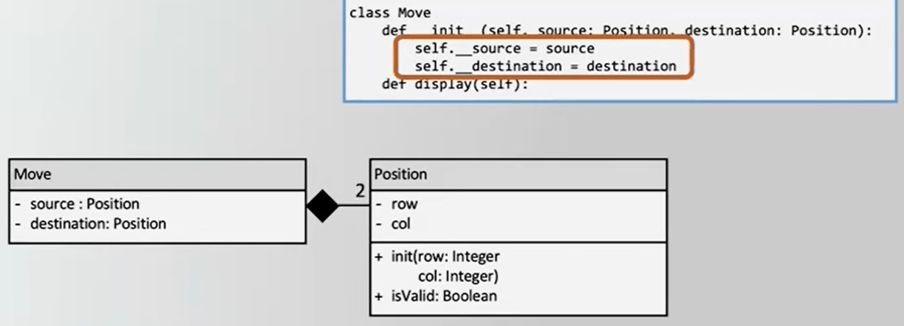

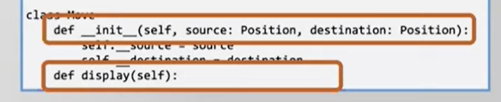
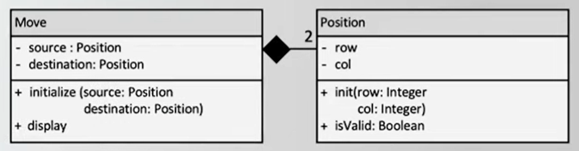


Code from Class Diagram - Example 3.0.2
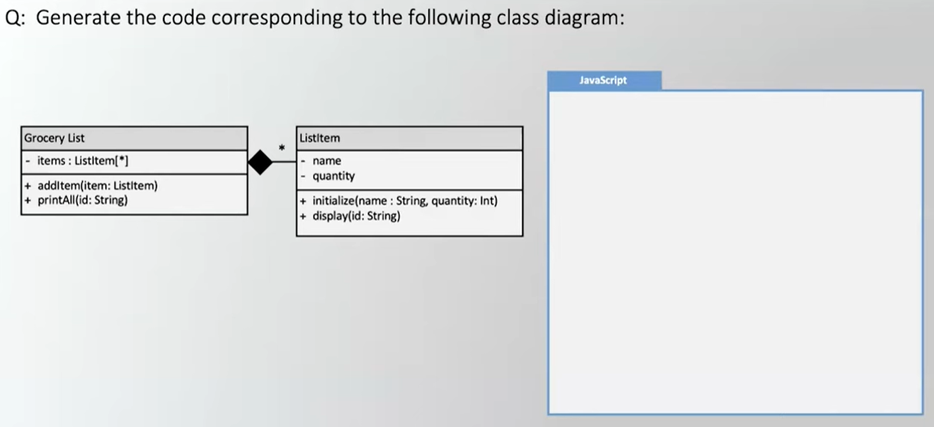

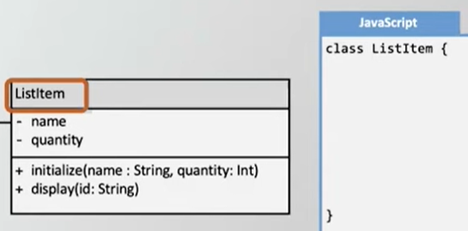

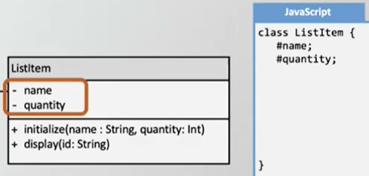

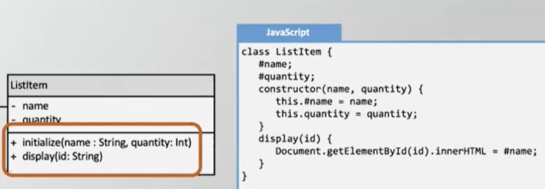

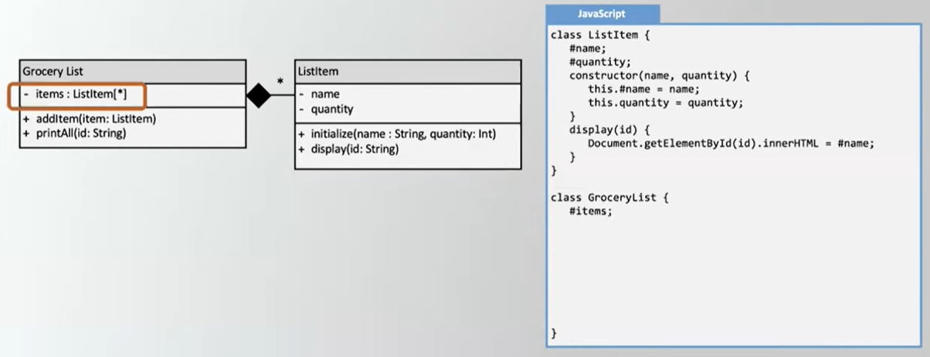

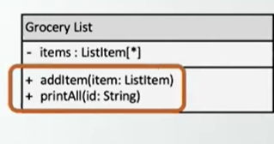

Final Result
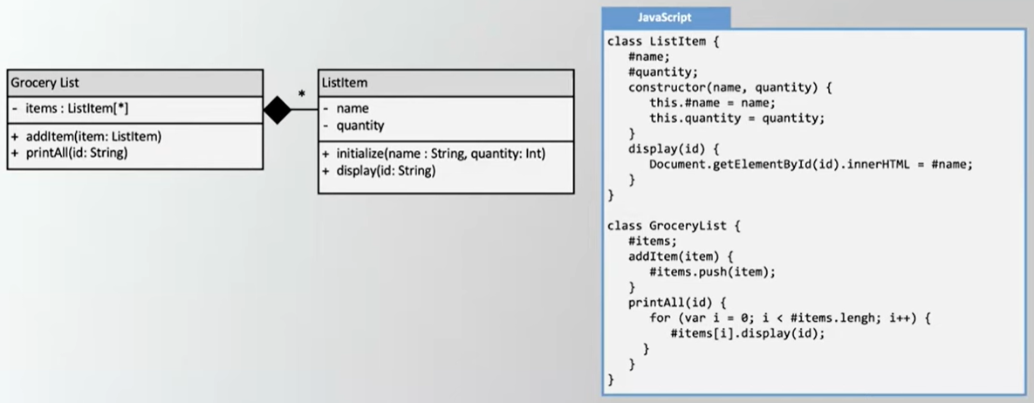

Source #6
https://www.youtube.com/watch?v=BxhgMB74ML0&list=PLSXY7z-v8oPBChTThEsgXooT_65KKm30-&index=7

Class Diagram for a Chart - Example 3.0.3
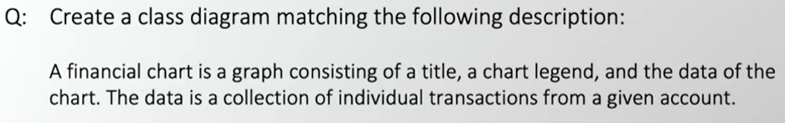

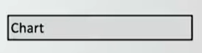

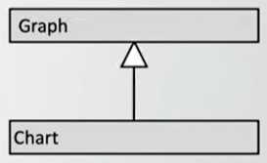


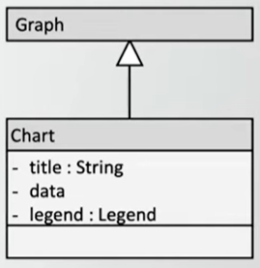

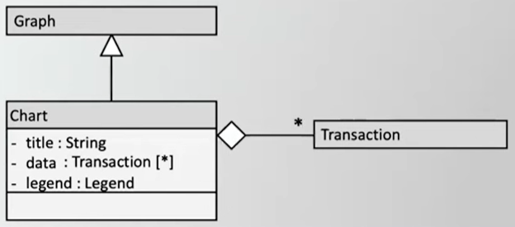

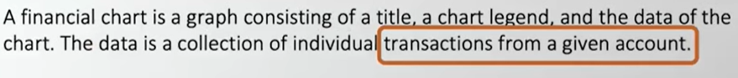
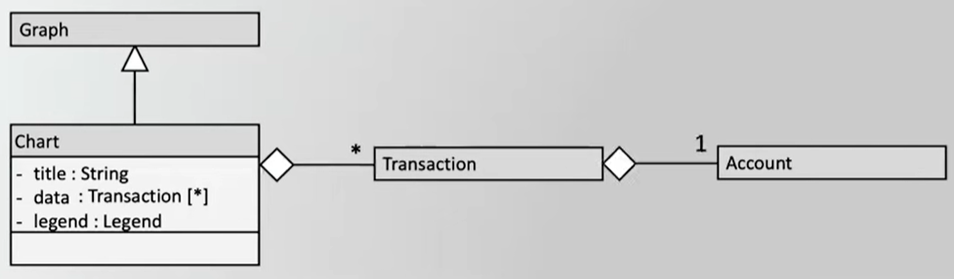

Legend is needed because the legend is intrinsically part of the chart.
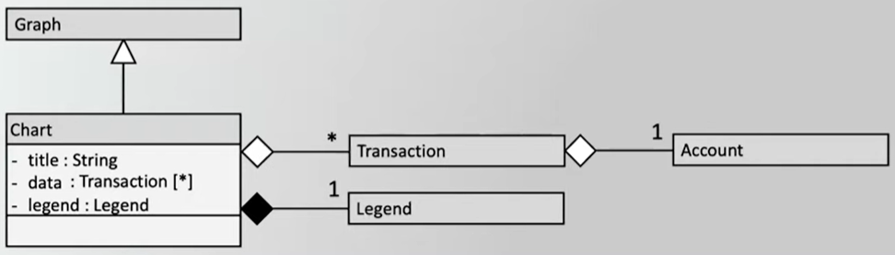

Class Design for Projectiles - Example 3.0.4
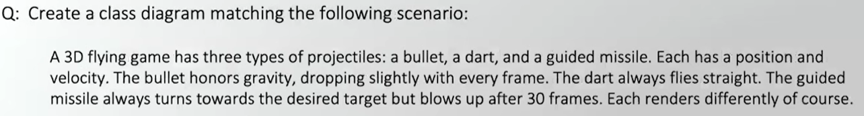

Not much difference between these.
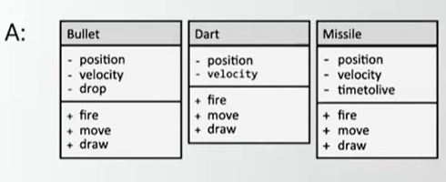
So, try something better using inheritance.
