2 Videos

Source #1
https://www.youtube.com/watch?v=PxAtXriRyE8&list=PLSXY7z-v8oPCR0YUDzgUReWEl6fka9snV&index=1

Designing with Pseudocode
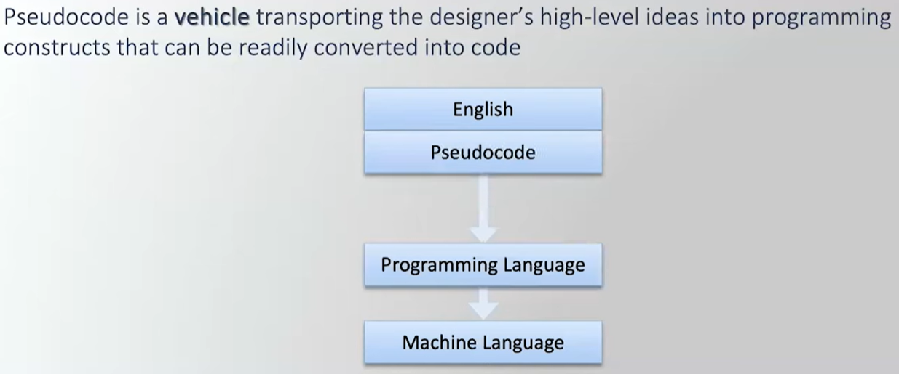
Through multiple iterations Pseudocode transports English so it gets closer and closer and closer to Programming Language.
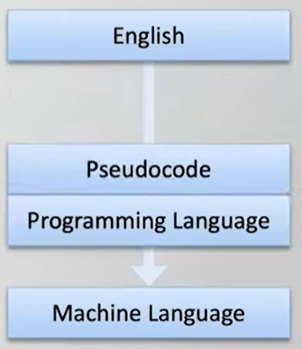

Bubble Sort - Example 02.1
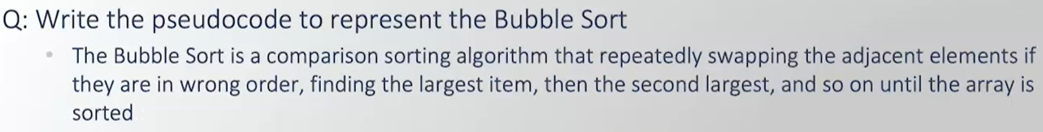
1st Pseudocode Iteration
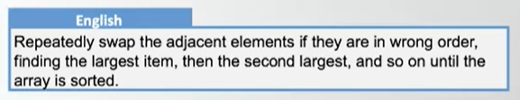
2nd Pseudocode Iteration
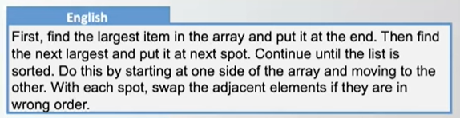
3rd Pseudocode Iteration
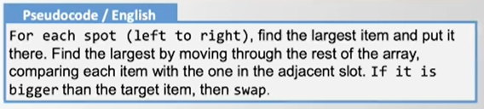
4th Pseudocode Iteration
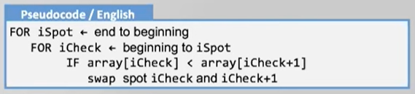
5th Pseudocode Iteration
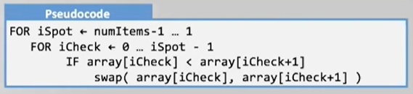
6th Pseudocode Iteration
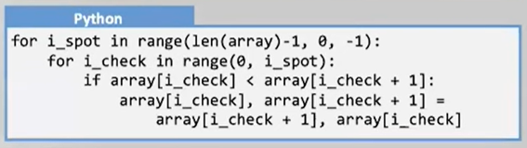

Compute Tax - Example 02.2
1st Pseudocode Iteration (Directly from the IRS website)
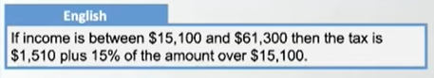
2nd Pseudocode Iteration
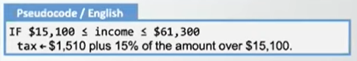
3rd Pseudocode Iteration
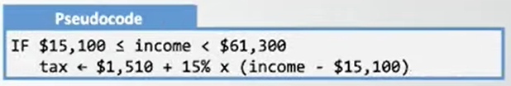
4th Pseudocode Iteration (Fill out the rest of the tax brackets)
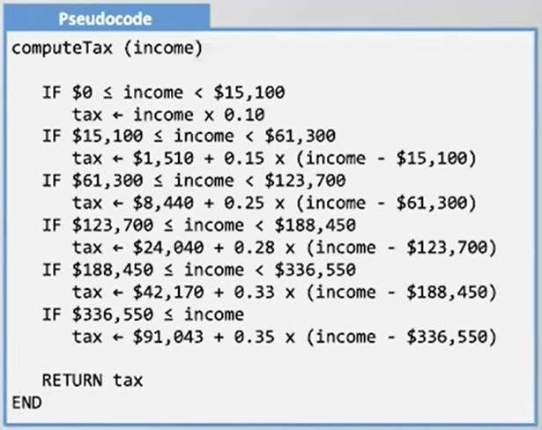

5th Iteration (Turn it into Python)
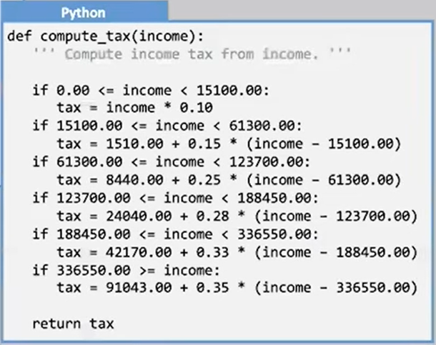

Source #1
https://www.youtube.com/watch?v=-mlDWNRQdCo&list=PLSXY7z-v8oPCR0YUDzgUReWEl6fka9snV&index=2

2 uses of Pseudocode (Design Tool & Communication Tool)
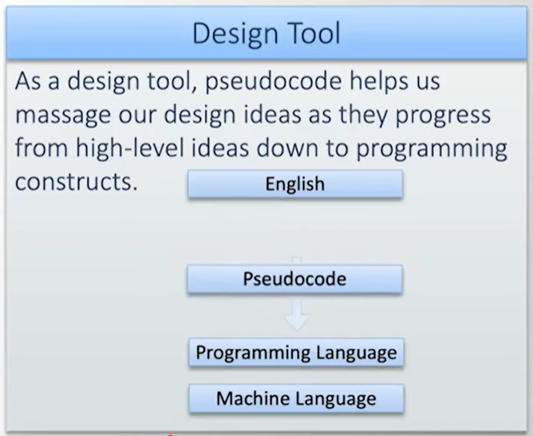
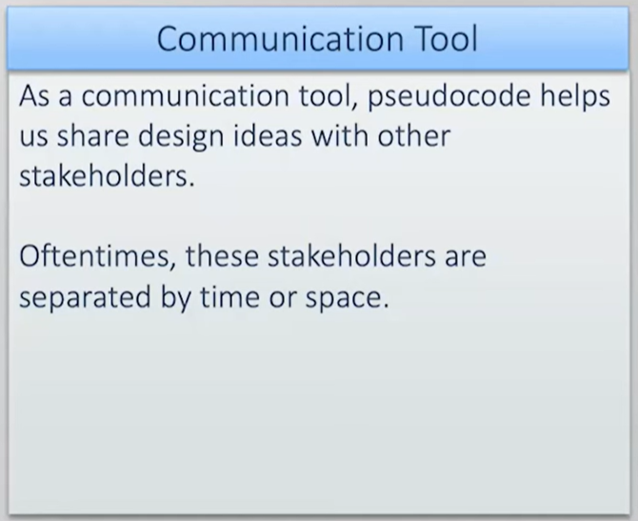

Focus on Example of it as a Design Tool
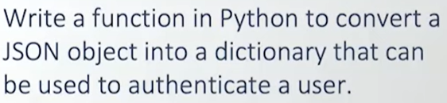
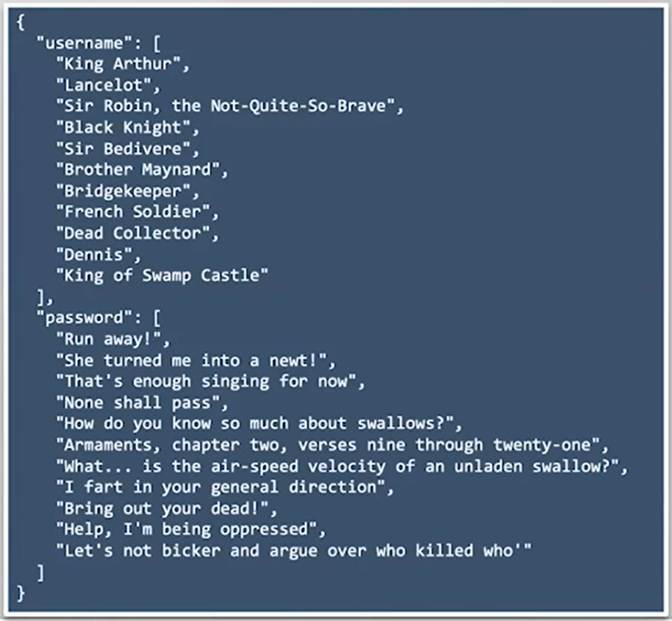

Want to write a Function named get_authentication
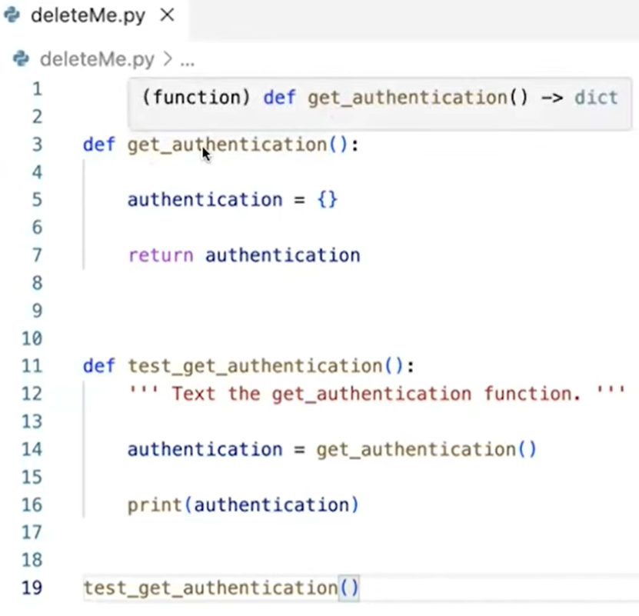

test_get_authentication will call get_authentication and see if it works

1st Step - Add a comment in the header describing the function in plain English
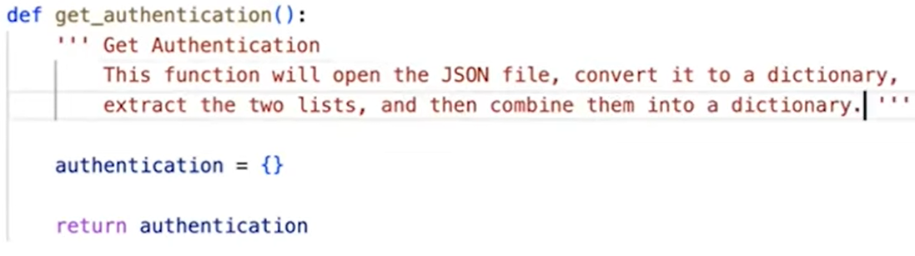
2nd Step - Take English definition of function and break up into the steps of the function.
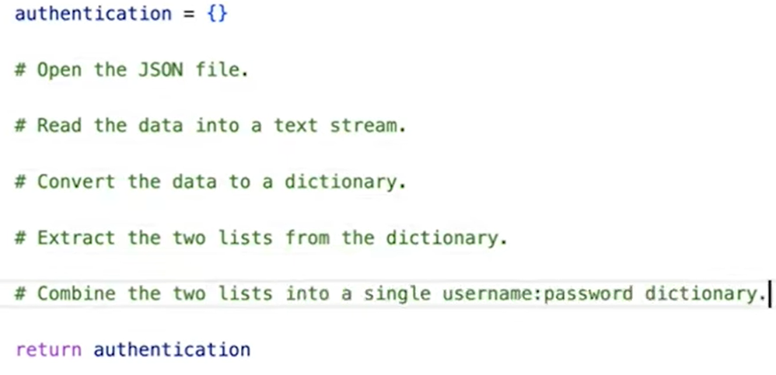

3rd Step - give a little more detail as to how
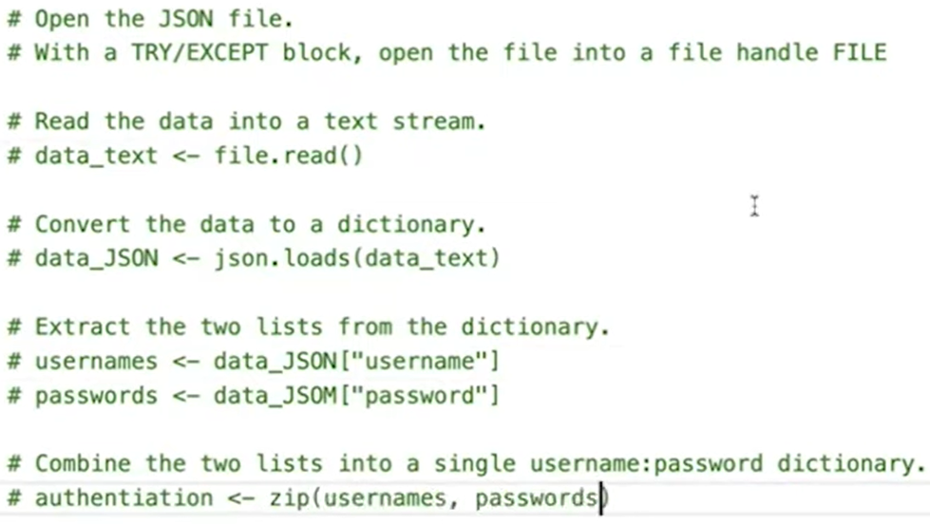
4th Step - convert it into Python code
