Class Diagrams – Web & Mobile Client
1.2.1 & 1.3.1 – CD Menu Class Diagram
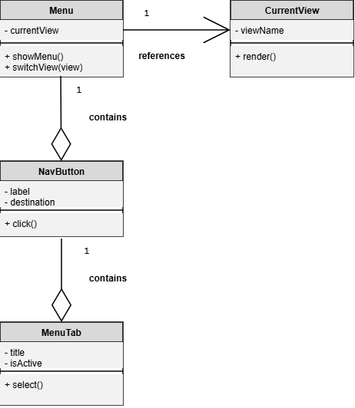
1.2.2 & 1.3.2 – CD Navigation Management Class Diagram
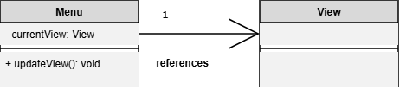

1.2.3 & 1.3.3 – View Class Diagram
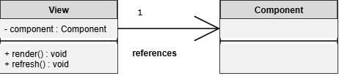
1.2.4 & 1.3.4 – CD Localization Class Diagram
