2.6 Application Status Tracking Screen

Desktop View
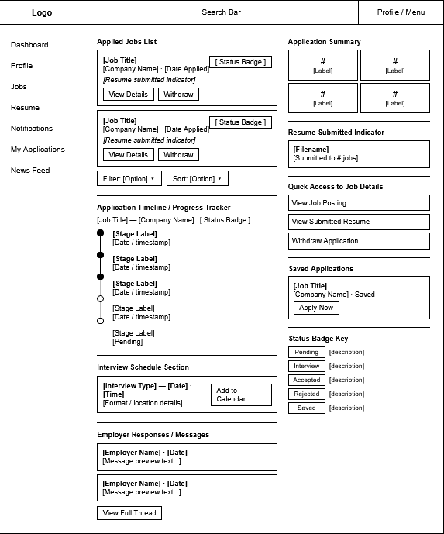

Mobile View
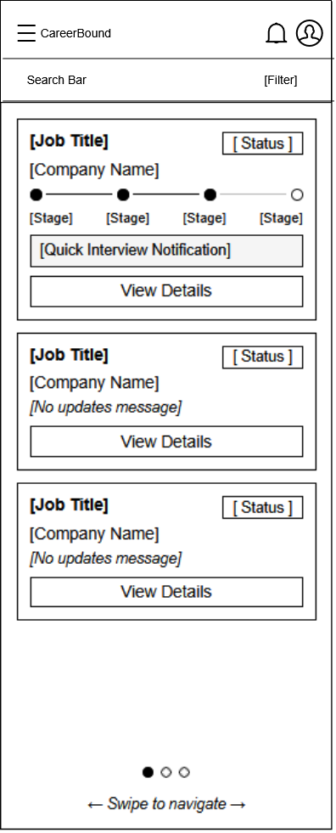
Design Information

Field | Description / Purpose
View Name & Number | 2.6 – Application Status Tracking Screen
Purpose / Design Concern | Allows students to view the status of their job applications.
Description | Displays applications students have submitted and their current status.
Requirements | 1.2.1, 2.5.6, 3.1.3.2, 3.3.1
Elements | Applied Jobs List
 | Application Summary
 | Application Timeline
Inputs | Filter selections, Button input
Outputs | Filtered Application list, Page redirect
Navigation / References | Job Details, Apply, Recent Applications Widget
Viewpoint | UI Wireframe / Mockup (Desktop & Mobile)

