Data Flow Diagrams – Database

DFD Figure 1.14.0.0.1 – Query Processing and Data Retrieval

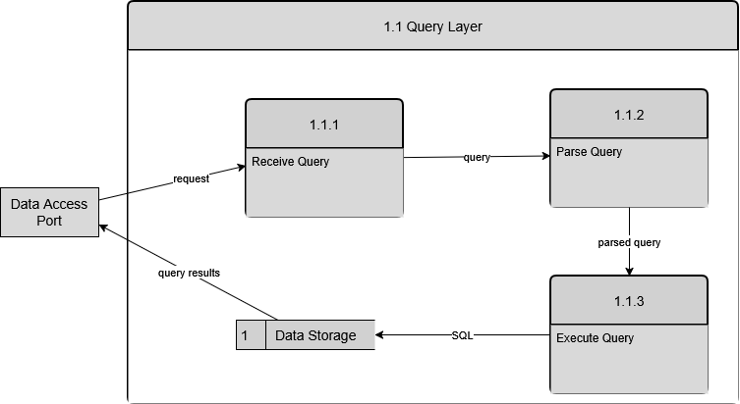

DFD Figure 1.14.0.0.2 – Indexed Data Lookup

