Data Flow Diagrams – Job Posting Service

DFD Figure 1.8.0.0.1 – Job Post Creation & Management

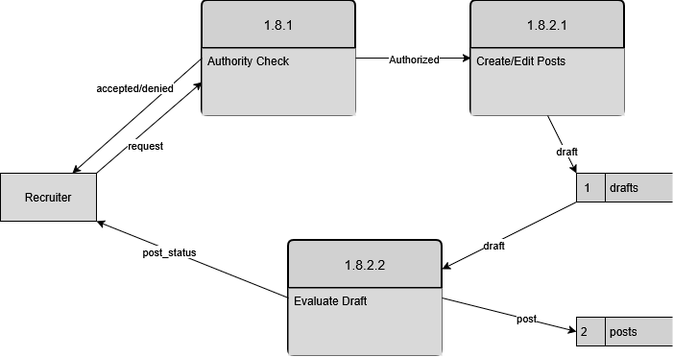

DFD Figure 1.8.0.0.2 – Post Validation & Publishing

