Structure Charts – Job Posting Service

SC Figure 1.8.0.1 – createPost()

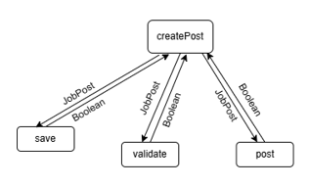
SC Figure 1.8.0.2 – validate()

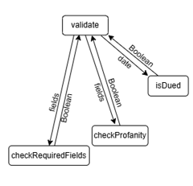
SC Figure 1.8.0.3 – modifyPost()

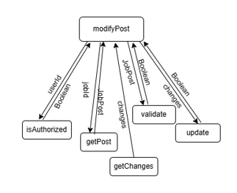

SC Figure 1.8.0.4 – isAuthorized()

