Structure Charts – Web Client and Mobile Client Shared Architecture

SC Figure 1.2.0.5 & 1.3.0.5 – selectNavigationTarget()

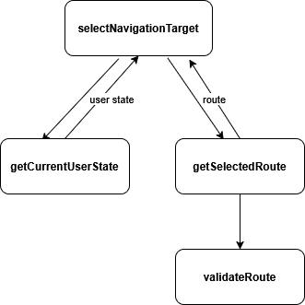

SC Figure 1.2.0.6 & 1.3.0.6 – displayValidationFeedback()

