Data Flow Diagrams – File / Blob Storage

DFD Figure 1.15.0.0.1 – File Upload and Storage

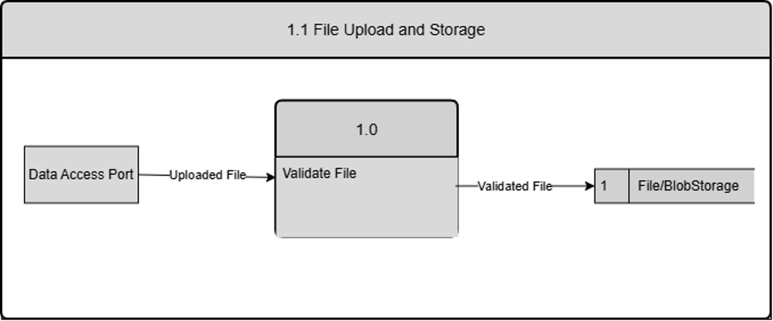

DFD Figure 1.15.0.0.2 – Backup Creation and File Recovery

