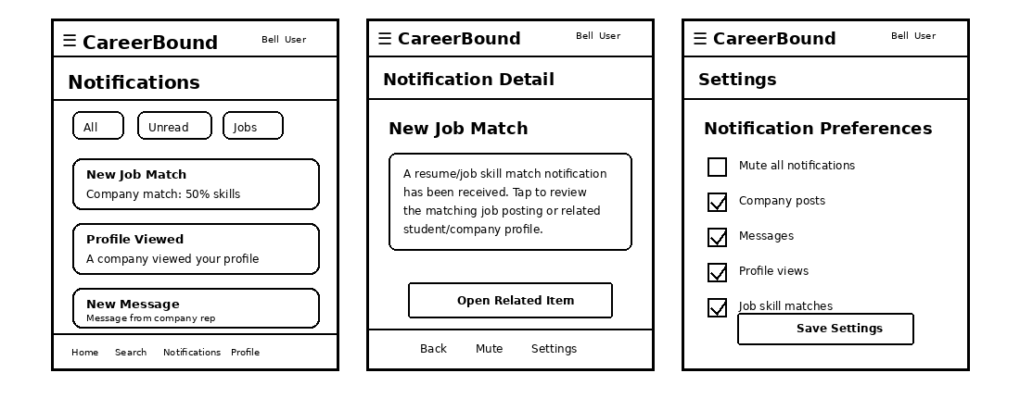
Design Information
Field | Description / Purpose
View Name & Number | 2.2 / 3.2 – Mobile Client Notifications Screens
Purpose / Design Concern | Allows mobile users to view, open, filter, and mute notifications from the mobile application interface.
Description | Shows mobile notification screens for student users and company representatives, including the notification list, notification detail screen, push notification handling, and notification preferences.
Requirements | SRS 1.2.1 Application Scope; 2.2 Notifications; 3.2 Notifications
Elements | Notification Screen; Notification List; Notification Detail View; Push Notification Handler; Notification Preferences; Filter Settings; Mute Notification Control; API Client Adapter / REST/HTTP API Port
Inputs | Selected notification, filter settings, mute setting changes, push notification trigger, and mobile navigation actions
Outputs | Notification list, notification detail information, filtered notification results, push notification display, and updated notification settings
Navigation / References | Mobile Client; Notification Screen; Notification Detail View; Notification Preferences; API Gateway / Orchestrator
Viewpoint | UI Wireframe / Mockup (Mobile)

