2.2 Student Profile
Desktop View
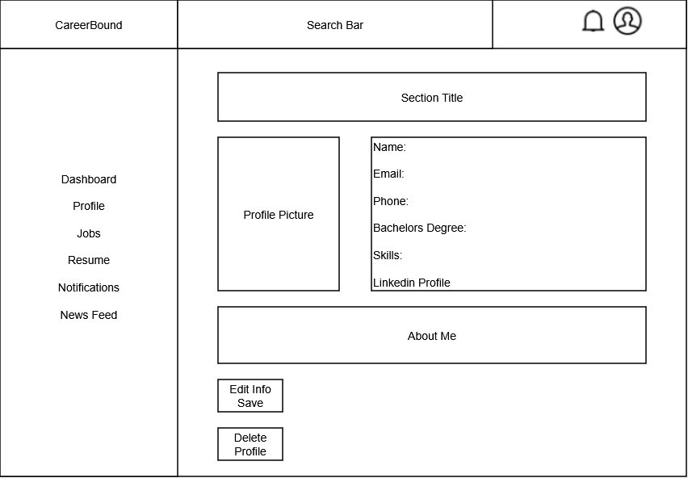

Mobile View
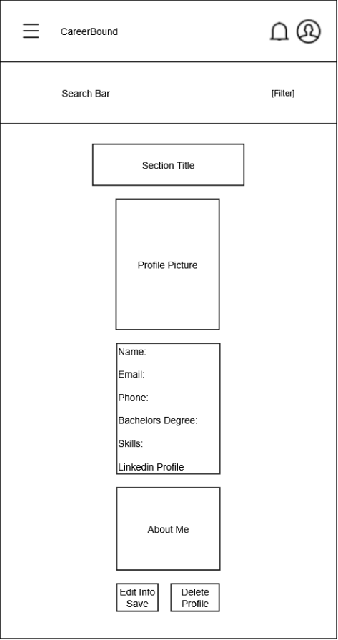

Design Information
Field | Description / Purpose
View Name & Number | 2.2 – Student Profile
Purpose / Design Concern | Allows students to view and manage their profile information.
Description | Displays student information such as name, contact information, program, skills, and resume-related details.
Requirements | 3.1 Student User Profile (3.1.1–3.1.3.3)
Elements | Logo
 | Search bar
 | Menu/Profile
 | Left Navigation
 | Section Title
 | Profile Picture
 | User Information
 | About Me
 | Save/Delete buttons
Inputs | Updated student profile information, Upload CV
Outputs | Displayed student profile information
Navigation / References | Dashboard, Profile, Jobs, Resume, Notifications, News Feed
Viewpoint | UI Wireframe / Mockup (Desktop & Mobile)

