Standards

For each API message, use this format:

Heading Requirements
<Inner Component Number>-API <Message Name>
(Arial 13.5 Bold, Outline Level 3 Header, Keep with next)

API Message Specification Table Requirements
(Table Design: Grid Table 4, Font: Arial, Header Row: 12pt Bold, Body 1st Column 11pt Bold, Rest of table rows and columns 11pt, Headings as shown below)
Field | Data Type | Required | Description
fieldName | DataType | Yes/No | Description of the field

Examples:

1.5.3-API LoginRequest
Field | Data Type | Required | Description
email | String | Yes | User email address
password | String | Yes | User password

1.5.3-API LoginResponse
Field | Data Type | Required | Description
userId | UUID | Yes | Unique user identifier
token | String | Yes | Authentication token
role | String | Yes | User role
The goal is to define what data is sent into and returned from each assigned service.

Team 5 — External Services & Analytics

Suggested API messages:
- AddressValidationRequest
- AddressValidationResponse
- AutocompleteRequest
- AutocompleteResponse
- AnalyticsEventRequest: JobPostingAnalyticsRequest, CandidateSearchAnalyticsRequest, ProfileResumeEngagementRequest
- AnalyticsEventResponse: JobPostingAnalyticsResponse, CandidateSearchAnalyticsResponse, ProfileResumeEngagementResponse
- PerformanceMetricRequest
- PerformanceMetricResponse
- PushNotificationRequest
- PushNotificationResponse

1.4.11 — External Services Orchestrator AND 1.4.12 — Analytics Orchestrator don’t require API messages because they are not sending a new message over the network but rather forward request/response payloads.

USPS Address Validation Adapter - William
- 1.12.1 – API AddressValidationRequest
- 1.12.1 – API AddressValidationResponse
Autocomplete API Adapter - Wessley
- 1.12.2 – API AutocompleteRequest
- 1.12.2 – API AutocompleteResponse
Push Notification Gateway – Ethan S.
- 1.12.3 – API PushNotificationRequest
- 1.12.3 – API PushNotificationResponse

Team 5 — Subcomponent Numbers External Services
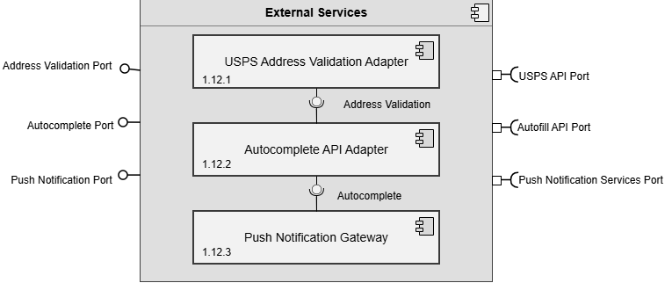

Job Posting Analytics - Dallin
- 1.13.1 – API JobPostingAnalyticsRequest
- 1.13.1 – API JobPostingAnalyticsResponse
Search and Candidate Analytics - Dallin
- 1.13.2 – API CandidateSearchAnalyticsRequest
- 1.13.2 – API CandidateSearchAnalyticsResponse
Profile and Resume Engagement - William
- 1.13.3 – API ProfileResumeEngagementRequest
- 1.13.3 – API ProfileResumeEngagementResponse
Notification and News Feed Analytics – Ethan S.
- 1.13.4 – API NotificationNewsFeedAnalyticsRequest
- 1.13.4 – API NotificationNewsFeedAnalyticsResponse
Performance Monitor - Adam
- 1.13.5 – API PerformanceMetricRequest
- 1.13.5 – API PerformanceMetricResponse

Team 5 — Subcomponent Numbers Analytics Service
