Entity Identification Tables – Recommendation Service

EI Table 1.11 – Recommendation Service
Subcomponent | Entity Name | Entity Type | Description / Purpose | Related Requirement(s) | Collaborators / Related Entities
Student-to-Job Matching | generateRecommendations() | Function | Generates ranked job recommendations for a student | 2.3.7, 3.3.3 | StudentProfile, JobPosting, MatchScore
Student-to-Job Matching | StudentProfile | Class | Stores student qualifications, skills, and academic information | 3.1.1–3.1.3.4 | Resume, Skill, Experience
Student-to-Job Matching | Resume | Object | Contains student’s education, experience, and skill data. | 3.5.1–3.5.5.3 | StudentProfile, MatchEngine
Student-to-Job Matching | Skill | Class | Represents a skill possessed by a student or required by a job. | 2.3.7, 3.3.3 | JobPosting, MatchScore
Student-to-Job Matching | JobPosting | Data Table | Stores active job opportunities available for matching | 2.5.1–2.5.9 | Company, MatchEngine
Student-to-Job Matching | compareSkills() | Method | Compares student skills against required job skills | 2.3.7, 3.3.3 | Skill, JobPosting
Student-to-Job Matching | compareExperience() | Method | Evaluate student experience against job requirements | 3.3.3 | Resume, JobPosting
Student-to-Job Matching | CalculateMatchScore() | Method | Calculates a compatibility score between the student and job | 2.3.7, 3.3.3 | compareSkills(), compareExperience()
Student-to-Job Matching | MatchScore | Object | Stores the compatibility score for a student-job pair | 2.3.7 | JobPosting, Recommendation
Student-to-Job Matching | rankMatches() | Method | Orders matched jobs by compatibility score | 2.3.7 | MatchScore, Recommendation
Student-to-Job Matching | Recommendation | Object | Represents a job recommended to a student | 3.3.3 | MatchScore, JobPosting
Student-to-Job Matching | JobPostingIndex | Data Store | Stores searchable active job postings used by the recommendation engine | 2.3.7, 3.3.3 | JobPosting
Student-to-Job Matching | ResumeListingIndex | Data Store | Stores student resume information used for matching. | 3.3.3 | Resume, StudentProfile
Student-to-Job Matching | filterJobs() | Method | Removes jobs that do not meet minimum matching criteria | 2.3.7 | JobPosting, MatchScore

Structure Charts – Recommendation Service

Structure Chart 1: Recommendation Generation Service
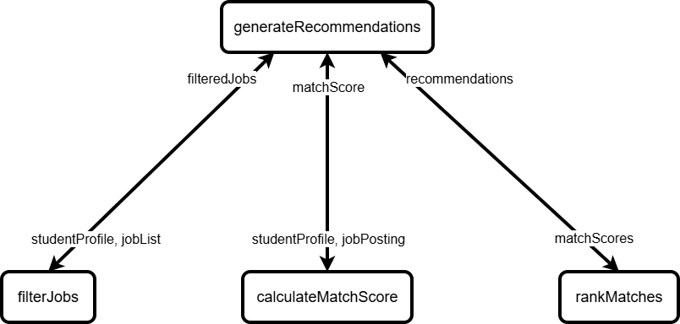

Structure Chart 2: Match Score Calculation Process
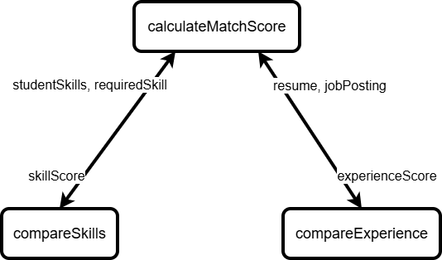

Data Flow Diagram – Recommendation Service

DFD: Student-to-Job Matching Data Flow
