Entity Table for Resume Input and Builder

Subcomponent | Entity Name | Entity Type | Description / Purpose | Related Requirement(s) | Collaborators / Related Entities
Resume Service | Resume | Class | Represents the student resume being created or uploaded. | 3.5.1, 3.5.2, 3.5.4.1 | StudentProfile, ResumeBuilder, ResumeFile
Resume Service | StudentProfile | Class | Provides student information that can be used in the resume. | 3.5.1, 3.5.4.1 | Resume, Profile Management Service
Resume Service | ResumeBuilder | Module | Handles the process of creating a resume from user input. | 3.5.1, 3.5.4.1 | Resume, ResumeForm, StudentProfile
Resume Service | ResumeForm | Object | Represents the form used by the student to enter resume information. | 3.5.1 | ResumeBuilder, ResumeInput
Resume Service | ResumeInput | Object | Stores the information entered by the student in the resume form. | 3.5.1 | ResumeForm, ResumeValidator
Resume Service | ResumeSection | Class | Represents a section of the resume such as education, skills, or experience. | 3.5.1 | Resume, ResumeInput
Resume Service | Skill | Class | Represents a skill added to the student resume. | 3.5.1, 3.5.4.1 | ResumeSection, StudentProfile
Resume Service | Education | Class | Represents education information included in the resume. | 3.5.1, 3.5.4.1 | ResumeSection, StudentProfile
Resume Service | Experience | Class | Represents work or project experience included in the resume. | 3.5.1, 3.5.4.1 | ResumeSection, StudentProfile
Resume Service | ResumeFile | Object | Represents the resume file selected by the student for upload. | 3.5.2 | Resume, File / Blob Storage
Resume Service | FileType | Variable | Stores the type of file being uploaded. | 3.5.2 | ResumeFile, ResumeValidator
Resume Service | FileSize | Variable | Stores the size of the uploaded resume file. | 3.5.2 | ResumeFile, ResumeValidator
Resume Service | ResumeValidator | Module | Checks that the resume input or uploaded file is valid. | 3.5.1, 3.5.2 | ResumeInput, ResumeFile
Resume Service | ResumeMetadata | Class | Stores information about the resume file such as name, type, size, and upload date. | 3.5.2 | ResumeFile, Database
Resume Service | ResumeFiles | Data Store | Stores uploaded resume documents and related files. | 3.5.2 | ResumeFile, File / Blob Storage
Resume Service | File / Blob Storage | Data Store | Stores the actual uploaded resume file. | 3.5.2 | ResumeFiles, Resume Service
Resume Service | Database | Data Store | Stores resume data, metadata, and links to the student profile. | 3.5.1, 3.5.2, 3.5.4.1 | Resume, ResumeMetadata, StudentProfile
Resume Service | API Gateway / Orchestrator | Module | Sends resume builder and upload requests between the client and Resume Service. | 3.5.1, 3.5.2 | Web Client, Resume Service
Resume Service | Web Client | Module | Provides the user interface where the student builds or uploads the resume. | 3.5.1, 3.5.2 | ResumeForm, API Gateway / Orchestrator
Resume Service | ResumeStatus | Variable | Tracks whether the resume is draft, uploaded, saved, or ready to submit. | 3.5.1, 3.5.2, 3.5.4.1 | Resume, Student Dashboard
Resume Service | createResume() | Function | Starts the process of creating a new resume. | 3.5.1 | ResumeBuilder, Resume
Resume Service | collectResumeInput() | Function | Collects resume information entered by the student. | 3.5.1 | ResumeForm, ResumeInput
Resume Service | validateResumeInput() | Function | Checks that required resume fields are completed correctly. | 3.5.1 | ResumeInput, ResumeValidator
Resume Service | saveResumeDraft() | Function | Saves the current resume as a draft. | 3.5.1, 3.5.4.1 | Resume, Database
Resume Service | uploadResume() | Method | Uploads a student resume file. | 3.5.2 | ResumeFile, File / Blob Storage
Resume Service | validateResumeFile() | Function | Checks the file type and file size before upload. | 3.5.2 | ResumeFile, FileType, FileSize
Resume Service | saveResumeMetadata() | Function | Saves resume file information after upload. | 3.5.2 | ResumeMetadata, Database
Resume Service | linkResumeToProfile() | Function | Connects the resume to the student profile. | 3.5.4.1 | Resume, StudentProfile, Database

Structure Chart 1 - Resume Builder / Input
Purpose: show the functional organization of the resume builder and input side of Resume Service.

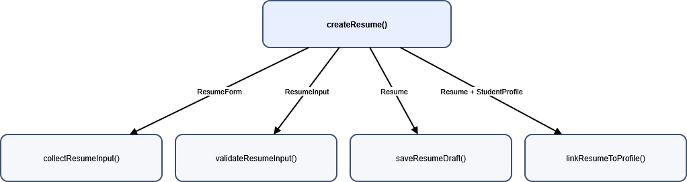

Structure Chart 2 — Resume File Upload Process
Purpose: show the functional organization of the file upload side of Resume Service.
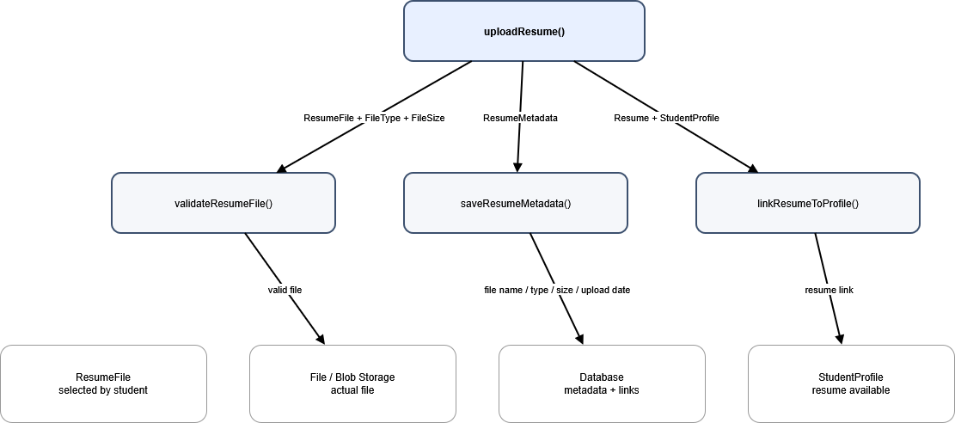

DFD — Resume Input and Builder
Purpose: show where data moves when a student enters contact and experience information.
