2.5.1 – 2.5.9-CD JobPosting Class Diagram
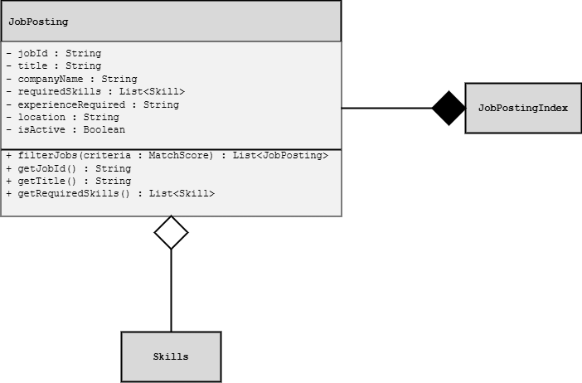

2.3.7, 3.3.3-CD Recommendation Class Diagram

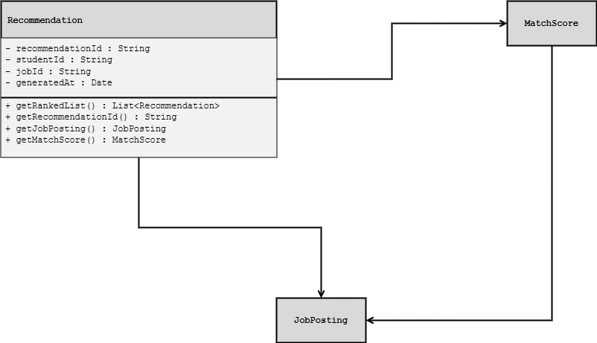

3.1.1 – 3.1.3.4-CD StudentProfile Class Diagram
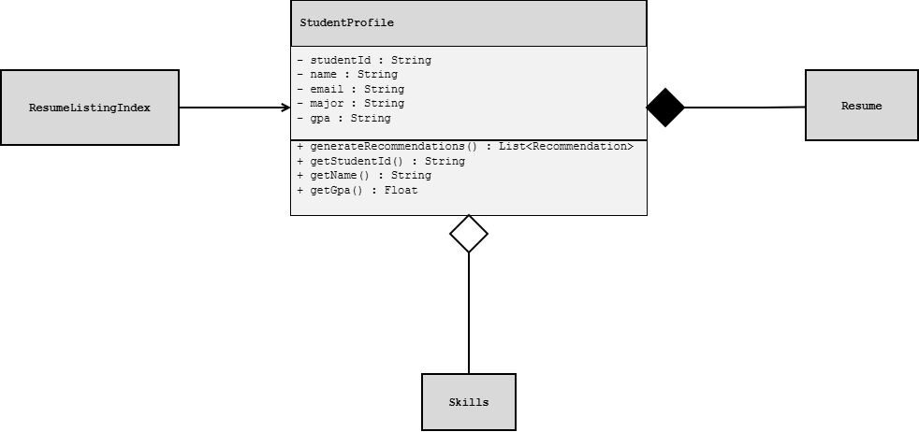

1.7.3-CD SkillTag Class Diagram

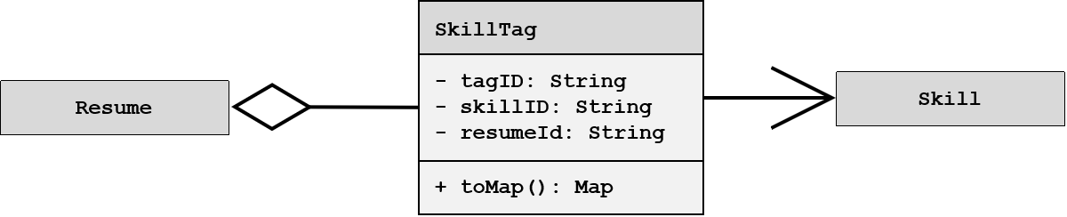

1.7.3-CD ResumeSubmission Class Diagram

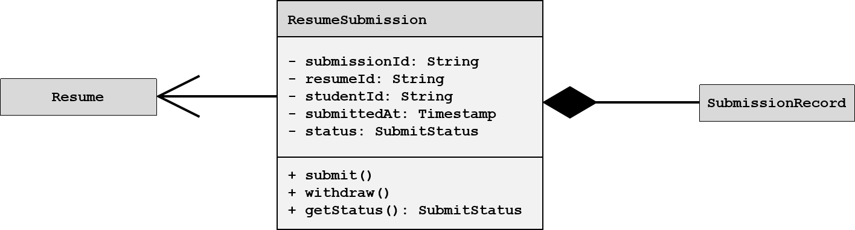

1.7.5-CD ValidationResult Class Diagram

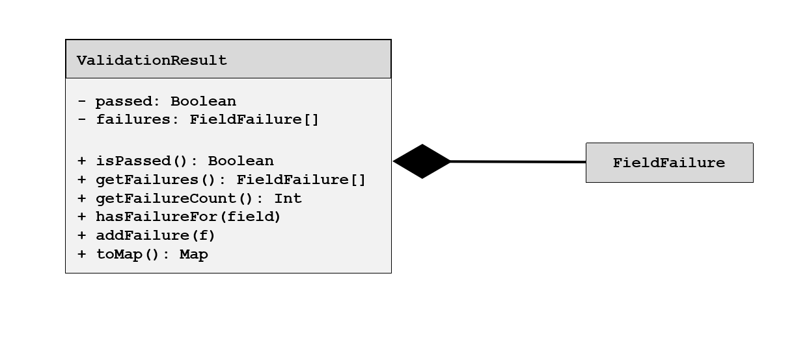

1.11.2-CD CandidateRecommender Class Diagram

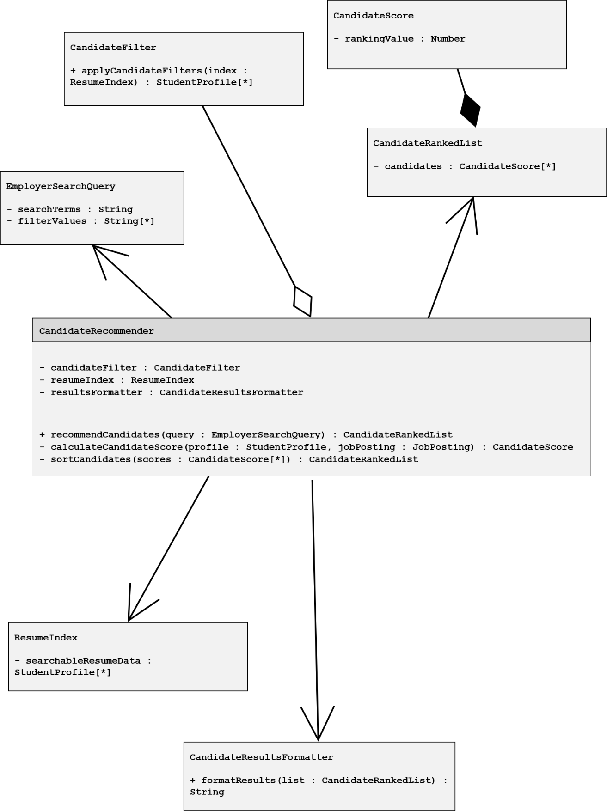

1.11.2-CD CandidateFilter Class Diagram

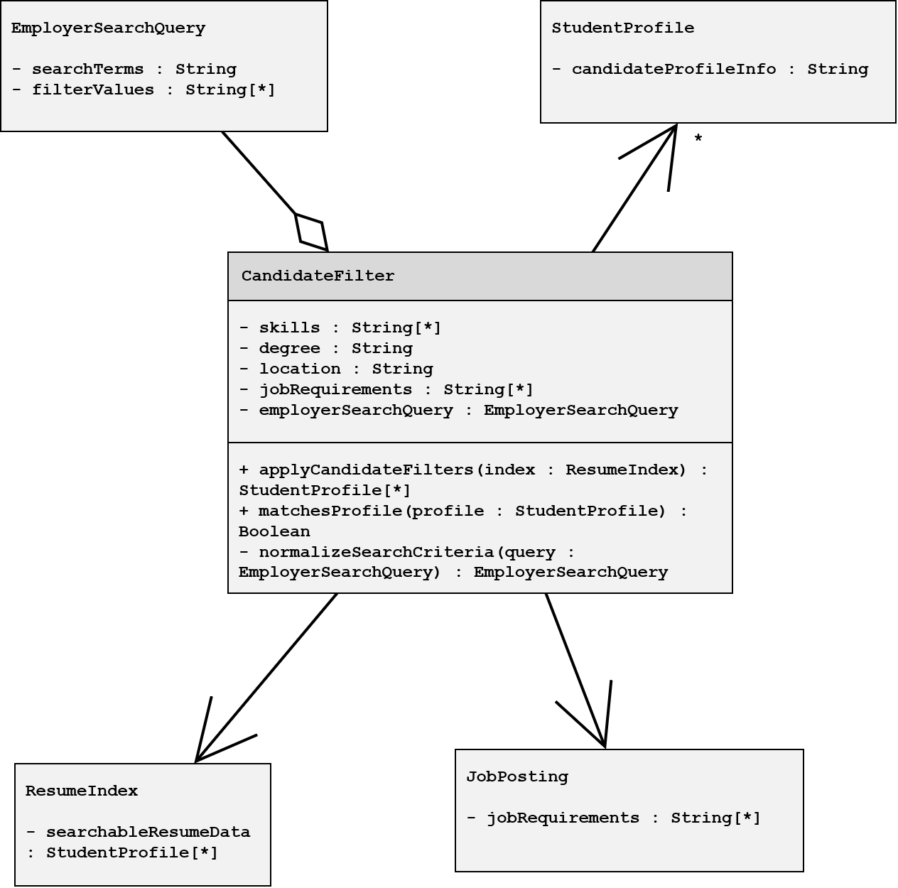

Summary of Work Done for Team 6
Subcomponent # and Diagram Name | Work Done By
2.5.1 – 2.5.9-CD JobPosting Class Diagram | Angie Milford
2.3.7, 3.3.3-CD Recommendation Class Diagram | Angie Milford
3.1.1 – 3.1.3.4-CD StudentProfile Class Diagram | Angie Milford
1.7.3-CD SkillTag Class Diagram | Sunseehray Tirazona
1.7.3-CD ResumeSubmission Class Diagram | Sunseehray Tirazona
1.7.5-CD ValidationResult Class Diagram | Sunseehray Tirazona
1.11.2-CD CandidateRecommender Class Diagram | Sergio Bravo
1.11.2-CD CandidateFilter Class Diagram | Sergio Bravo

