SWDD- [obtain number from Conduct of Engineering Document Numbering SharePoint site]

CSE 430 Architectural Design
Career Bound

Software Design Document

Name (s): Jeremy Troy Suchanski, Robert Anderson, Danny Capps, Savannah Harvey, Spencer Beals, Kimberly Uresti, Adam Sheridan, Marco Quintero, Corbin Probasco, Nathan Lipovich, Abraham Moreno-Sanchez, Kaleb Swertfeger, Mike Olson, Kyle Jones, Yat Lam, Ernesto Quispe Cajan, Jacob Mychal Kertesz, Pavel Shvets, Peyton Markus, Carson Roberts, Joe Allen, Sam Evans, Zach Crittenden, Caleb Schmid, Jackson Aden, Scott Shumway, Zachary Humphreys, Braulio Garcia Gonzalez, Ethan Houser, Wessly Green Contreras, William Torman, Ethan Seegmiller, Sergey Tsybenko, Sergio Bravo Bravo Moran, Dallin Stephens, Sunseehray Tirazona, Teph Milford
Section: BYUI
Workstation: Online

Date: 05/13/2026

Revision History
Version | Date | Author | Change Description
1.0 | 5/14/26 | Jeremy Troy Suchanski | Filled in work done for Milestone 1 and started filling in sections relevant to Milestone 2 for Initial SWDD draft
2.0 | 5/22/26 | Nathan Lipovich | Filled in the diagrams for 6.2 and 7 as well as the 6.1 introduction
3.0 | 5/24 | Corbin Probasco | Fill in the missing information for Component Diagram Design Information Tables & other fixes.

TABLE OF CONTENTS
1.0 INTRODUCTION 4
1.1 Purpose 4
1.2 Scope 4
1.3 Overview 4
1.4 Reference Material 4
1.5 Definitions and Acronyms 4
2.0 SYSTEM OVERVIEW 4
3.0 SYSTEM ARCHITECTURE 4
3.1 Architectural Design 4
3.2 Decomposition Description 5
3.3 Design Rationale 5
4.0 DATA DESIGN 5
4.1 Data Description 5
4.2 Data Dictionary 5
5.0 COMPONENT DESIGN 5
6.0 HUMAN INTERFACE DESIGN 5
6.1 Overview of User Interface 5
6.2 Screen Images 6
6.3 Screen Objects and Actions 6
7.0 REQUIREMENTS MATRIX 6
8.0 APPENDICES 6

INTRODUCTION

Purpose
This Software Design Document (SWDD) describes the architecture, subsystem breakdown, data design, component structure, and human interface design of the Career Bound system. The document provides the design foundation necessary for implementation and integration of the Career Bound software platform.
The intended audience of this document includes:
- Developers
- Designers
- QA reviewers
- Project managers
- Instructors
- Stakeholders
This document serves as the primary design reference for the Career Bound project and establishes standardized architecture, interface, workflow, and UI design patterns used throughout the system.

Scope
Career Bound is a web and mobile application for career networking and job searching designed to connect students and employers through profiles, resumes, job postings, notifications, and search capabilities.
The system supports:
- Student profile management
- Company profile management
- Resume creation and submission
- Job posting management
- Candidate and job search
- Notifications and news feed updates
- Responsive desktop and mobile interfaces
The goals of the project are to:
- Simplify finding jobs and candidates
- Improve communication between students and employers
- Provide a centralized career development platform
- Support scalable and modular software architecture
- Demonstrate standardized software engineering practices
The project delivers the following key benefits:
- Improved organization of career-related information
  - All student profiles, resumes, job postings, company information, news, and notifications are centralized in one easy-to-access platform instead of being scattered across emails, spreadsheets, and multiple websites.
- Streamlined resume and application workflows
  - Students can create, update, and submit resumes quickly and efficiently, while companies can easily review candidates and manage job postings, which reduces the manual work and speeds up the entire hiring process.
- Improved accessibility on desktop and mobile devices
  - Students and companies can access all features (profiles, search, notifications, resumes, etc.) conveniently from any device. The platform provides consistent, high-quality experiences whether on a desktop computer, laptop, tablet, or mobile phone.
- Modular architecture supporting maintainability and scalability
  - The system is built using well-defined and independent components (as shown in the component diagram). This modularity makes the application easier to maintain, update, and expand in the future without disrupting the entire system.

Overview
This document is organized into the following major sections:
- Introduction and project overview
- System architecture and subsystem decomposition
- Data design and storage structure
- Component design
- Human interface design and screen views
- Requirements traceability
- Supporting appendices and standards
The SWDD combines architectural diagrams, interface views, workflow standards, and UI design patterns to provide a complete description of the Career Bound software system.

Reference Material
The following references were used in the design of Career Bound:
- Software Requirements Specification (SRS)
- IEEE 1016 Software Design Description guidance
- Course textbook Chapter 4.1 – Design Description
- GitHub CareerBound-SDD Repository Standards and Workflow Documentation
- Career Bound Component Diagram Standards
- Career Bound UI and Wireframe Standards

Definitions and Acronyms

Term / Acronym | Definition
API | Application Programming Interface
UI | User Interface
UX | User Experience
QA | Quality Assurance
IC | Individual Contributor
SWDD | Software Design Document
SRS | Software Requirements Specification
REST | Representational State Transfer
Wireframe | Simplified UI layout representation
Component Diagram | Diagram representing major system components and interfaces
Responsive Design | UI design adapting to multiple screen sizes

SYSTEM OVERVIEW

Career Bound is designed as a modular career networking platform that supports interaction between students and employers. The system provides profile management, resume handling, job posting functionality, notifications, and advanced search features.

The system is divided into multiple major services and interface layers in order to improve maintainability, scalability, and separation of responsibilities.

The primary system users include:
- Students
- Employers / Companies
- Administrators

The system supports both desktop and mobile user interfaces through responsive UI design patterns.

Major functional areas include:
- Authentication and user management
- Profile management
- Resume services
- Job posting services
- Search services
- Communication services
- Data storage services

SYSTEM ARCHITECTURE

Architectural Design

The Career Bound system is designed using modular, component-based architecture to clearly separate concerns and thus enable scalability and maintainability. The overall system is decomposed into well-defined, replaceable components that communicate through explicit interfaces and ports.

Figure 1.1 below shows the high-level component diagram for the Career Bound system. This diagram shows how the system responsibilities have been partitioned into major subsystems and how those subsystems collaborate to deliver the complete functionality required by the SRS.

Figure 1.1 – Career Bound System Master Component Diagram (UML 2.0)
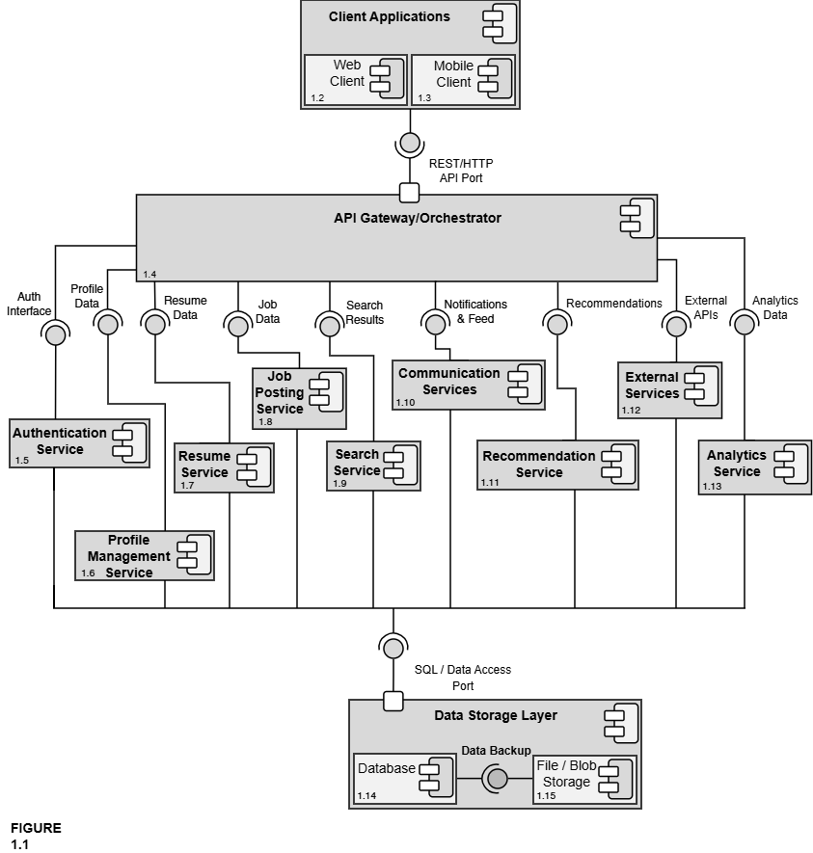
Design Information
Field | Description / Purpose
View Name & Number | 1.1 – Career Bound System Master Component Diagram (UML 2.0)
Purpose | Describe the overall system view.
Description | Basic client, application, database architecture with two types of clients: mobile and web.
Requirements | All SRS sections — 2.1 Company Profile, 2.2 Notifications, 2.3 Search, 2.4 News Feed, 2.5 Job Postings, 3.1 Student Profile, 3.2 Notifications, 3.3 Search, 3.4 News Feed, 3.5 Resume, 4.0 Hardware.
Elements | Client Applications: Web Client and Mobile Client
 | API Gateway/Orchestrator
 | Auth Service
 | Profile Management Service
 | Resume Service
 | Job Posting Service
 | Search Service
 | Communications Service
 | Recommendation Service
 | External Services
 | Analytics Service
Navigation / References | Figures 1.2–1.15 all component detail views
Viewpoint | Component Diagram

The interfaces and ports shown in Figure 1.1 are formally defined in the Interface Glossary below. All components communicate exclusively through these explicit interfaces, ensuring low coupling and high replaceability.

Interface Glossary – Career Bound System Master Component Diagram
Interface Name | Description | Provided By | Required By
REST/HTTP API Port | Formal, well-defined entry point for all client (Web + Mobile) communication | API Gateway / Orchestrator | Client Applications (Web Client + Mobile Client)
Auth Interface | Login, registration, role management, and session handling | Authentication Service | API Gateway
Profile Data | Read/write access to company and student profiles (locations, following, skills, GPA, etc.) | Profile Management Service | API Gateway, Search Service, Recommendation Service
Resume Data | Resume creation, submission, storage, retrieval, and access control | Resume Service | API Gateway, Search Service, Company profiles
Job Data | Job posting creation, editing, deletion, required skills, and job details | Job Posting Service | API Gateway, Search Service, Recommendation Service
Search Results | Candidate and job search results, filters, autocomplete, and wildcards | Search Service | API Gateway
Notifications & Feed | In-app notifications, push notifications, news feed posts, and updates | Communication Services | API Gateway
Recommendations | Job and candidate recommendations based on profiles, resumes, and job data | Recommendation Service | API Gateway
External APIs | Integration with third-party services (USPS address validation, autocomplete APIs, push notification providers, etc.) | External Services | API Gateway
Analytics Data | System usage metrics, reporting, and analytics data | Analytics Service | API Gateway
SQL / Data Access Port | Formal port — the single standardized interface through which all services access persistent data (the only way any service talks to the database or file storage) | Data Storage Layer | All services
The architecture is organized into four primary layers:
- Client Applications (parent) – Encloses the Web Client and Mobile Client. These components provide the unified user interface for both students and companies, supporting all features described in SRS sections 2.x and 3.x.
- API Gateway / Orchestrator – Serves as the single, centralized entry point for all client requests. It routes traffic to the appropriate backend services and enforces cross-cutting concerns such as authentication and request orchestration.
- Core Services Layer – Contains the business logic components:
      - Authentication Service
      - Profile Management Service
      - Resume Service
      - Job Posting Service
      - Search Service
      - Communication Services (Notifications + News Feed)
      - Recommendation Service
      - External Services
      - Analytics Service
Each service is responsible for a cohesive set of related functions and exposes well-defined interfaces to the rest of the system.
- Data Storage Layer (parent) – Acts as the single source of truth for all persistent data. It encloses the Database and File / Blob Storage components and exposes the formal SQL / Data Access Port used by every service in the system.

All communication between the Client Applications and the backend services flows through the REST/HTTP API Port provided by the API Gateway. Every service communicates with the Data Storage Layer exclusively through the SQL / Data Access Port. This design ensures reduced dependencies between components, clear separation of responsibilities, and makes individual components replaceable and maintainable. Detailed views of each major component are provided in Figures 1.2 through 1.15.This modular architecture directly supports the system’s requirements for accessibility, scalability, and maintainability while providing a clear roadmap for implementation and future extension.

Decomposition Description

The master component diagram (Figure 1.1) provides a high-level view of the overall system architecture. This section presents the detailed decomposition of each major component identified in the master diagram. Each sub-diagram shows the internal structure of the component, its sub-components, and the interfaces through which it interacts with the rest of the system. All sub-diagrams maintain the same interface names and ports as defined in the master diagram and the Interface Glossary to ensure consistency.

The following figures provide the detailed decomposition of each major component shown in the master diagram (Figure 1.1):

Figure 1.2 & 1.3 – Web & Mobile Client Detail
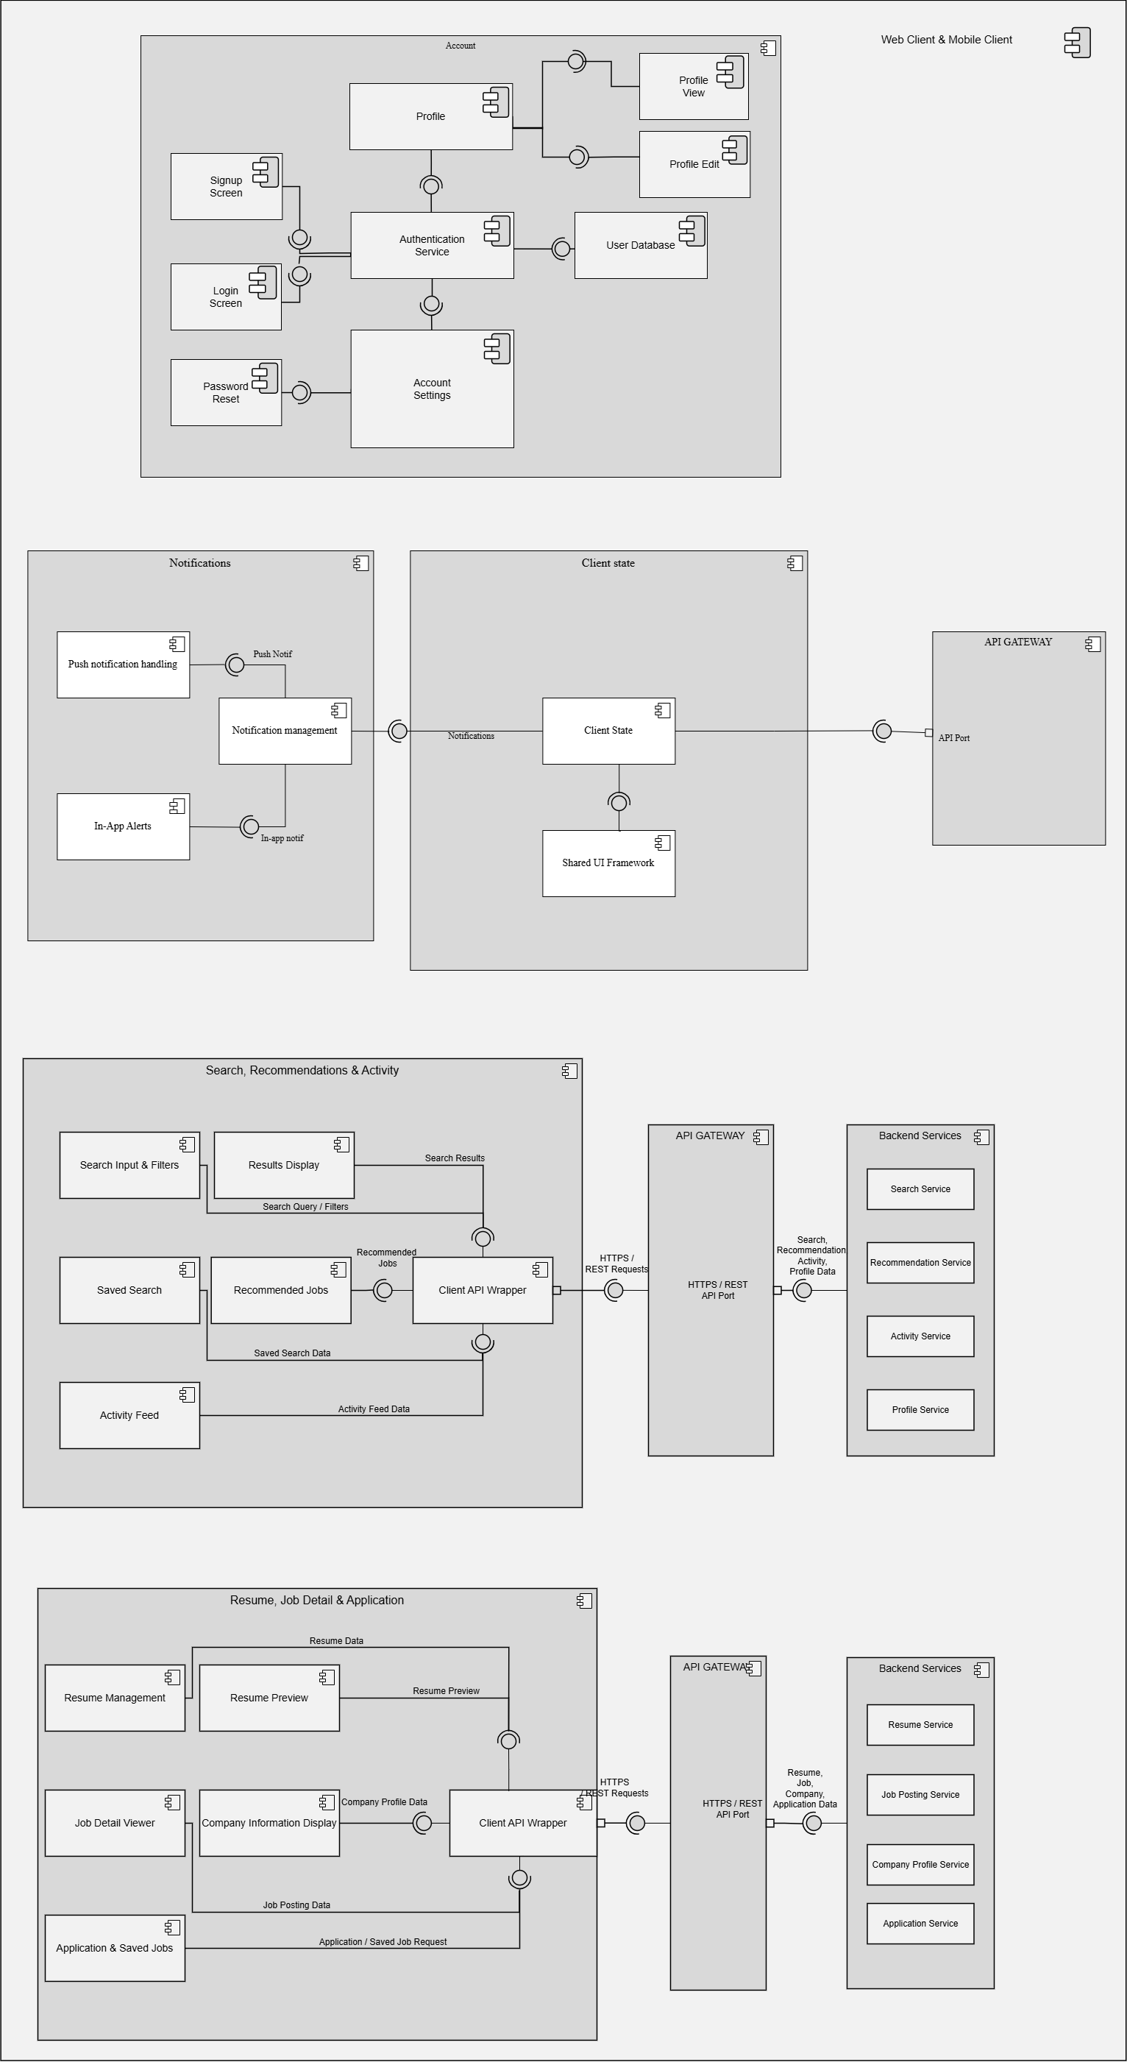
Design Information
Field | Description / Purpose
View Name & Number | 1.2 – Web Client & 1.3 – Mobile Client
Purpose | Describe the overall system view.
Description | Basic client, application, database architecture with two types of clients: mobile and web.
Requirements | Account
Elements | Profile
 | Profile View
 | Profile Edit
 | Authentication Service
 | Signup Screen
 | Login Screen
 | Password Reset
 | Account Settings
 | User Database
 | Notifications
 | Notification Management
 | Push Notification Handler
 | In-App Alerts
 | Client State
 | Shared UI Framework
 | Search, Recommendations, & Activity
 | Search Input Filters
 | Results Display
 | Saved Search
 | Recommended Jobs
 | Activity Feed
 | Client API Wrapper
 | Resume Management
 | Resume Preview
 | Job Detail Viewer
 | Company Information Display
 | Application & Saved Jobs
 | Client API Wrapper
Navigation / References | 1.4 API Gateway / Orchestrator; all screen views (1.1–4.2)
Viewpoint | Component Diagram

Figure 1.4 – API Gateway / Orchestrator Detail
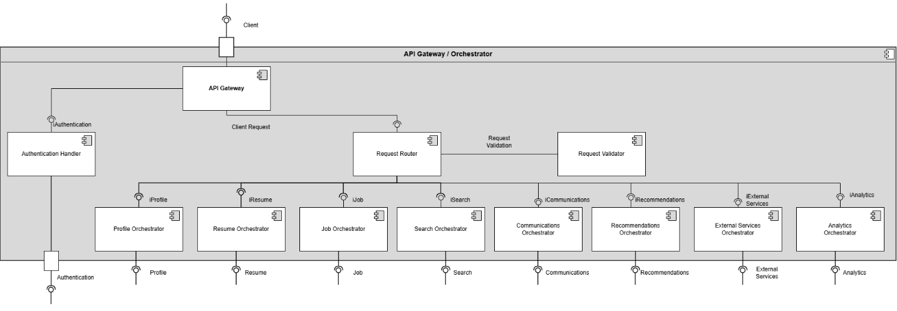
Design Information
Field | Description / Purpose
View Name & Number | 1.4 – API Gateway / Orchestrator
Purpose | Describe the API/ Orchestrator View
Description | API Gateway with authentication Handling and request routing to various component orchestration.
Requirements | Cross-cutting for all SRS sections — routes all client requests to backend services
Elements | API Gateway
 | Authentication Handler
 | Auth Service
 | Request Handler
 | Request Validator
 | Profile Orchestrator
 | Resume Orchestrator
 | Job Orchestrator
 | Search Orchestrator
 | Communications Orchestrator
 | Recommendation Orchestrator
 | External Orchestrator
 | Analytics Orchestrator
Navigation / References | 1.2 Web Client, 1.3 Mobile Client, 1.5–1.13 all backend service detail views
Viewpoint | Component Diagram

Figure 1.5 – Authentication Service Detail
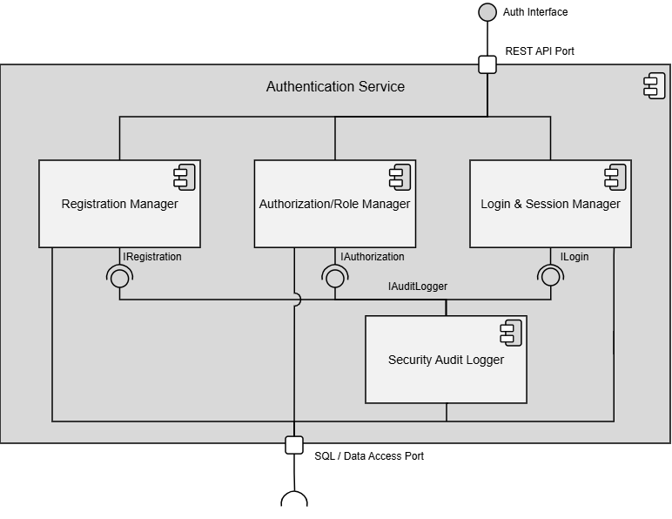
Design Information
Field | Description / Purpose
View Name & Number | 1.5 Authentication Service
Purpose | Describe the authentication system view.
Description | Basic service demonstrating the authentication service.
Requirements | Foundational requirement for all logged-in features — SRS 2.1.3.10 (Security), 3.1.1 (Student account), 2.1.1 (Company account)
Elements | Registration Manager
 | Authorization/ Role Manager
 | Login and Session Manager
Navigation / References | 1.4 API Gateway / Orchestrator, 1.14 Database; Screen views 1.1 Login / Logout, 1.2 Registration
Viewpoint | Component Diagram

Figure 1.6 – Profile Management Service Detail
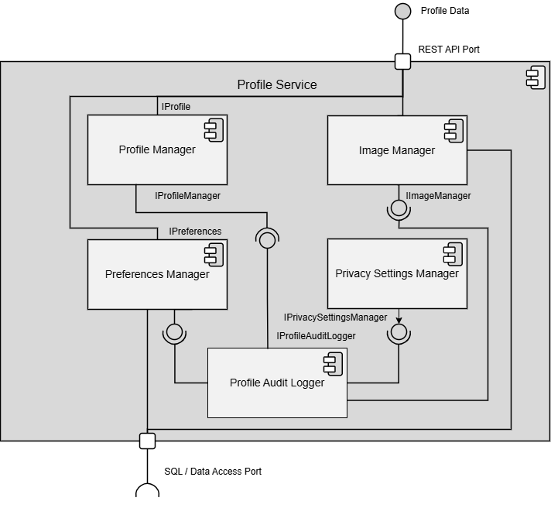
Design Information
Field | Description / Purpose
View Name & Number | 1.6 Profile Management Service
Purpose | Describe the profile management service.
Description | Basic service demonstrating the profile management service.
Requirements | SRS 2.1 Company Profile Page (2.1.1–2.1.3.10), 3.1 Student User Profile (3.1.1–3.1.3.3)
Elements | Profile Manager
 | Image Manager
 | Preferences Manager
 | Privacy Settings Manager
 | Profile Audit Logger
Navigation / References | 1.4 API Gateway / Orchestrator, 1.14 Database, 1.15 File / Blob Storage
Viewpoint | Component Diagram

Figure 1.7 – Resume Service Detail
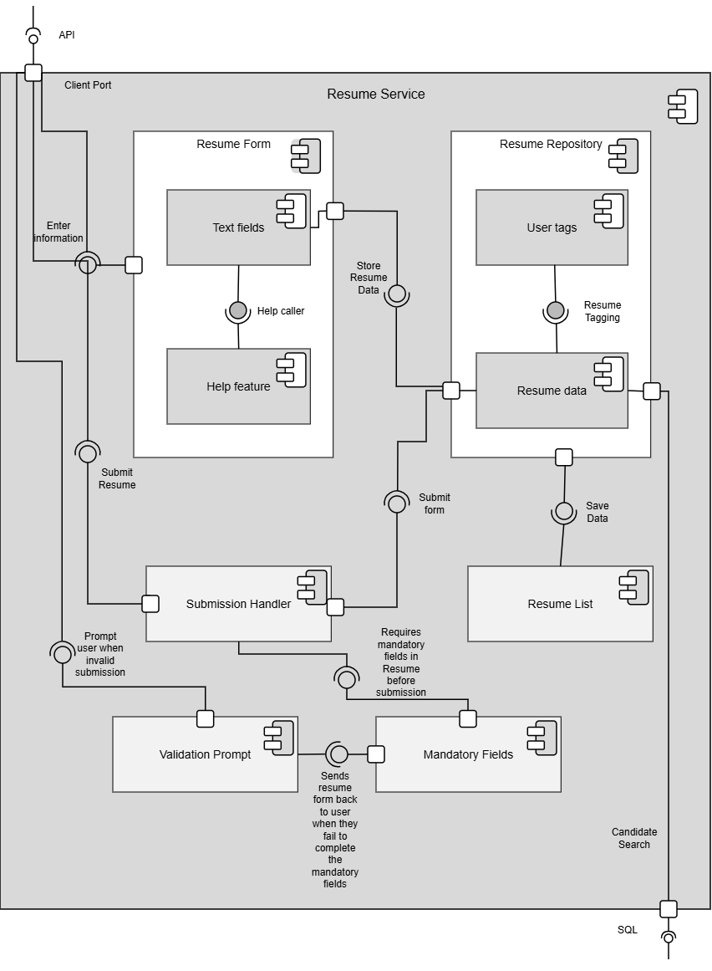
Design Information
Field | Description / Purpose
View Name & Number | 1.7 Resume Service
Purpose | Describe the resume service.
Description | Basic service demonstrating the resume service.
Requirements | SRS 3.5 Resume (3.5.1–3.5.5.2); referenced in 2.1.2, 2.2.5, 2.3.3, 2.3.5, 2.5.6
Elements | Resume Form
 | Resume Repository
 | Text Fields
 | Help Feature
 | User Tags
 | Resume data
 | Submission Handler
 | Resume List
 | Validation Prompt
 | Mandatory Fields
Navigation / References | 1.4 API Gateway / Orchestrator, 1.14 Database, 1.15 File / Blob Storage; Screen view 2.3 Resume Builder
Viewpoint | Component Diagram

Figure 1.8 – Job Posting Service Detail
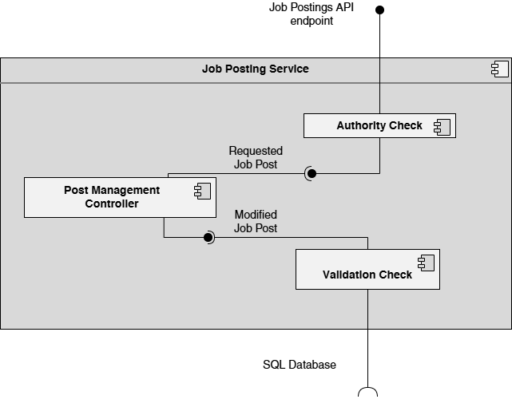
Design Information
Field | Description / Purpose
View Name & Number | 1.8 Job Postings Service
Purpose | Describe the jobs posting service.
Description | Basic service demonstrating the jobs posting service.
Requirements | SRS 2.5 Job Postings (2.5.1–2.5.7); referenced in 3.3.1, 3.4.1, 2.2.5
Elements | Authority Check
 | Post Management Control
 | Validation Check
Navigation / References | 1.4 API Gateway / Orchestrator, 1.14 Database; Screen views 3.3 Job Posting Creation, 2.4 Job Search, 2.5 Job Detail
Viewpoint | Component Diagram

Figure 1.9 – Search Service Detail
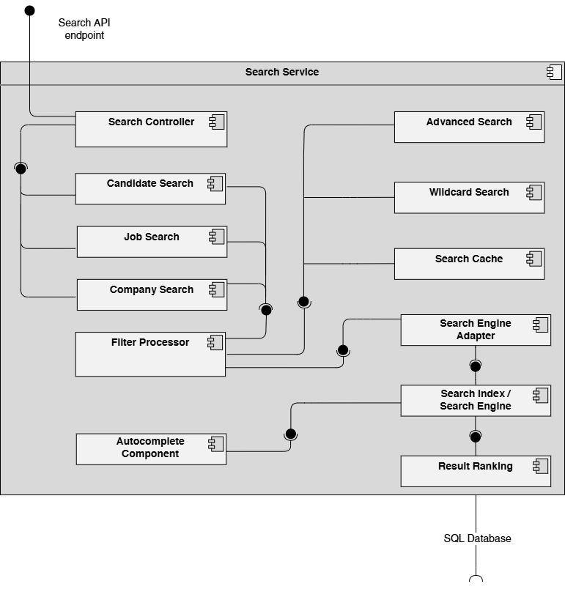
Design Information
Field | Description / Purpose
View Name & Number | 1.9 Search Service
Purpose | Describe the search service.
Description | Basic service demonstrating the search service.
Requirements | SRS 2.3 Search Features (2.3.1–2.3.8), 3.3 Student Search Features (3.3.1–3.3.2)
Elements | Search Controller
 | Advanced Search
 | Candidate Search
 | Wildcard Search
 | Job Search
 | Search Cache
 | Company Search
 | Filter Processor
 | Search Engine Adapter
 | Search Index / Search Engine
 | Autocomplete Component
 | Result Ranking
Navigation / References | 1.4 API Gateway / Orchestrator, 1.14 Database; Screen views 2.4 Job Search, 3.2 Candidate Search
Viewpoint | Component Diagram

Figure 1.10 – Communication Services (Notifications + News Feed) Detail
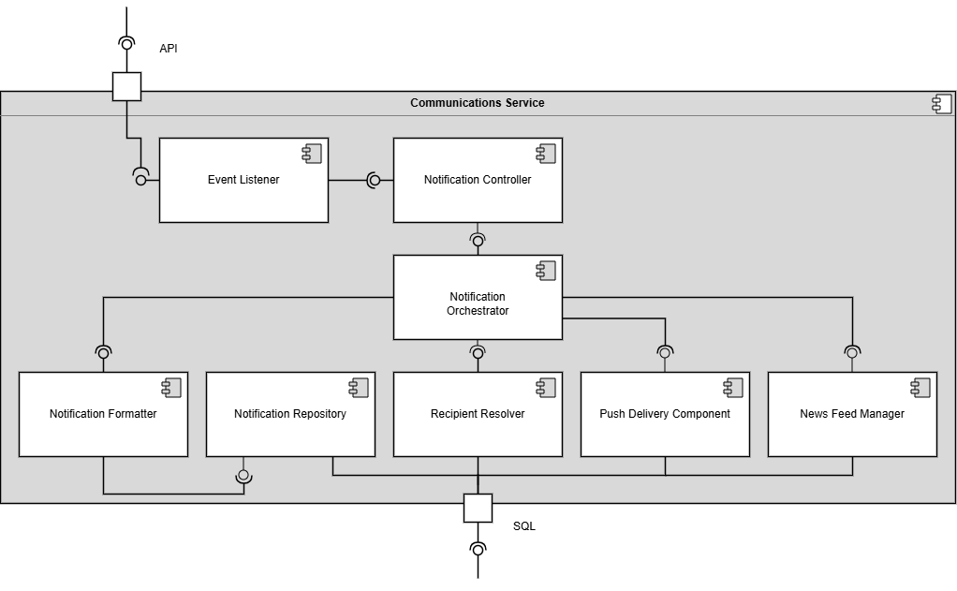
Design Information
Field | Description / Purpose
View Name & Number | 1.10 Communication Service
Purpose | Describe the communication service.
Description | Basic service demonstrating the communication service.
Requirements | SRS 2.2 Notifications (2.2.1–2.2.5), 2.4 News Feed (2.4.1–2.4.6), 3.2 Notifications (3.2.1–3.2.2), 3.4 News Feed (3.4.1–3.4.2)
Elements | Event Listener
 | Notification Controller
 | Notification Orchestrator
 | Notification Formatter
 | Notification Repository
 | Recipient Resolver
Navigation / References | 1.4 API Gateway / Orchestrator, 1.14 Database; Screen views 4.1 Notifications, 4.2 News Feed
Viewpoint | Component Diagram

Figure 1.11 – Recommendation Service Detail
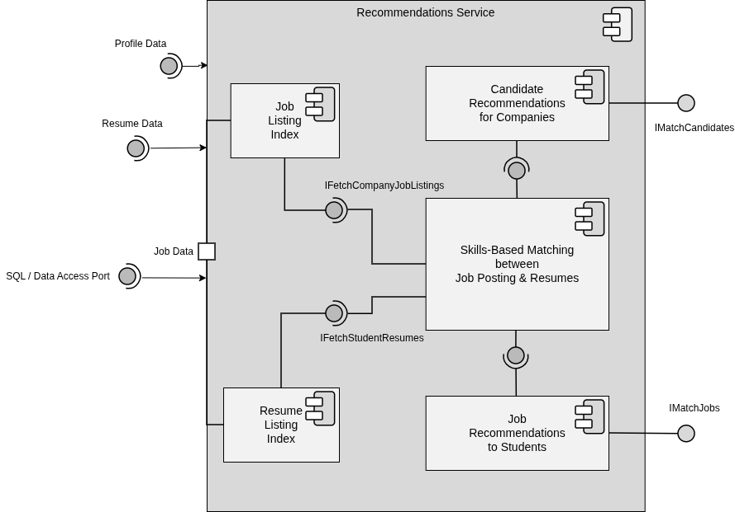
Design Information
Field | Description / Purpose
View Name & Number | 1.11 Recommendation Service
Purpose | Describe the recommendation service.
Description | Basic service demonstrating the recommendation service.
Requirements | Implicit in SRS 2.3 Search (2.3.7 Ranking), 2.1.3.8 (Search), 3.3 (Student Search); supports job and candidate recommendations
Elements | Job Posting Index
 | Candidate Recommendations
 | Skills-Based Matching
 | Resume Listing Index
 | Job Recommendations to Students
Navigation / References | 1.4 API Gateway / Orchestrator, 1.6 Profile Management Service, 1.7 Resume Service, 1.8 Job Posting Service, 1.14 Database
Viewpoint | Component Diagram

Figure 1.12 – External Services Detail
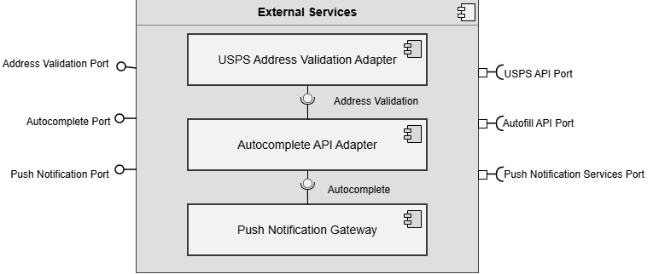
Design Information
Field | Description / Purpose
View Name & Number | 1.12 External Services
Purpose | Describe the external services.
Description | Basic service demonstrating the external services.
Requirements | SRS 2.1.3.9 (USPS address validation), 2.3.6 (Autocomplete API), 2.2.3–2.2.4 (Push notification delivery)
Elements | USPS Validation
 | Autocomplete API Adapter
 | Push Notifications Gateway
Navigation / References | 1.4 API Gateway / Orchestrator
Viewpoint | Component Diagram

Figure 1.13 – Analytics Service Detail
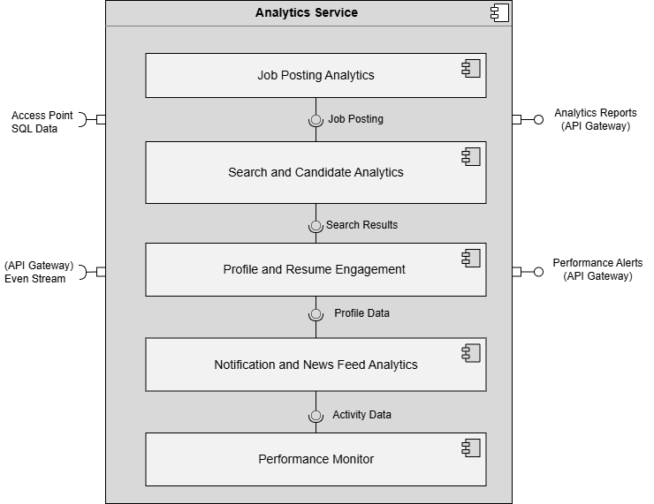
Design Information
Field | Description / Purpose
View Name & Number | 1.13 Analytics Service
Purpose | Describe the analytics service.
Description | Basic service demonstrating the analytics service.
Requirements | SRS 2.1.3.6 (Company analytics), 2.5.7 (Job posting status/performance tracking)
Elements | Job Posting Analytics
 | Search and Candidate Analytics
 | Profile and Resume Engagement
 | Notifications and News Feed Analytics
 | Performance Monitor
Navigation / References | 1.4 API Gateway / Orchestrator, 1.14 Database
Viewpoint | Component Diagram

Figure 1.14 – Database Detail
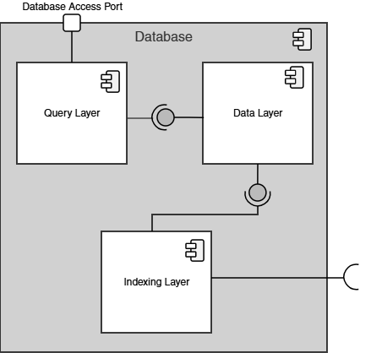
Design Information
Field | Description / Purpose
View Name & Number | 1.14 Database
Purpose | Describe the database.
Description | Basic service demonstrating the database.
Requirements | All SRS sections — provides persistent storage for all services. supports 2.1, 2.2, 2.3, 2.4, 2.5, 3.1, 3.2, 3.3, 3.4, 3.5
Elements | Query Layer
 | Data Layer
 | Indexing Layer
Navigation / References | 1.5–1.13 (all service detail views)/ part of Data Storage Layer  (Figure 1.1)
Viewpoint | Component Diagram

Figure 1.15 – File / Blob Storage Detail
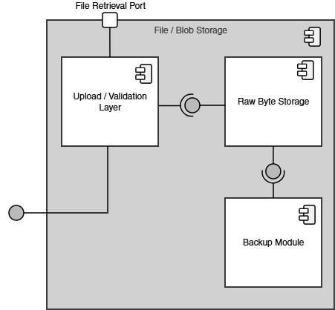
Design Information
Field | Description / Purpose
View Name & Number | 1.15 File / Blob Storage
Purpose | Describe the file and blob storage.
Description | Basic service demonstrating file and blob storage.
Requirements | SRS 3.5 Resume (resume file storage), 2.1.3.1 (profile image uploads), 2.1.2 (company resume access)
Elements | Upload / Validation Layer
 | Raw Byte Storage
 | Backup Module
Navigation / References | 1.14 Database; 1.6 Profile Management Service, 1.7 Resume Service; part of Data Storage Layer (Figure 1.1)
Viewpoint | Component Diagram

These sub-diagrams illustrate how each major component has been further decomposed into smaller, cohesive sub-components while preserving the explicit interfaces and ports defined at the system level. This decomposition supports modular design principles and enables independent development and maintenance of each subsystem.

Design Rationale
Discuss the rationale for selecting the architecture described in 3.1 including critical issues and trade/offs that were considered. You may discuss other architectures that were considered, provided that you explain why you didn’t choose them.

DATA DESIGN

Data Description
Explain how the information domain of your system is transformed into data structures. Describe how the major data or system entities are stored, processed and organized. List any databases or data storage items.

Data Dictionary
Alphabetically list the system entities or major data along with their types and descriptions. If you provided a functional description in Section 3.2, list all the functions and function parameters. If you provided an OO description, list the objects and its attributes, methods and method parameters.

COMPONENT DESIGN

In this section, we take a closer look at what each component does in a more systematic way. If you gave a functional description in section 3.2, provide a summary of your algorithm for each function listed in 3.2 in procedural description language (PDL) or pseudocode. If you gave an OO description, summarize each object member function for all the objects listed in 3.2 in PDL or pseudocode. Describe any local data when necessary.

HUMAN INTERFACE DESIGN

Overview of User Interface

The following diagrams provide an approximation of the central UI elements that will allow the users to utilize the various services provided, including descriptions of their functionality and purposes as well as site navigation details.

Screen Images

1.1 Login / Logout
Desktop View
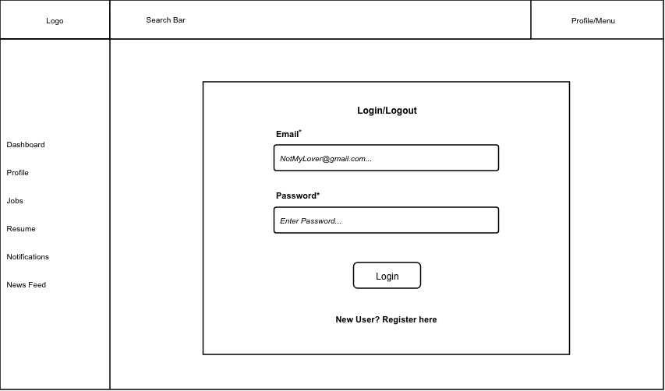
Mobile View
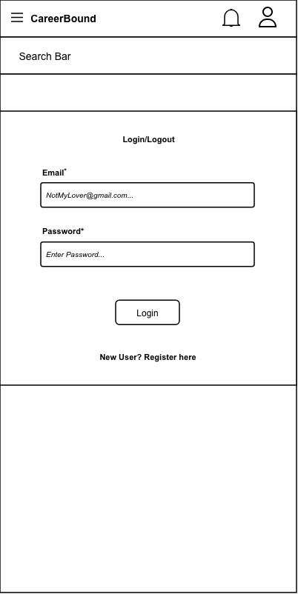
Design Information
Field | Description / Purpose
View Name & Number |  | 1.1 Login / Logout
Purpose / Design Concern |  | Provides a way for students and companies to log into their profiles.
Description |  | A website page which displays a log in field for the user to input their email and password to authenticate themselves.
Requirements |  | Authentication requirements supporting all protected system functionality under Sections 2.x and 3.x
Elements |  | Email Field
 |  | Password Field
 |  | Login Button
 |  | Invalid Login Information Field
 |  | Registration Redirect Button
Inputs |  | Email and Password fields, Login button click, Register link click, Forgot Password link click.
Outputs |  | Redirect to Dashboard (2.1 for students, 3.1 for companies) if user log in was successful. Displays an error message if invalid credentials were provided.
Navigation / References |  | Student Dashboard 2.1, Company Dashboard 3.1, Registration 1.2
Viewpoint |  | UI Wireframe / Mockup (Desktop & Mobile).

1.2 Registration
Desktop View
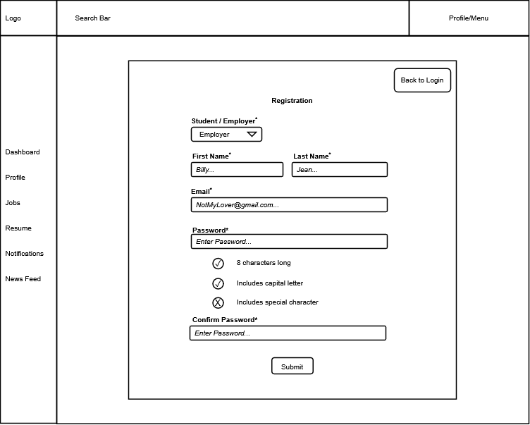

Mobile View
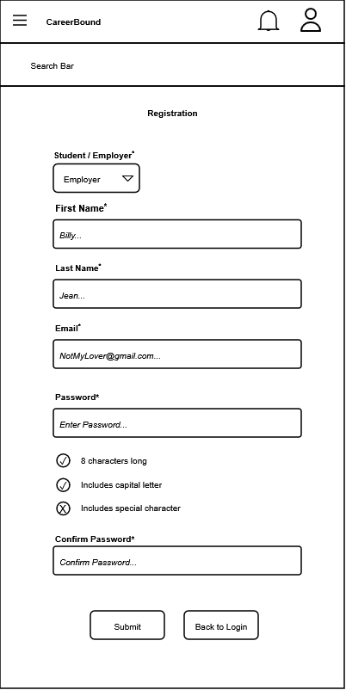

Design Information
Field | Description / Purpose
View Name & Number | 1.2 Registration
Purpose / Design Concern | Facilitates user account creation and role selection for new users.
Description | Displays a registration form allowing a user to select their role and establish account credentials.
Requirements | SRS 2.1 Company Profile Page, 3.1 Student User Profile
Elements | Back to Login button
 | Student / Employer role selection dropdown
 | Text fields
 | Password validation checklist
 | Submit button
Inputs | Role selection, First Name string, Last Name string, Email string, Password string, Confirm Password string, Submit action.
Outputs | Visual feedback on password requirement validation (status icons for "8 characters long", "Includes capital letter", and "Includes special character").
Navigation / References | 1.1 Login / Logout (accessed via "Back to Login" button).  2.1 Student Dashboard or 3.1 Company Dashboard upon successful submission.
Viewpoint | UI Wireframe / Mockup (Desktop & Mobile).

2.1 Student Dashboard
Desktop View
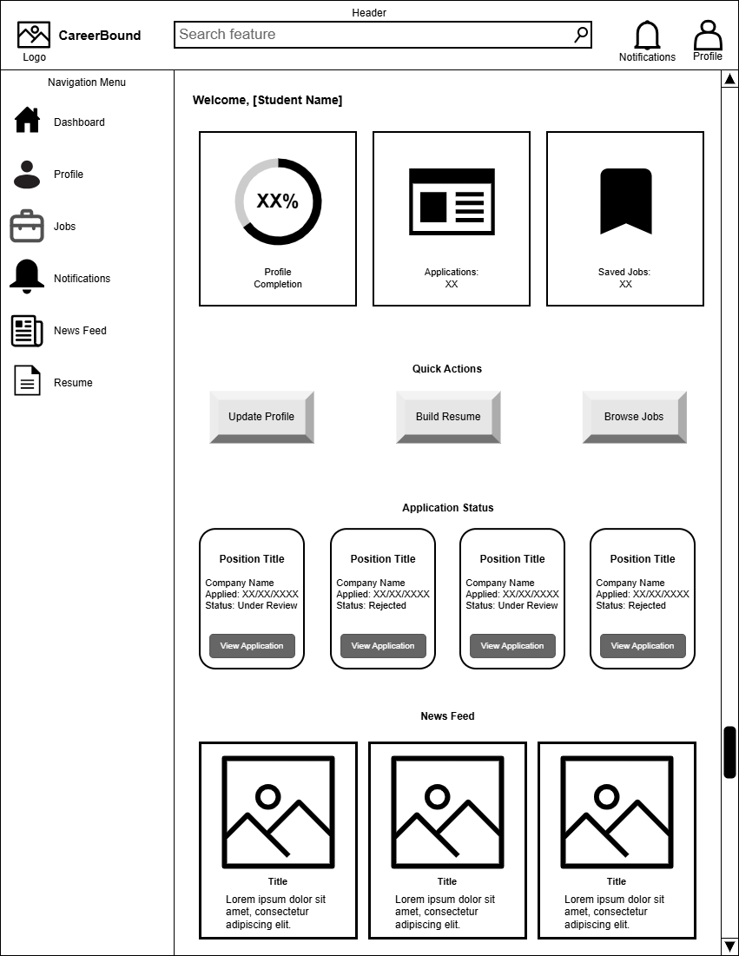
Mobile View
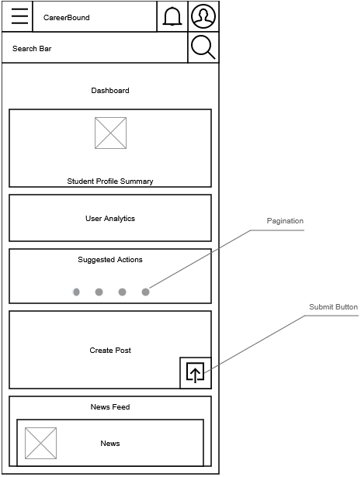

Design Information
Field | Description / Purpose
View Name & Number | 2.1 – Student Dashboard
Purpose / Design Concern | Provides students with a centralized dashboard for managing career development activities, tracking applications, accessing important tools, and viewing personalized updates within the Career Bound system.
Description | Displays a summarized student profile; profile progress (desktop) provides analytics such as profile views, profile completion, matching jobs, post impressions, application summaries; application tracking cards (desktop); recommends actions (mobile) to take such as improve profile, create resume, apply for a job; provides a shortcut to post creation; and displays social media-style news feed containing career-related updates and announcements.
Requirements | 3.1 Student User Profile, 3.2 Notifications, 3.3 Search Features, 3.4 News Feed, 3.5 Resume
Elements | Student Profile Summary Card (mobile)
 | Student User Analytics Card (mobile)
 | Suggested Actions Card (mobile)
 | Quick Create Post Card (mobile)
 | News feed List
 | News feed Cards
 | Submit Button
 | Navigation menu (Sidebar for desktop, toggle for mobile)
 | Header
 | Search Feature
 | Applications Summary Card (desktop)
 | Saved Jobs Summary Card (desktop)
 | Applications Status Cards (desktop)
 | Notifications toggle button
 | Profile Page hyperlink button
 | Pagination
Inputs | Student Post, Click, Scroll, Search queries, navigation selections, notification interactions, profile selections, quick action button selections, application card selections, news feed interactions
Outputs | Profile completion percentage, application status information, saved job totals, recommended actions, job application details, career updates, company announcements, News feed content, New Student Post, Navigation redirects, Navigate to next action card
Navigation / References | Authentication, Student Profile, Resume Builder, Job Search, Job Details, Notifications, News Feed, Saved Jobs, Job Applications
Viewpoint | UI Wireframe / Mockup (Desktop & Mobile)

2.2 Student Profile
Desktop View
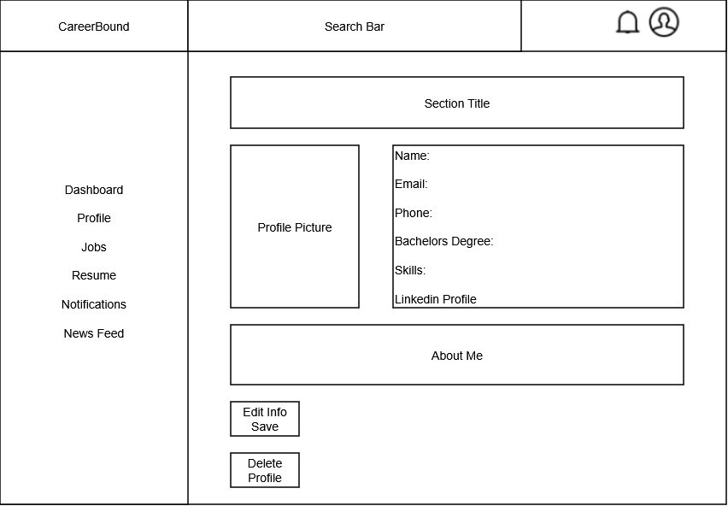
Mobile View
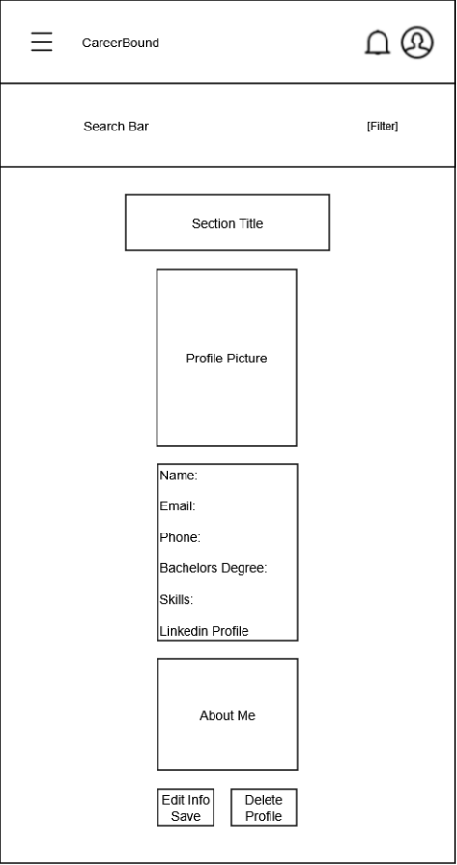

Design Information
Field | Description / Purpose
View Name & Number | 2.2 – Student Profile
Purpose / Design Concern | Allows students to view and manage their profile information.
Description | Displays student information such as name, contact information, program, skills, and resume-related details.
Requirements | 3.1 Student User Profile (3.1.1–3.1.3.3)
Elements | Logo
 | Search bar
 | Menu/Profile
 | Left Navigation
 | Section Title
 | Profile Picture
 | User Information
 | About Me
 | Save/Delete buttons
Inputs | Updated student profile information, Upload CV
Outputs | Displayed student profile information
Navigation / References | Dashboard, Profile, Jobs, Resume, Notifications, News Feed
Viewpoint | UI Wireframe / Mockup (Desktop & Mobile)

2.3 Resume Builder
Desktop View
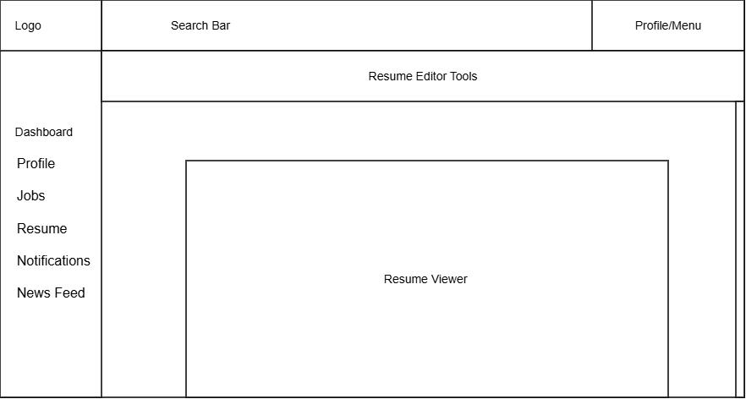
Mobile view
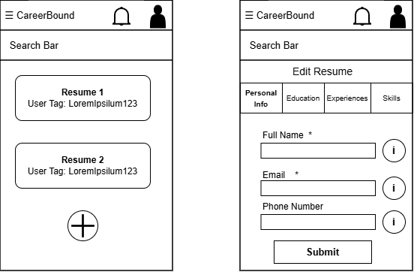
Design Information

Field | Description / Purpose
View Name & Number | 2.3 Resume Builder
Purpose / Design Concern | Provides a space that allows students to view and edit their resume that is to be used.
Description | Displays student’s resume and gives tools to make and save changes to the resume.
Requirements | SRS 3.5 Resume (3.5.1–3.5.5.2), 3.5.4 User Input, 3.5.5 Input Submission
Elements | Logo
 | Search Bar
 | Profile/Menu
 | Dashboard
 | Profile
 | Jobs
 | Resume
 | Notifications
 | News Feed
 | Resume Editor Tools: Edit Resume Section Tabs/ Add New Resume Button/ Helpful info buttons/ Submit Resume Button/ Asterisks denoting Required Data Entry
 | Resume Viewer: Resume List
Inputs | Resume Edits, Search terms, Resume data entries, Wildcard search
Outputs | Resume reflecting saved changes and recent changes made, Matching resume data terms, resume list search results, new resume data entries
Navigation / References | Profile/Menu, Dashboard, Profile, Jobs, Resume, Notifications, News Feed, Resume List, Edit Resume Screen
Viewpoint | UI Wireframe / Mockup (Desktop & Mobile)

2.4 Job Search
Desktop View
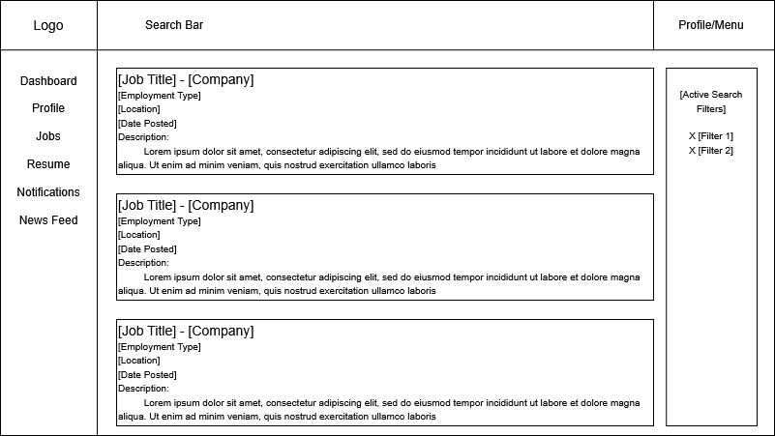
Mobile View
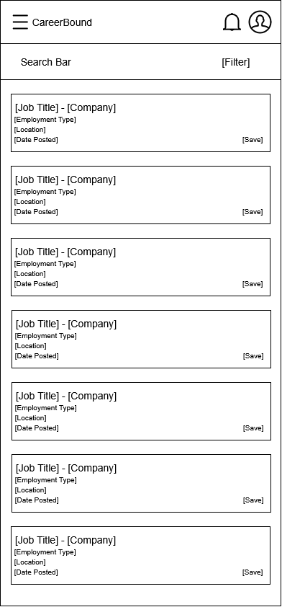
Design Information

Field | Description / Purpose
View Name & Number | 2.4 – Job Search
Purpose / Design Concern | Allows students to search for jobs and companies.
Description | Displays searchable job listings with filters and detailed results.
Requirements | SRS 2.3 Search Features, 3.3 Student Search Features
Elements | Search bar
 | Filters
 | Results list
 | Save/apply buttons
Inputs | Search terms, filter selections, wildcard search
Outputs | Matching job postings and company search results
Navigation / References | Job Details Screen, Company Profile, Student Dashboard
Viewpoint | UI Wireframe / Mockup (Desktop & Mobile)

2.5 Job Details
Desktop View
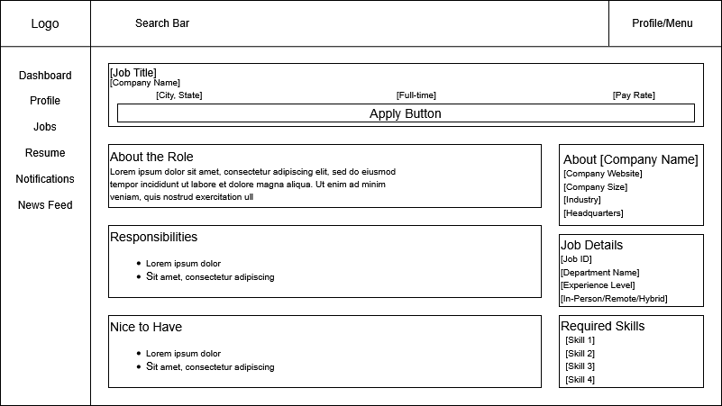

Mobile View
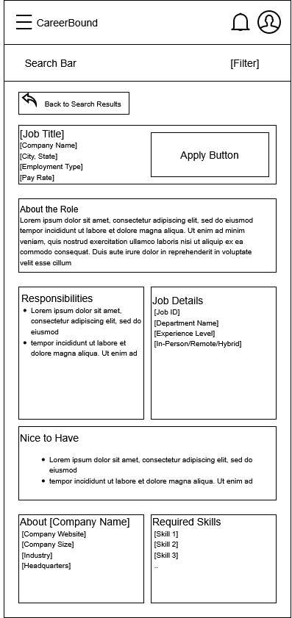

Design Information

Field | Description / Purpose
View Name & Number | 2.5 – Job Details
Purpose / Design Concern | Allows students to get more information for Job Postings.
Description | Displays all information relevant to a given Job Postings.
Requirements | SRS 2.5.2, SRS 2.5.7, SRS 2.5.9
Elements | Back Button
 | Job Data
Inputs | Tap/Click on Apply Button
Outputs | Application Submission Confirmation, Updated Application Status
Navigation / References | Job Search Screen, Company Profile, Student Dashboard
Viewpoint | UI Wireframe / Mockup (Desktop & Mobile)

3.1 Company Dashboard
Desktop View
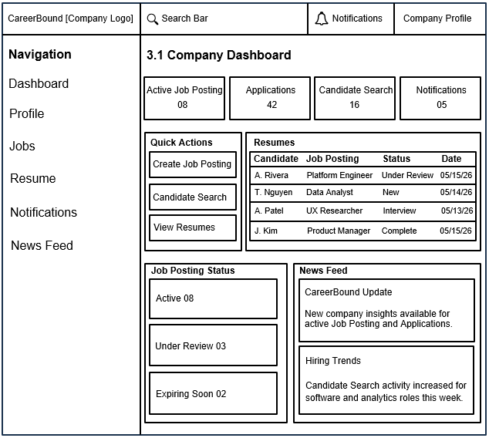

Mobile View
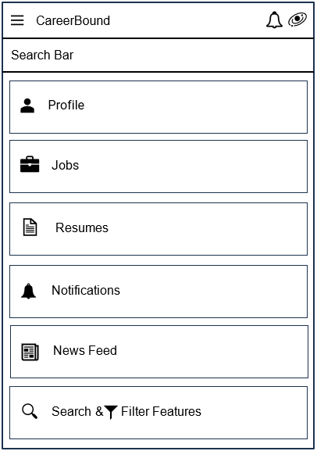
Design Information
Field | Description / Purpose
View Name & Number | 3.1 – Company Dashboard
Purpose / Design Concern | Company dashboard to help a company manage recruiting activity from desktop and mobile views.
Description | Provides a desktop and mobile view where company users can review job posting activity, applications, candidate search access, notifications, and company-related updates.
Requirements | Software Requirements Specification (SRS) for Career Bound:  2.1 Company Profile Page, 2.2 Notifications, 2.3 Search Features,  2.4 News Feed, 2.5 Job Postings  Reference: https://content.byui.edu/file/968cdd33-09eb-4430-99a4-131d25e138d4/1/Teach/SRS/430.SRS.CareerBound.pdf
Elements | Navigation menu: provides a company with a list of options to select from.
 | Search bar: provides a company the ability to search.
 | Company Profile area: provides a company with access to all company profile data.
 | Notifications area: provides a company with access to company notifications.
 | Candidate Search feature: provides a company the ability to search or filter job candidates.
 | Job Posting area: provides a company access to job postings.
 | Resume section: provides a company access to a list of candidates who have submitted job applications.
 | News Feed section: provides a company access to news feed options
 | Login / Logout: clicking the company logo provides a company with the ability to login or logout.
Inputs | Search query text, clicks on navigation items, clicks on quick action buttons, and selections related to applications or job postings.
Outputs | Company dashboard metrics, application status information, job posting status information, notifications, and news feed updates.
Navigation / References | 1.1 Login / Logout, 3.2 Candidate Search, 3.3 Job Posting Creation, 4.1 Notifications, 4.2 News Feed
Viewpoint | UI Wireframe / Mockup (Desktop & Mobile)

3.2 Candidate Search
Desktop View
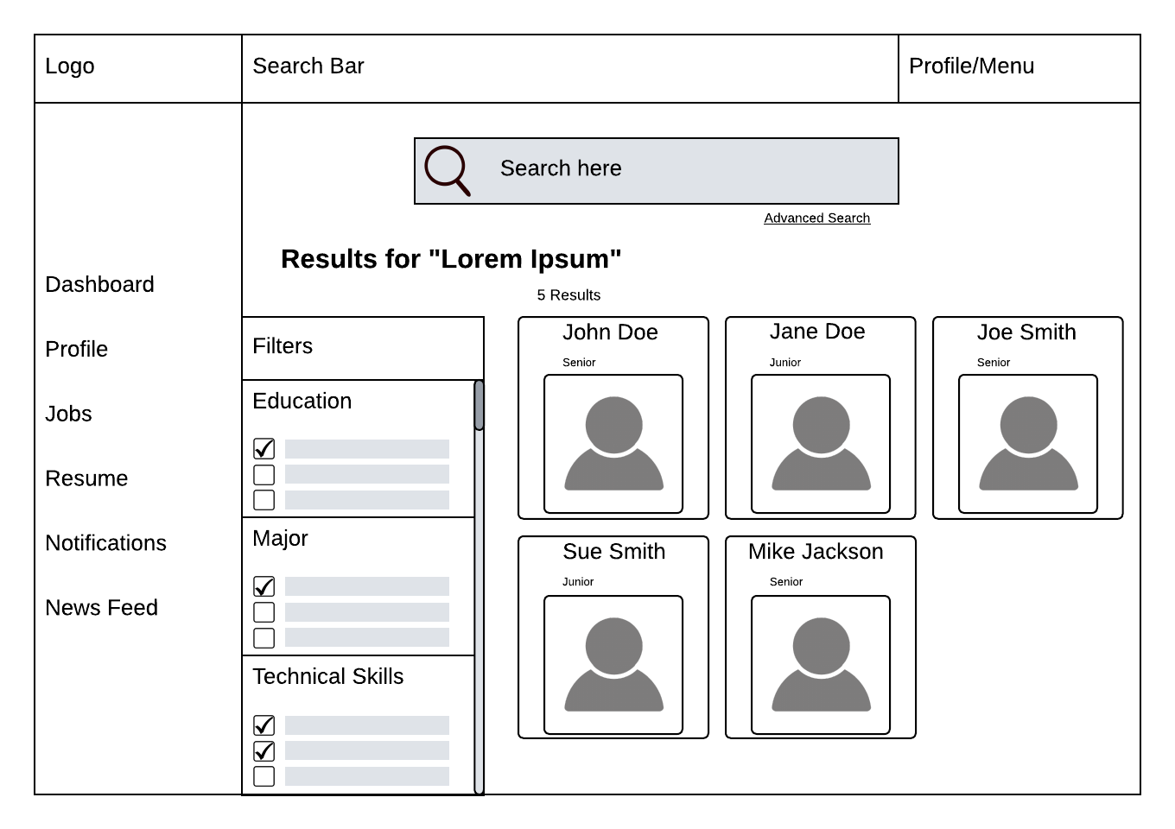
Mobile View
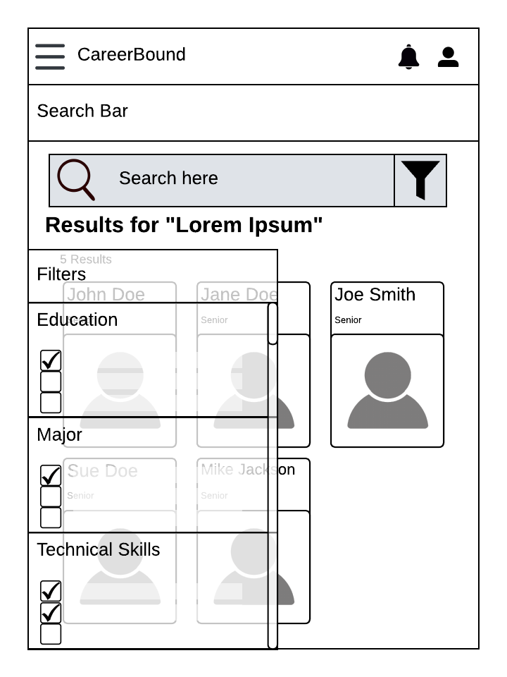
Design Information
Field | Description / Purpose
View Name & Number | 3.2 Candidate Search
Purpose / Design Concern | Allows company recruiters a way to find potential job seekers.
Description | A specialized search engine for the user to find candidates based on desired filters. Designed for both desktop users and mobile users.
Requirements | 2.3.1, 2.3.2, 2.3.4, 2.3.8
Elements | Search Bar
 | Site Navigation
 | Search Results Grid
 | Filter Categories
 | Filter Checkboxes
 | Search Result Cards
 | Advanced Search Toggle
 | Candidate Name
 | Candidate Profile Picture
 | Candidate Year
 | Filter Scroll Bar
Inputs | User will click on the search bar and enter a search item; user can choose a filter to toggle; the user can choose a candidate to open a new page.
Outputs | Candidate profile cards display candidate information; candidate profiles can be filtered.
Navigation / References | 3.1 Company Dashboard, 3.3 Job Posting Creation
Viewpoint | UI Wireframe / Mockup (Desktop & Mobile)

3.3 Job Posting Creation
Desktop View
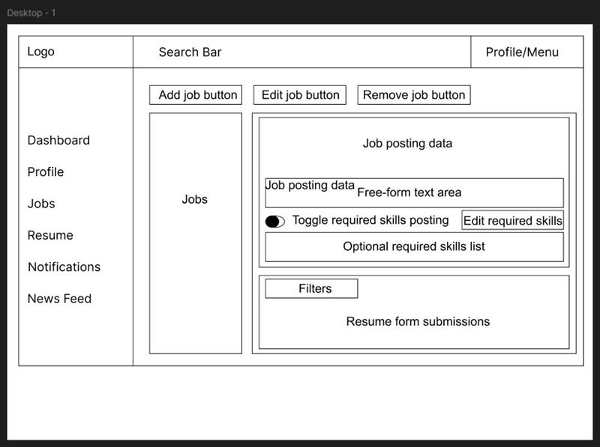
Mobile View
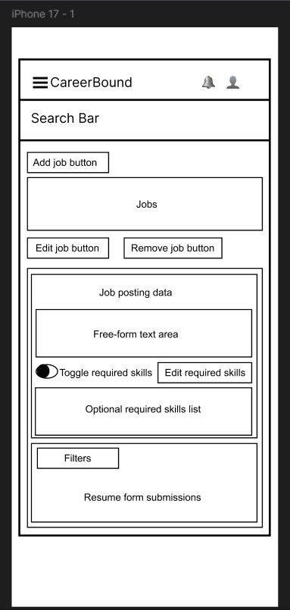
Design Information
Field | Description / Purpose
View Name & Number | 3.3 Job Posting Creation
Purpose / Design Concern | Allows company users to create, edit, and remove job postings, manage required skills, and review resume submissions in a centralized Jobs view.
Description | Displays a company-facing Jobs screen with job posting controls, a job posting data panel, a free-form text area, a required skills toggle, an editable required-skills list, a filters section, and a resume form submissions area in both desktop and mobile wireframe layouts.
Requirements | SRS 2.5 Job Postings (2.5.1--2.5.7)
Elements | Header with logo, search bar, and profile/menu
 | Navigation menu with Dashboard, Profile, Jobs, Resume, Notifications, and News Feed
 | Add Job Button
 | Edit Job Button
 | Remove Job Button
 | Jobs Panel
 | Job Posting data section
 | Free-form text area
 | Required skills toggle
 | Edit Required Skills button
 | Optional required skills list
 | Filters section
 | Resume form submission panel
Inputs | Company user selects Add Job, Edit Job, or Remove Job; enters or edits job posting text; toggles required skills on or off; edits the required skills list; applies filters; reviews submitted resumes.
Outputs | Displayed job posting information, updated required skills settings, filtered submission results, and visible resume form submissions for review.
Navigation / References | Related views include Company Dashboard (3.1), Candidate Search (3.2)
Viewpoint | UI Wireframe / Mockup (Desktop & Mobile)

4.1 Notifications
Desktop View
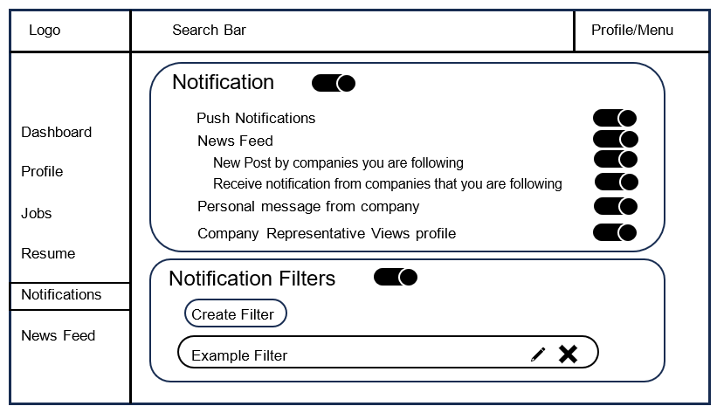
Mobile View
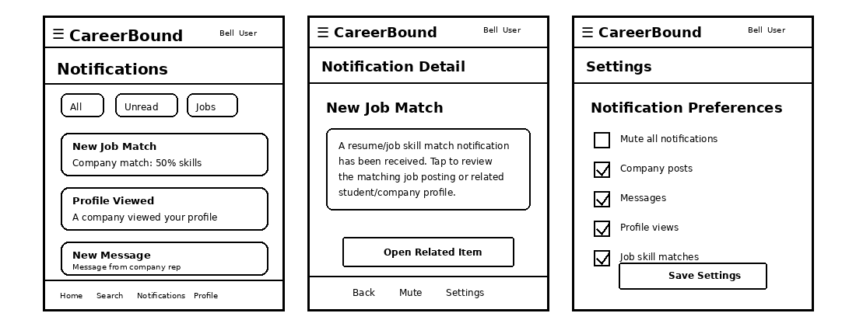
Design Information
Field | Description / Purpose
View Name & Number | 4.1 Notifications Screen
Purpose / Design Concern | The Notification Screen exist to allow the user to customize what notifications they receive from Career Bound. This is for the End User and satisfies section 2.2 / 3.2 in the SRS.CareerBound.docx
Description | The Notification Screen will allow the user to customize notifications about their News Feed, Company Viewing their profile, Push Notifications, New posts by company they follow, notifications from company they follow, personal messages, and allow the user to mute all notifications. Uses the filter component to create a list of companies to receive notifications from.  Shows mobile notification screens for student users and company representatives, including the notification list, notification detail screen, push notification handling, and notification preferences.
Requirements | 1.2.1 Application Scope;  2.2 Notifications;  3.2.1. There shall be a notification push sent to the student user instantly after a notification trigger.  3.2.2. The student user shall receive a notification when a company they are following makes a post or sends out a notification to its followers.  3.2.3. The student user shall receive a notification when a company sends them a personal message.  3.2.4. Notifications may be pushed to a student user’s phone outside of the system  3.2.5.Student users may receive a notification when a company representative views his/her  profile.  3.2.6.All users may choose to mute notifications  3.2.7.There shall be settings allowing the student user to add, alter and remove filters for notifications.
Elements | Search Bar
 | App navigation
 | Toggle Switch
 | Create Filter Button
 | Edit Pen Icon
 | Delete X Icon
 | Notification Card: Notification Screen; Notification List; Notification Detail View; Push Notification Handler; Notification Preferences; Mute Notification Control;
 | Notification Filter Card: Filter Settings;
 | Profile/Menu
 | API Client Adapter / REST/HTTP API Port
Inputs | Toggle Switch, Click Button, Click Text, Filter Companies, Search, Selected notification, filter settings, mute setting changes, push notification trigger, and mobile navigation actions
Outputs | Notifications Settings, Filtered Company List, Notification list, notification detail information, filtered notification results, push notification display, and updated notification settings
Navigation / References | Filter Create Screen, Dashboard Screen, Profile Screen, Jobs Screen, Resume Screen, News Feed Screen, Mobile Client, Notification Screen, Notification Detail View, Notification Preferences, API Gateway / Orchestrator
Viewpoint | UI Wireframe / Mockup (Desktop & Mobile)

4.2 News Feed
Desktop View
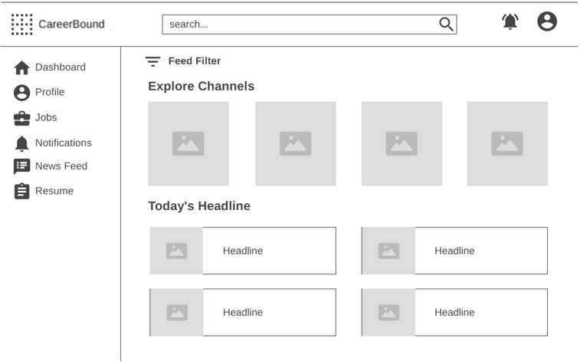
Mobile View
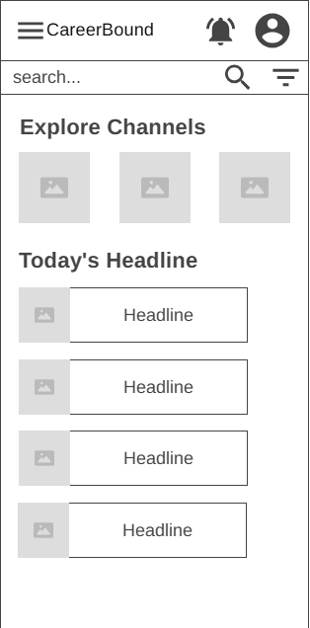
Design Information
Field | Description/Purpose
View Name & Number | 4.2 – News Feed
Purpose / Design Concern | Allows students to filter and view their news feed.
Description | Displays relevant news for students, which can be filtered by different tags to view specific news reports.
Requirements | 2.4 News Feed (2.4.1–2.4.6), 3.4 News Feed (3.4.1–3.4.2)
Elements | Logo
 | Notifications
 | Search Bar
 | Menu/Profile
 | Feed Filter
 | Explore Channels
 | Headlines
Inputs | Current news, current location
Outputs | Updated news feed, current location displayed
Navigation / References | Dashboard, Profile, Jobs, Resume, Notifications, News Feed
Viewpoint | UI Wireframe / Mockup (Desktop & Mobile)

Screen Objects and Actions

A discussion of screen objects and actions associated with those objects.

REQUIREMENTS MATRIX
The following table provides a cross-reference that traces each major component in the system architecture to the specific SRS requirements it fulfills. Below this SRS Requirements Mapping Table you will find Requirements Traceability Matrices for quick visual SRS Requirements tracing.

SRS Requirements Mapping Table

Component | SRS Sections / Requirements It Directly Supports
Client Applications  (Parent) | • 1.2 Application Scope (web and mobile interfaces that share the same features)  • Overall client-side architecture, shared UI patterns, role-based views, and coordination between web and mobile clients
Web Client | • Primary web-based user interface (browser UI)  • Implements all web UI elements for Company and Student features (sections 2.x and 3.x)  • Profile pages, search bar, forms, news feed display, notifications display, resume form, job browsing, etc. (1.2.1)
Mobile Client | • Mobile application user interface  • Implements the same features and characteristics as the Web Client (per SRS 1.2.1)  • Mobile-optimized UI for all features in sections 2.x and 3.x (profiles, search, news feed, notifications, resume form, job browsing, etc.)
API Gateway / Orchestrator | • Cross-cutting orchestration for all client–service communication (implicit in 1.2 and all functional requirements in 2.x / 3.x)
Authentication Service | • Foundational requirement for all logged-in features (profiles, following, notifications, job postings, resume access, etc.)  • Required for every section under 2.x and 3.x
Profile Management Service | • 2.1 Company Profile Page (2.1.1–2.1.3.10)  • 3.1 Student User Profile (3.1.1–3.1.3.3)
Resume Service | • 3.5 Resume (3.5.1–3.5.5.2)  • Referenced in 2.1.2, 2.2.5, 2.3.3, 2.3.5, 2.5.6, 3.1.3.1–3.1.3.3
Job Posting Service | • 2.5 Job Postings (2.5.1–2.5.7)  • Referenced in 3.3.1, 3.4.1, 2.2.5
Search Service | • 2.3 Search Features (2.3.1–2.3.8)  • 3.3 Search Features (3.3.1–3.3.2)
Communication Services (Notifications + News Feed) | • 2.2 Notifications (2.2.1–2.2.5)  • 2.4 News Feed (2.4.1–2.4.6)  • 3.2 Notifications (3.2.1–3.2.7)  • 3.4 News Feed (3.4.1–3.4.2)
Recommendation Service | • Job and candidate recommendations based on profiles, resumes, and job postings  • Supports 2.3 Search Features, 2.5 Job Postings, 3.3 Search Features, and 3.1/3.5 profile/resume data
External Services | • External integrations (USPS address validation in 2.1.3.9, autocomplete API in 2.3.6, push notification services in 2.2, etc.)  • Any third-party APIs referenced throughout the SRS
Analytics Service | • Provides reporting and analytics on job posting performance (views, applications, 2.5), candidate search effectiveness (filters, results, 2.3), profile and resume engagement (2.1, 3.1, 3.5), and notification / news feed activity (2.2, 2.4, 3.2, 3.4)  • Monitors key performance metrics (e.g., search results returned within 3 seconds per 2.3.5)  • Supports data-driven platform improvements, usage insights, and overall system monitoring
Data Storage Layer  (Parent) | • Provides the single unified SQL / Data Access Port used by every service in the system  • Acts as the central enclosing component that coordinates Database and File/Blob Storage  • Manages system-wide data concerns (transactions, consistency, backups, scalability, reliability)  • 4. Hardware requirements (implicit backend storage, servers, infrastructure)
Database | • All persistent data storage for profiles, resumes, job postings, notifications, news feed, authentication, etc.  • Referenced in every “Data X.X.X” entry throughout the SRS
File / Blob Storage | • Storage of uploaded resumes, profile images, attachments, and other binary files  • Supports 3.5 Resume submission and any file-related requirements
The following Requirements Traceability Matrices map the requirements defined within the Software Requirements Specification (SRS) to the CareerBound system architecture components responsible for supporting, implementing, or interacting with those requirements.
These matrices are intended to:
- verify that all documented requirements are addressed within the system design,
- demonstrate traceability between requirements and architectural components,
- support validation and quality assurance activities, and
- ensure consistency between the SRS and the Software Design Description (SDD).
An “X” within a matrix cell indicates that the corresponding component directly supports, implements, manages, or participates in fulfilling the specified requirement.
The matrices are organized by major SRS requirement sections for improved readability and maintainability.

  - Company Profile Requirements Matrix (SRS 2.1)

Component | 2.1.1 Profile | 2.1.2 Resume | 2.1.3.1 Contact | 2.1.3.2 Location | 2.1.3.3 Skills | 2.1.3.4 Following | 2.1.3.5 Posting | 2.1.3.6 Analytics | 2.1.3.7 Messaging | 2.1.3.8 Search | 2.1.3.9 Validation | 2.1.3.10 Security
Web Client | X | X | X | X | X | X | X | X | X | X | X | X
Mobile Client | X | X | X | X | X | X | X | X | X | X | X | X
API Gateway / Orchestrator | X | X | X | X | X | X | X | X | X | X | X | X
Authentication Service | X | X | X | X | X | X | X | X | X | X | X | X
Profile Management Service | X | X | X | X | X | X | X | X | X | X | X | X
Resume Service |  | X |  |  | X |  |  | X
Job Posting Service |  |  |  | X |  | X
Search Service |  | X |  |  |  | X |  |  |  | X | X
Communication Services |  |  | X |  |  | X |  |  | X
Recommendation Service |  | X |  |  |  | X |  |  |  | X
External Services |  |  |  |  |  |  |  |  |  |  | X
Analytics Service |  | X |  | X | X | X |  |  | X
Database | X | X | X | X | X | X | X | X | X | X | X | X
File / Blob Storage |  | X |  |  |  | X

  - Notification Requirements Matrix (SRS 2.2)

Component | 2.2.1 Alerts | 2.2.2 Updates | 2.2.3 Push | 2.2.4 Delivery | 2.2.5 Preferences
Web Client | X | X | X | X | X
Mobile Client | X | X | X | X | X
API Gateway / Orchestrator | X | X | X | X | X
Authentication Service | X | X | X | X | X
Profile Management Service
Resume Service
Job Posting Service
Search Service
Communication Services | X | X | X | X | X
Recommendation Service
External Services |  |  | X | X
Analytics Service | X | X | X | X | X
Database | X | X | X | X | X
File / Blob Storage

  - Search Requirements Matrix (SRS 2.3)

Component | 2.3.1 Candidate | 2.3.2 Company | 2.3.3 Filters | 2.3.4 Wildcards | 2.3.5 Performance | 2.3.6 Autocomplete | 2.3.7 Ranking | 2.3.8 Resume
Web Client | X | X | X | X | X | X | X | X
Mobile Client | X | X | X | X | X | X | X | X
API Gateway / Orchestrator | X | X | X | X | X | X | X | X
Authentication Service | X | X | X | X | X | X | X | X
Profile Management Service |  | X | X
Resume Service |  |  | X
Job Posting Service | X | X | X | X | X
Search Service | X | X | X | X | X | X | X | X
Communication Services
Recommendation Service |  | X | X | X |  |  | X | X
External Services |  |  |  |  |  | X | X
Analytics Service | X | X | X | X | X | X | X | X
Database | X | X | X | X | X | X | X | X
File / Blob Storage

  - News Feed Requirements Matrix (SRS 2.4)

Component | 2.4.1 Posts | 2.4.2 Updates | 2.4.3 Media | 2.4.4 Comments | 2.4.5 Reactions | 2.4.6 Feed
Web Client | X | X | X | X | X | X
Mobile Client | X | X | X | X | X | X
API Gateway / Orchestrator | X | X | X | X | X | X
Authentication Service | X | X | X | X | X | X
Profile Management Service
Resume Service
Job Posting Service
Search Service
Communication Services | X | X | X | X | X | X
Recommendation Service
External Services
Analytics Service | X | X | X | X | X | X
Database | X | X | X | X | X | X
File / Blob Storage |  |  | X

  - Job Posting Requirements Matrix (SRS 2.5)

Component | 2.5.1 Create | 2.5.2 Edit | 2.5.3 Delete | 2.5.4 Skills | 2.5.5 Details | 2.5.6 Apply | 2.5.7 Status | 2.5.8 Filters | 2.5.9 Data
Web Client | X | X | X | X | X | X | X | X | X
Mobile Client | X | X | X | X | X | X | X | X | X
API Gateway / Orchestrator | X | X | X | X | X | X | X | X | X
Authentication Service | X | X | X | X | X | X | X | X | X
Profile Management Service
Resume Service |  |  |  |  |  | X | X | X
Job Posting Service | X | X | X | X | X | X | X | X | X
Search Service | X | X | X | X |  |  | X | X | X
Communication Services
Recommendation Service | X | X | X | X | X | X | X | X | X
External Services
Analytics Service | X | X | X | X | X | X | X | X | X
Database | X | X | X | X | X | X | X | X | X
File / Blob Storage |  |  | X

  - Student Profile Requirements Matrix (SRS 3.1)

Component | 3.1.1 Student | 3.1.2 Accolades | 3.1.3.1 GPA | 3.1.3.2 Skills | 3.1.3.3 Experience | 3.1.3.4 Resume
Web Client | X | X | X | X | X | X
Mobile Client | X | X | X | X | X | X
API Gateway / Orchestrator | X | X | X | X | X | X
Authentication Service | X | X | X | X | X | X
Profile Management Service | X | X | X | X | X | X
Resume Service |  |  | X | X | X | X
Job Posting Service
Search Service
Communication Services
Recommendation Service |  | X | X | X | X | X
External Services
Analytics Service | X | X | X | X | X | X
Database | X | X | X | X | X | X
File / Blob Storage |  |  | X | X |  | X

  - Shared Notification Requirements Matrix (SRS 3.2)

Component | 3.2.1 Alerts | 3.2.2 Messages | 3.2.3 Push | 3.2.4 Delivery | 3.2.5 Tracking | 3.2.6 Preferences | 3.2.7 History
Web Client | X | X | X | X | X | X | X
Mobile Client | X | X | X | X | X | X | X
API Gateway / Orchestrator | X | X | X | X | X | X | X
Authentication Service
Profile Management Service
Resume Service
Job Posting Service
Search Service
Communication Services | X | X | X | X | X | X | X
Recommendation Service
External Services |  |  | X | X |  | X
Analytics Service | X | X | X | X | X | X | X
Database | X | X | X | X | X | X | X
File / Blob Storage

  - Student Search Requirements Matrix (SRS 3.3)

Component | 3.3.1 Jobs | 3.3.2 Companies | 3.3.3 Matches | 3.3.4 Filters
Web Client | X | X | X | X
Mobile Client | X | X | X | X
API Gateway / Orchestrator | X | X | X | X
Authentication Service
Profile Management Service |  | X |  | X
Resume Service
Job Posting Service | X |  | X
Search Service | X | X | X | X
Communication Services
Recommendation Service | X | X | X | X
External Services
Analytics Service | X | X | X | X
Database | X | X | X | X
File / Blob Storage

  - Shared News Feed Requirements Matrix (SRS 3.4)

Component | 3.4.1 Feed | 3.4.2 Updates
Web Client | X | X
Mobile Client | X | X
API Gateway / Orchestrator | X | X
Authentication Service
Profile Management Service
Resume Service
Job Posting Service
Search Service
Communication Services | X | X
Recommendation Service
External Services
Analytics Service | X | X
Database | X | X
File / Blob Storage

  - Resume Requirements Matrix (SRS 3.5)

Component | 3.5.1 Builder | 3.5.2 Upload | 3.5.3 Storage | 3.5.4.1 Fields | 3.5.4.2 Help | 3.5.5.1 Submit | 3.5.5.2 Review | 3.5.5.3 Required
Web Client | X | X | X | X | X | X | X | X
Mobile Client | X | X | X | X | X | X | X | X
API Gateway / Orchestrator | X | X | X | X | X | X | X | X
Authentication Service | X | X | X | X | X | X | X | X
Profile Management Service |  |  | X |  |  |  | X
Resume Service | X | X | X | X | X | X | X | X
Job Posting Service
Search Service
Communication Services
Recommendation Service |  | X | X |  |  |  | X
External Services
Analytics Service | X | X | X | X | X | X | X | X
Database | X | X | X | X | X | X | X | X
File / Blob Storage | X | X | X |  |  | X | X

  - Hardware Requirements Matrix (SRS 4.0)

Component | 4.1 Performance | 4.2 Browsers | 4.3 Devices | 4.4 Supported
Web Client | X | X | X | X
Mobile Client | X | X | X | X
API Gateway / Orchestrator | X
Authentication Service | X
Profile Management Service | X
Resume Service | X
Job Posting Service | X
Search Service | X
Communication Services | X
Recommendation Service | X
External Services |  |  | X | X
Analytics Service | X
Database | X
File / Blob Storage | X

APPENDICES

This section is optional.

Appendices may be included, either directly or by reference, to provide supporting details that could aid in the understanding of the Software Design Document.

