4.2 News Feed
Desktop View
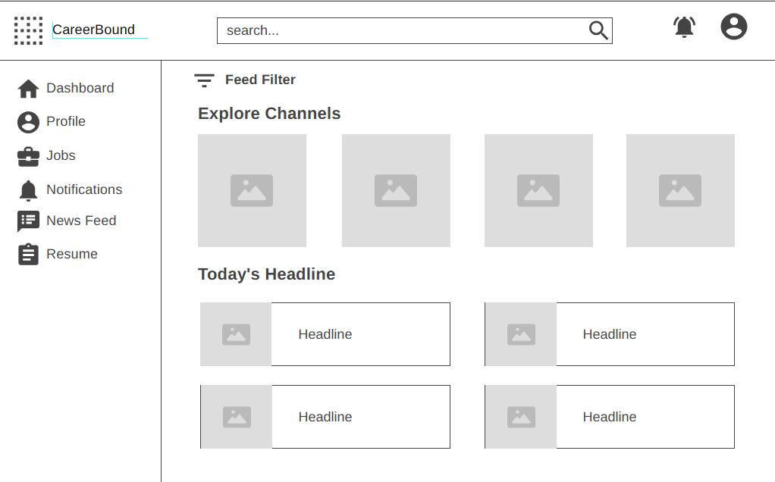
Mobile View
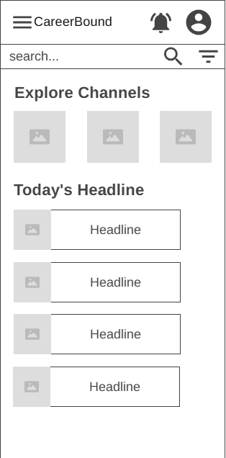
Design Information
Field | Description/Purpose
View Name & Number | 4.2 – News Feed
Purpose / Design Concern | Allows students to filter and view their news feed.
Description | Displays relevant news for students, which can be filtered by different tags to view specific news reports.
Requirements | 2.4 News Feed (2.4.1–2.4.6), 3.4 News Feed (3.4.1–3.4.2)
Elements | Logo
 | Notifications
 | Search Bar
 | Menu/Profile
 | Feed Filter
 | Explore Channels
 | Headlines
Inputs | Current news, current location
Outputs | Updated news feed, current location displayed
Navigation / References | Dashboard, Profile, Jobs, Resume, Notifications, News Feed
Viewpoint | UI Wireframe / Mockup (Desktop & Mobile)

