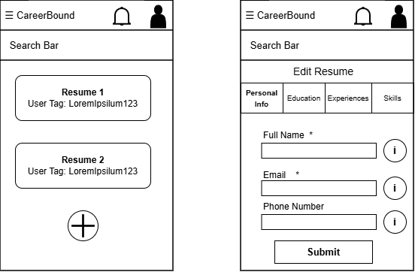

Design Information

Field | Description / Purpose
View Name & Number | 2.3 – Resume Builder Screens
Purpose / Design Concern | Allows students to create and edit resumes to submit to companies.
Description | Show currently available resumes with user tags with the option to either create a new resume or edit an existing one
Requirements | SRS 3.5 Resume, 3.5.4 User Input, 3.5.5 Input Submission
Elements | Search bar
 | Resume List
 | Add New Resume Button
 | Edit Resume Section Tabs
 | Helpful info buttons
 | Submit Resume Button
 | Asterisks denoting Required Data Entry
Inputs | Search terms, resume data entries, wildcard search
Outputs | Matching resume data terms, resume list search results, new resume data entries
Navigation / References | Resume List, Edit Resume Screen
Viewpoint | UI Wireframe / Mockup (Mobile)

