DFD Figure 1.2.0.0.1 & 1.3.0.0.1 – UI View Rendering Data Flow
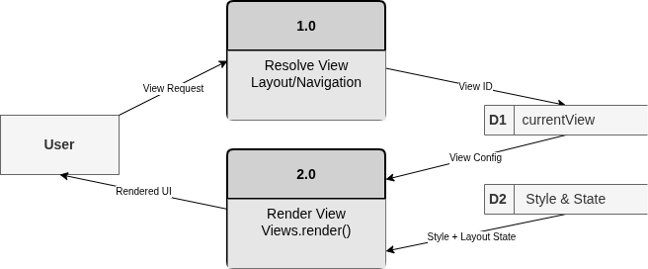

DFD Figure 1.2.0.0.2 & 1.3.0.0.2 – Client State Update Data Flow
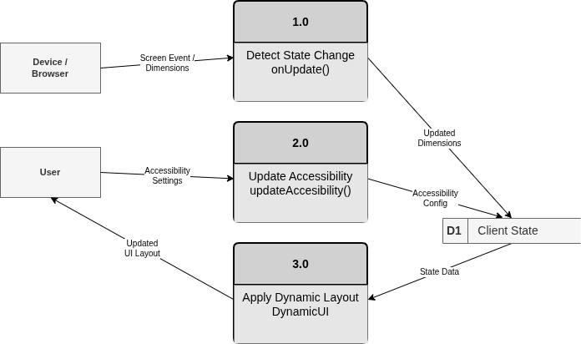

DFD Figure 1.2.0.0.3 & 1.3.0.0.3 – Navigation Selection Data Flow
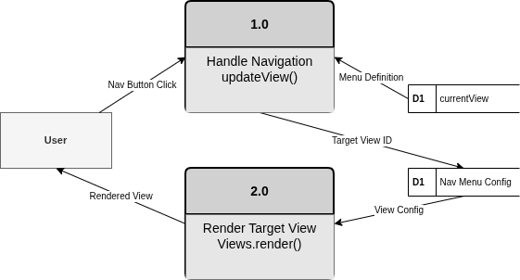

DFD Figure 1.2.0.0.4 & 1.3.0.0.4 – Client API Response Display Data Flow
