Figure 1.4 — API Gateway / Orchestrator Detail
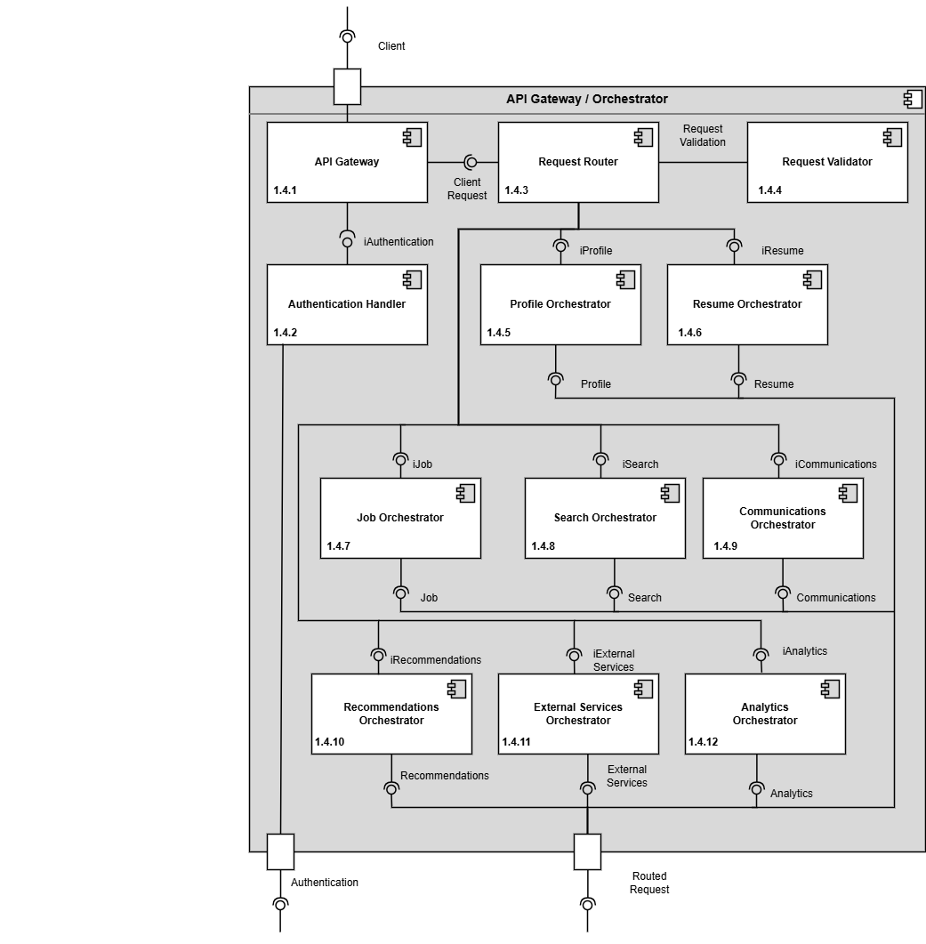
Design Information — API Gateway / Orchestrator
[No Table for 1.4 API Gateway / Orchestrator]
Entity Identification Tables — API Gateway / Orchestrator
EI Table 1.4.5 – Profile Orchestrator
Subcomponent | Entity Name | Entity Type | Description / Purpose | Related Requirement(s) | Collaborators / Related  Entities
Profile Orchestrator | ProfileOrchestrator | Class | Coordinates profile-related workflows between the profile page and supporting managers. | 3.1.2, 3.1.3.3, 3.1.3.4, 2.1.2, 2.1.3.6 | Profile Manager, Resume Manager, Privacy Settings Manager, Authentication Service
Profile Orchestrator | ProfileRequest | Object | Represents a request to view, update, or access profile-related information. | 3.1.2, 3.1.3.3, 3.1.3.4 | StudentUser, CompanyRepresentative, Profile Manager
Profile Orchestrator | ProfileResponse | Object | Represents the profile information or access result returned after coordination | 3.1.3.1, 3.1.3.4, 2.1.3.1, 2.1.3.6 | Profile Manager, Resume Manager
Profile Orchestrator | AccessContext | Object | Represents the requesting user, their role, and the action being requested | 3.1.3.3, 3.1.3.4, 2.1.3.6 | Authentication Service, Privacy Settings Manager
Profile Orchestrator | ProfileNavigationReference | Data Store | Represents profile page links or reference to related features managed by other subcomponents | 3.1.3.3, 3.1.3.4, 2.1.3.6 | Resume Manager, Profile Manager
Profile Orchestrator | ProfileWorkflow | Class | Represents a coordinated profile process such as viewing a student profile or accessing a resume link. | 3.1.2, 3.1.3.3, 3.1.3.4, 2.1.2 | Profile Manager, Resume Manager, Job Posting Service

Figure 1.5 — Authentication Service Detail
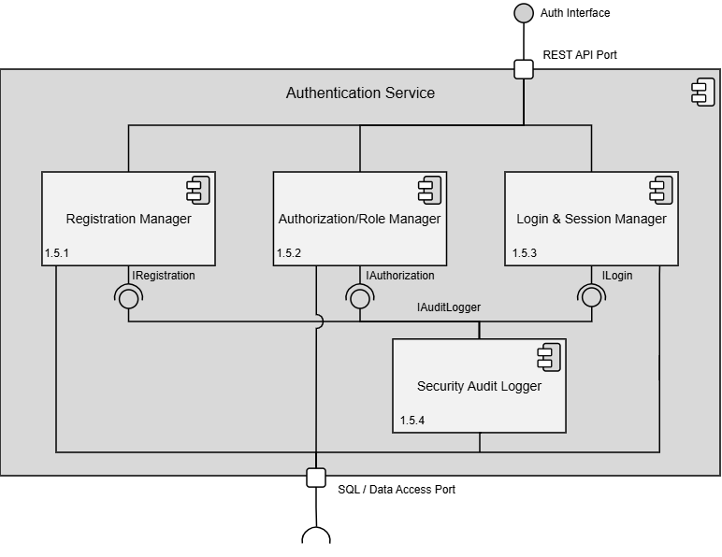Design Information — Authentication Service
[No Table for Authentication Service]
Entity Identification Tables — Authentication Service
EI Table 1.5.1 — Registration Manager
Subcomponent | Entity Name | Entity Type | Description / Purpose | Related Requirement(s) | Collaborators / Related Entities
Registration Manager | UserAccount | Class | Represents a user’s account which contains credentials and role information. | 1.1, 1.2 | UserData  UserForm  registerUser()
Registration Manager | UserForm | Class | A form which contains the user’s information for registration. | 1.1, 1.2 | /api/auth/register/
RegistrationManager | validateEmail() | Function | Checks if the email isn’t already used and ensure it’s in a valid format. | 1.1, 1.2 | UserForm
Registration Manager | validatePassword() | Function | Checks if the password contains any invalid characters and ensures it’s in the valid format. | 1.1, 1.2 | UserForm
Registration Manager | hashPassword() | Function | Hashes the user’s password to be stored securely. | 1.1, 1.2 | UserForm
Registration Manager | registerUser() | Function | Creates the user’s account from the form data. | 1.1, 1.2 | validateEmail(), validatePassword(), hashPassword(), UserAccount
Registration Manager | User Data | Data Table | The database where all user information is held. | 1.1, 1.2 | UserAccount
Registration Manager | /api/auth/register | API Endpoint | Handles incoming API requests for user registration. | 1.1, 1.2 | registerUser()  UserForm

EI Table 1.5.2 — Authorization / Role Manager
Subcomponent | Entity Name | Entity Type | Description / Purpose | Related Requirement(s) | Collaborators / Related Entities
Authorization/Role Manager | Authorization Manager | Class | Manages which users can access protected resources depending on their role. | 1.1,  1.2,  2.1.1,  2.1.3.10, 3.1.2 | checkPermissions()
Authorization/Role Manager | UserAccount | Class | Represents a user’s account which contains credentials and role information. | 1.1,  1.2,  2.1.3.10,  2.5.6, 3.1.2,  3.1.3.4 | User Data,  role
Authorization/Role Manager | role | Variable | The role the user has attached to their account. | 1.1,  1.2 | UserAccount, User Data
Authorization/Role Manager | User Data | Data Table | The database where all user information is held. | 1.1,  1.2 | UserAccount, role
Authorization/Role Manager | checkPermissions() | Function | Validates that a user has access to a protected resource. | 1.1,  1.2,  2.1.1,  2.5.6,  3.1.3.4 | UserAccount, User Data, role
Authorization/Role Manager | /api/auth/authorize | API Endpoint | Handles incoming API requests for user authentication. | 1.1,  1.2 | checkPermissions()

EI Table 1.5.3 — Login & Session Manager
Subcomponent | Entity Name | Entity Type | Description / Purpose | Related Requirement(s) | Collaborators / Related Entities
Login & Session Manager | UserAccount | Class | Represents a user’s account which contains credentials and role information. | 1.1,  1.2 | loginUser(),  Session
Login & Session Manager | UserForm | Class | A form which contains the user’s email and password needed for logging in. | 1.2 | loginUser()o
Login & Session Manager | Session | Class | Represents a user’s active session for their device. | 1.2 | sessionToken
Login & Session Manager | loginUser() | Function | Reads the user’s credentials and creates a new session if there’s a match. | 1.2 | UserAccount,  UserForm,  Session
Login & Session Manager | logoutUser() | Function | Deletes the user’s session for their device on request. | 1.2 | Session, sessionToken
Login & Session Manager | sessionToken | Variable | Represents a user’s session token for their device for later validation. | 1.2 | Session
Login & Session Manager | /api/auth/login | API Endpoint | Handles incoming API requests for user login. | 1.2 | loginUser()
Login & Session Manager | /api/auth/logout | API Endpoint | Handles incoming API requests for user logout. | 1.2 | logoutUser()

EI Table 1.5.4 — Security Audit Logger
Subcomponent | Entity Name | Entity Type | Description / Purpose | Related Requirement(s) | Collaborators / Related Entities
Security Audit Logger | buildAuditLog() | Method | Builds an audit log of different security metrics and displays it to the development team. | 1.2 | logId, loginAttempts, AuditLogException
Security Audit Logger | loginAttempts | Variable | Represents how many times a failed login was attempted for a specific user. | 1.2 | logId, AuditLogException
Security Audit Logger | logId | Variable | Comes from user’s input and gets packaged into the userData structure. | 1.2 | AuditLogException,  buildAuditLog()
Security Audit Logger | AuditLogException | Class | Locks the user’s account in the event that their account was potentially compromised. | 1.2 | buildAuditLog(), throwException()
Security Audit Logger | throwException() | Method | Throws an exception to the system when a security threat arises. | 1.2 | AuditLogException, submit()
Security Audit Logger | submit() | Method | Receives the user’s data where the security risk was brought up to help in the threat assessment. | 1.2 | AuditLogException,  throwException()
Security Audit Logger | /api/auth/log | API Endpoint | Handles incoming Security Audit Logger API requests. | 1.2 | buildAuditLog(),  submit()

Data Flow Diagrams — Authentication Service
DFD Figure 1.5.0.0.1 — Register User
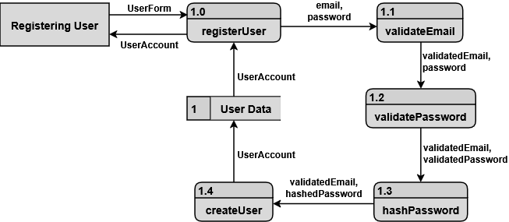DFD Figure 1.5.0.0.2 — Login Session Validation
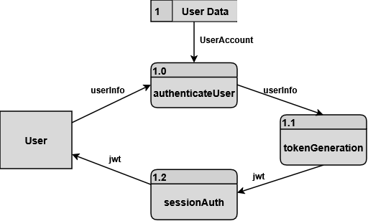
Figure 1.6 — Profile Service Detail
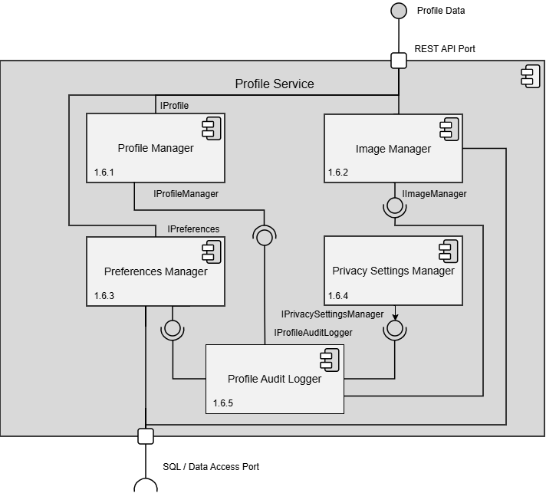Design Information — Profile Service
[No Table for 1.6 Profile Service]
Entity Identification Tables — Profile Service
EI Table 1.6.1 — Profile Manager
Subcomponent | Entity Name | Entity Type | Description / Purpose | Related Requirement(s) | Collaborators / Related  Entities
Profile  Manager | StudentProfile | Class | Represents and organizes the main profile information for a student. | 3.1.1, 3.1.2, 1.3.2 | Accolades, addAccolade()
Profile Manager | Accolades | Class | Represents achievements, honors, certifications, awards, or recognition that belongs to a student profile. | 3.1.1, 3.1.2,  1.3.2 | StudentProfile
Profile Manager | addAccolade() | Method | Represents a method that adds an accolade. | 3.1.1, 3.1.2,  1.3.2 | StudentProfile
Profile Manager | updateAccolade() | Method | Represents a method that updates an accolade | 3.1.1, 3.1.2, 1.3.2 | StudentProfile
Profile Manager | deleteAccolade() | Method | Represents a method that deletes an accolade | 3.1.1,  3.1.2, 1.3.2 | StudentProfile
Profile Manager | updateProfileImageReference() | Method | Connects the selected image to the student profile. | 3.1.2, 1.3.2 | StudentProfile
Profile Manager | ContactInformation | Data Store | Stores student contact details shown on the profile. | 3.1.2, 1.3.2 | StudentProfile
Profile Manager | EducationInformation | Data Store | Stores student education information shown on the profile | 3.1.2, 1.3.2 | StudentProfile
Profile Manager | Skill(s) | Data Store | Stores a list of one or more skills shown on the profile. | 3.1.2, 1.3.2 | StudentProfile
Profile Manager | AboutMe | Data Store | Stores a summary of content that describes the student, shown on the profile | 3.1.2, 1.3.2 | StudentProfile
Profile Manager | CompanyProfile | Class | Represents and organizes the main profile information for a company. | 2.1.3.1, 2.1.2, 2.1.3.2 | CompanyProfile, CompanyLocation, JobInterestForm
Profile Manager | CompanyLocation | Data Store | Represents a location where the company conducts business and may include a physical address | 2.1.3.3, 2.1.3.4, 2.1.3.5, 2.1.3.6 | CompanyProfile, PhysicalAddress
Profile Manager | PhysicalAddress | Data Store | Stores the address details for a company location. | 2.1.3.5, 2.1.3.7 | CompanyLocation
Profile Manager | JobInterestForm | Data Store | Represents the form a student submits to express interest in a job | 2.1.2 | CompanyProfile, StudentUser, Qualification
Profile Manager | Qualification | Data Store | Represents a student’s listed qualification for a job interest form | 2.1.2 | JobInterestForm, StudentUser
Profile Manager | StudentFollow | Data Store | Represents the relationship between a company representative and a followed student user. | 2.1.2 | CompanyRepresentative, StudentUser
Profile Manager | GPA | Variable | Represents the student’s grade point average shown on the profile. | 3.1.3.1 | StudentProfile
Profile Manager | addProfileInformation | Method | Adds profile-owned data | 3.1.2 | StudentProfile, CompanyProfile
Profile Manager | updateProfileInformation | Method | Updates profile-owned data | 3.1.2 | StudentProfile, CompanyProfile
Profile Manager | deleteProfileInformation | Method | Deletes profile-owned data | 3.1.2 | StudentProfile,  CompanyProfile
Profile Manager | addCompanyLocation | Method | Adds a new company location | 2.1.3.3, 2.1.3.4 | CompanyProfile
Profile Manager | updateCompanyLocation | Method | Updates a company location from the location list. | 2.1.3.3, 2.1.3.5, 2.1.3.7 | CompanyProfile
Profile Manager | deleteCompanyLocation | Method | Deletes a company location from the location list. | 2.1.3.3 | CompanyProfile

EI Table 1.6.2 — Image Manager
Subcomponent | Entity Name | Entity Type | Description / Purpose | Related Requirement(s) | Collaborators / Related Entities
Image Manager | ImageHandler | Class | This oversees handling all image related methods | 2.1, 2.1.3, 3.1, 3.1.3 | UpdateImage(), ValidateImage(), ImageStore
Image Manager | updateImage() | Method | This handles updating images for users | 2.1.3.10  3.1.2 | ImageManager, ImageValidator
Image Manager | processImage() | Method | This crops, resizes, and manipulates an image | 2.1, 2.1.3, 3.1, 3.1.3 | ImageManager, ImageValidator
Image Manager | retrieveImage() | Method | This handles retrieving image data from a database | 2.1, 2.1.3, 3.1, 3.1.3 | ImageManager, ImageStore
Image Manager | ImageValidator | Class | This validates whether an image meets platform standards | 2.1, 2.1.3, 3.1, 3.1.3 | ImageManager
Image Manager | ImageStore | Data Store | This stores all profile images for various users | 2.1, 2.1.3, 3.1, 3.1.3,  3.1.2,  2.1.3.10 | ImageManager
Image Manager | /api/profile | API Endpoint | This is an API endpoint to the overall audit logger | 2.1, 2.1.3, 3.1, 3.1.3 | ImageManager

EI Table 1.6.3 — Preferences Manager
Subcomponent | Entity Name | Entity Type | Description/ Purpose | Related Requirement(s) | Collaborators / Related Entities
Preferences Manager | updateNotificationPreferences() | Method | Updates the user's notification delivery and filtering settings. | 3.3.5, 3.3.6 | NotificationPreferences, ProfileManager
Preferences Manager | NotificationPreferences | Data Table | Stores persistent user settings regarding which notifications to receive and how. | 3.3.5, 3.3.6 | updateNotificationPreferences(), getPreferences()
Preferences Manager | muteNotifications | Variable | Boolean flag representing whether a user has opted to silence all incoming notifications. | 3.3.5 | NotificationPreferences
Preferences Manager | getPreferences() | Method | Retrieves the user's saved preferences for system display and notification routing. | 3.3.6 | NotificationPreferences
Preferences Manager | /api/profile/preferences | API Endpoint | Handles incoming requests to view or modify user preference configurations. | 3.3.5, 3.3.6 | updateNotificationPreferences(), getPreferences()

EI Table 1.6.4 — Privacy Settings Manager
Subcomponent | Entity Name | Entity Type | Description / Purpose | Related Requirement(s) | Collaborators / Related Entities
Privacy Settings Manager | UserPrivacySettings | Object | This contains variables controlling the privacy settings for the user | 3.2 | PrivacySettingsManager
Privacy Settings Manager | updateSettings() | Method | This edits settings for the user | 3.2,  3.2.7 | PrivacySettingsManager, SaveSettings()
Privacy Settings Manager | SettingsValidator | Class | This ensures that all settings for the user all valid | 3.2,  3.2.7 | PrivacySettingsManager
Privacy Settings Manager | initializeSettings() | Method | This sets default settings for an account | 3.2,  3.2.7 | PrivacySettingsManager
Privacy Settings Manager | PrivacySettingsManager | Class | This handles all changes that occur for the privacy settings | 3.2 | UserPrivacySettings, SaveSettings, InitializeSettings(), SettingsValidator, UpdateSettings()
Privacy Settings Manager | saveSettings() | Method | Saves the settings associated with the account | 3.2,  3.2.7 | PrivacySettingsManager
Privacy Settings Manager | /api/profile/manage | API Endpoint | This is an API endpoint to the overall audit logger | 3.2,  3.2.7 | ImageManager

EI Table 1.6.5 — Profile Audit Logger
Subcomponent | Entity Name | Entity Type | Description/ Purpose | Related Requirement(s) | Collaborators / Related Entities
Profile Audit Logger | logActivity() | Method | Records a specific user action or security event into the audit trail. | 3.1.2, UI 4.4 | AuditLog, ProfileManager
Profile Audit Logger | AuditLog | Data Store | Stores immutable records of account changes, logins, and security-related events. | UI 4.4 | logActivity(), getLoginHistory()
Profile Audit Logger | getLoginHistory() | Method | Retrieves past login instances and locations for display on the security screen. | UI 4.4 | AuditLog
Profile Audit Logger | SecurityEvent | Object | An instance of a tracked user action, such as a password change or profile update. | 3.1.2, UI 4.4 | logActivity(), AuditLog
Profile Audit Logger | /api/profile/audit | API Endpoint | Handles requests to fetch the user's recent login and profile activity history. | UI 4.4 | getLoginHistory()

Data Flow Diagrams — Profile Management
DFD Figure 1.6.0.0.1 — Profile Creation And Update
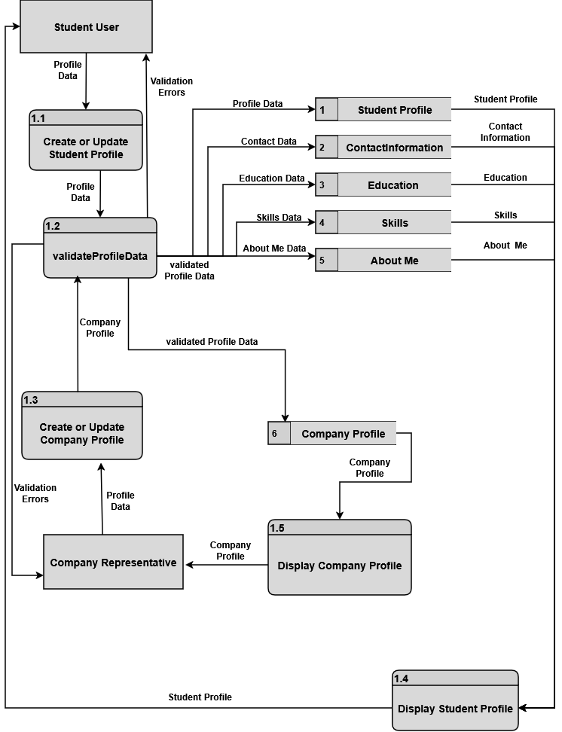DFD Figure 1.6.0.0.2 — Privacy Settings Update
