Structure Charts – Search Service
SC Figure 1.9.0.1 – SearchQuery()
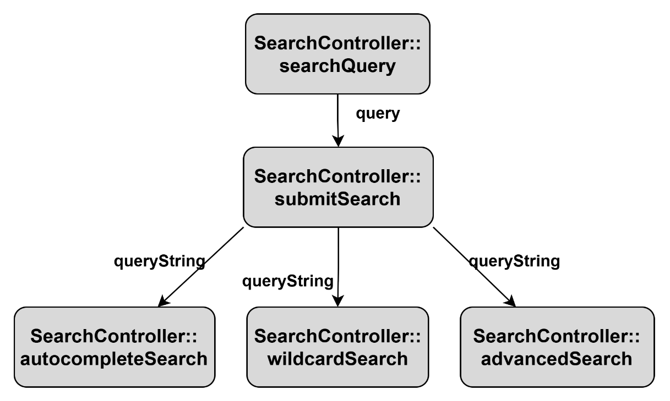

SC Figure 1.9.0.2 – InputFilters()
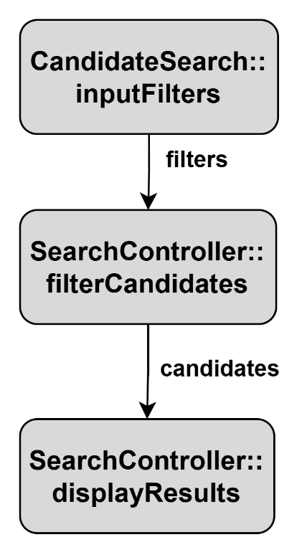

SC Figure 1.9.0.3 – ProcessFilters()
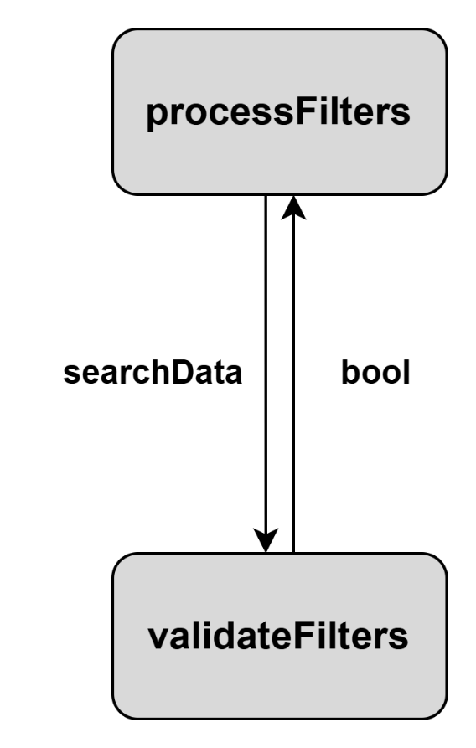

SC Figure 1.9.0.4 – Search()
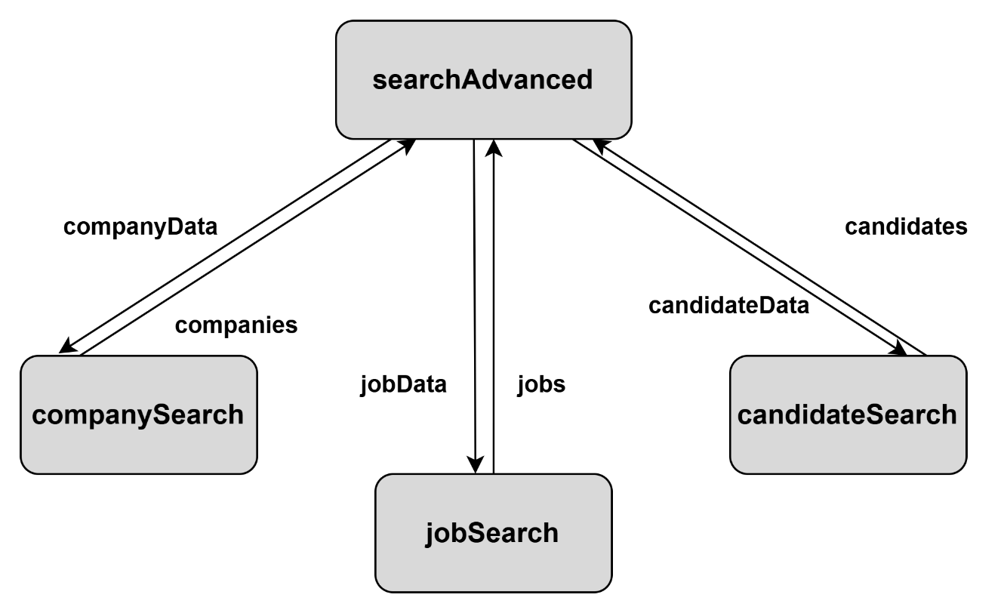

SC Figure 1.9.0.5 – processWildcardSearch()
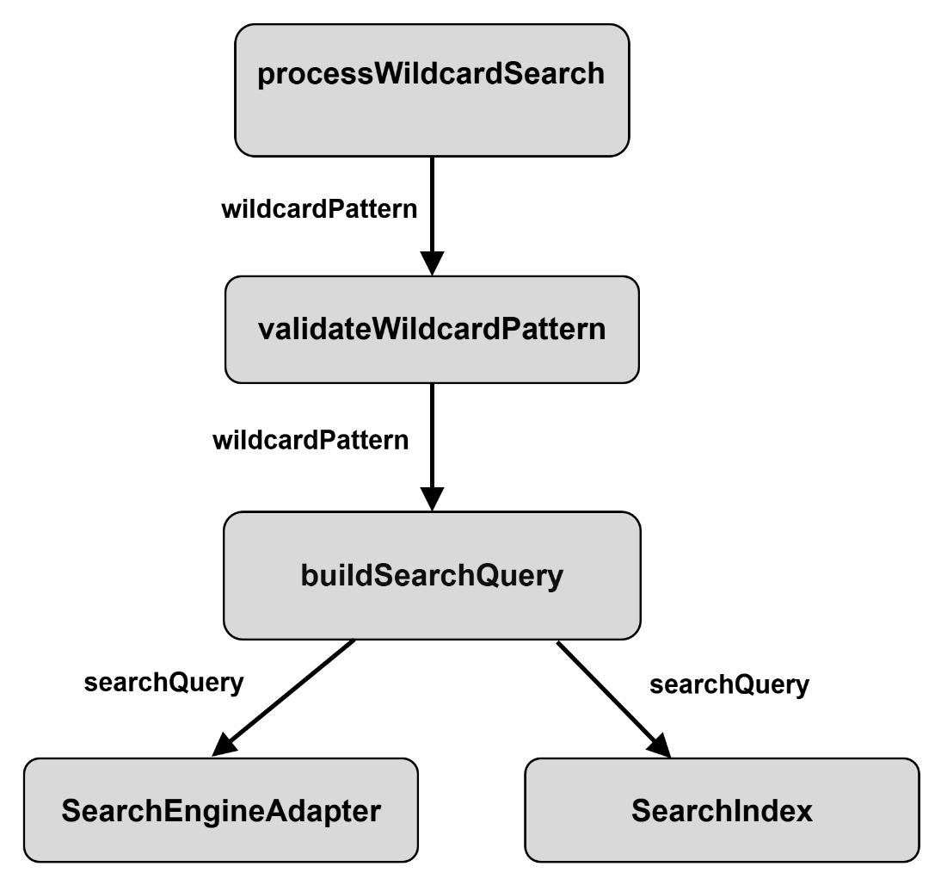

SC Figure 1.9.0.6 – SearchCache()
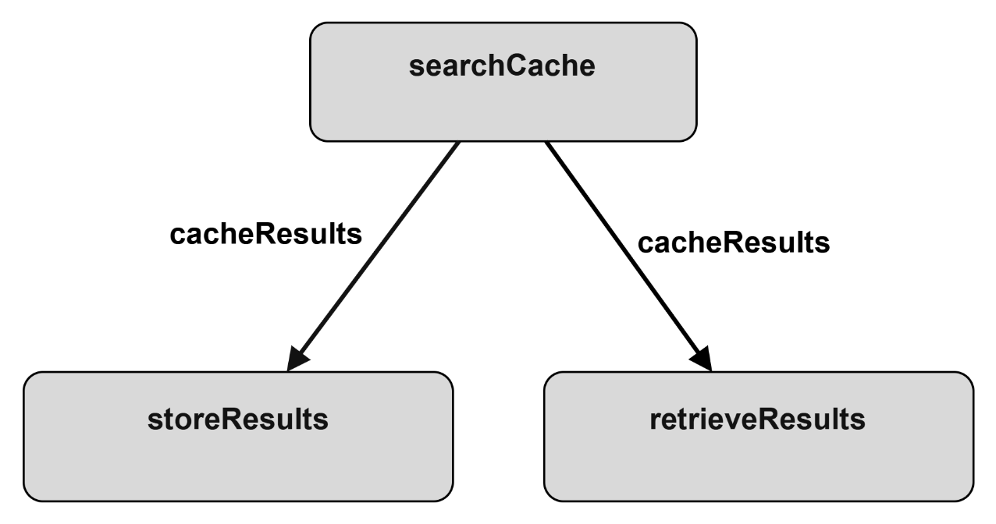

Data Flow Diagrams – Search Service
DFD 1.9.0.0.1 – Job Search
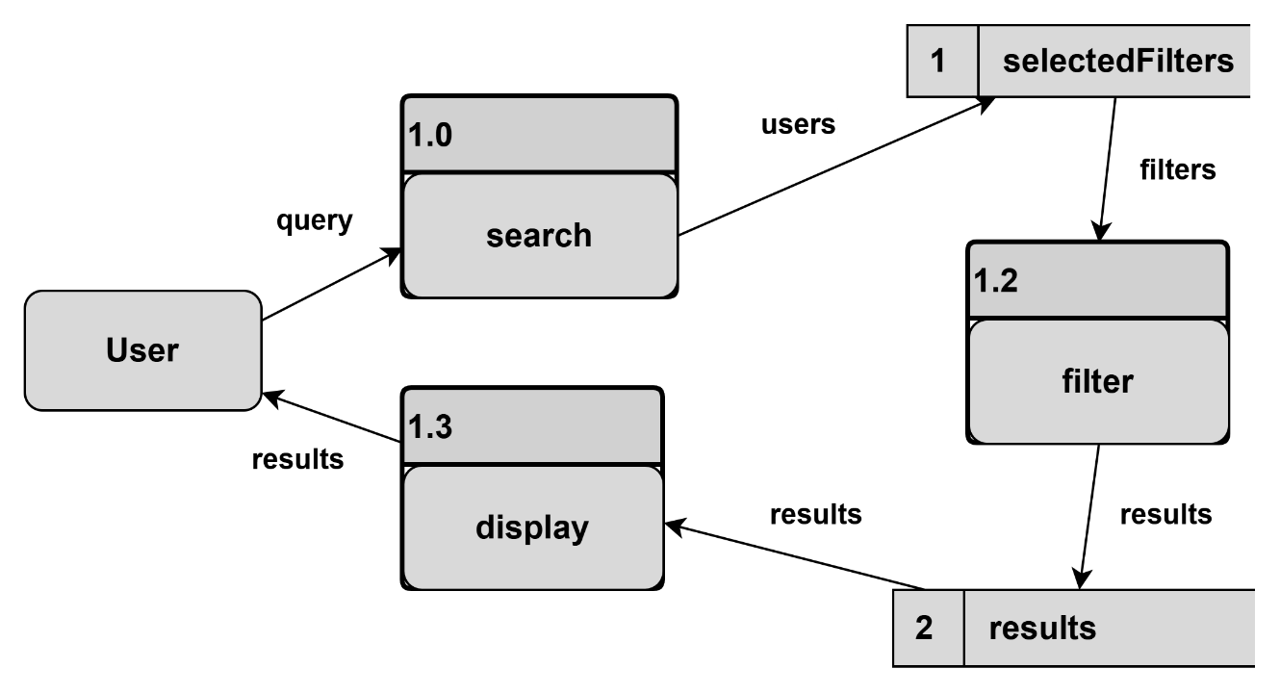

DFD Figure 1.9.0.0.2 – Company Search
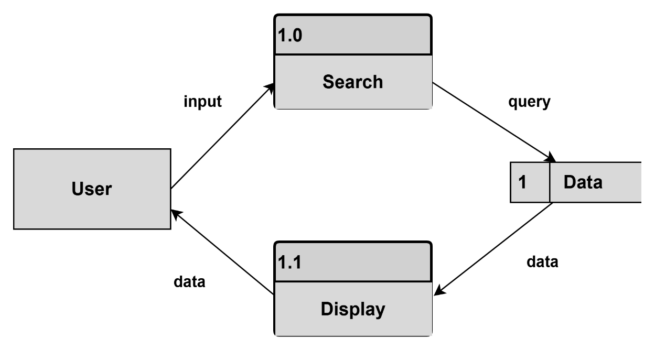

DFD Figure 1.9.0.0.3 – Search Engine Adapter
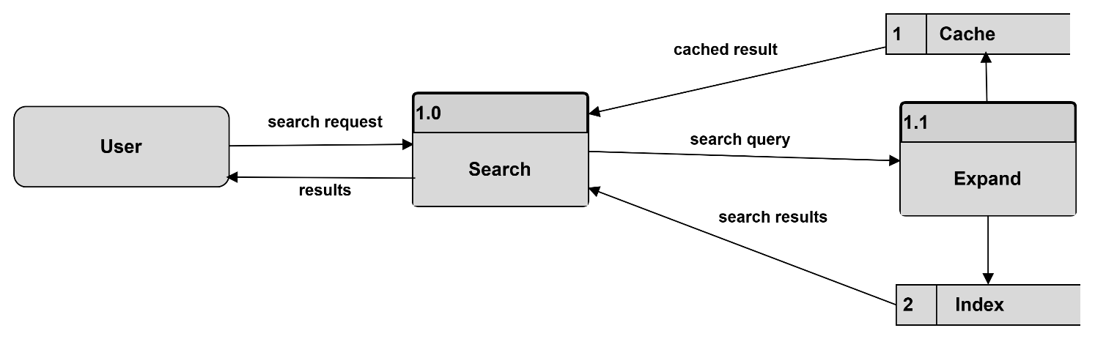

DFD Figure 1.9.0.0.4 – Search Index / Search Engine
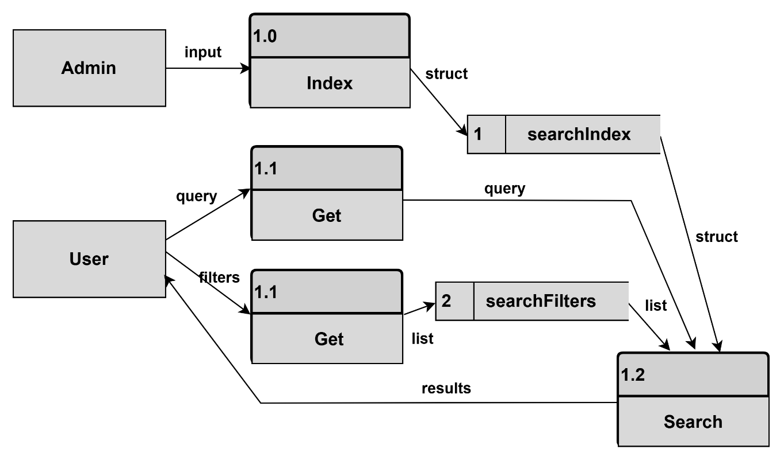

DFD Figure 1.9.0.0.5 – Autocomplete
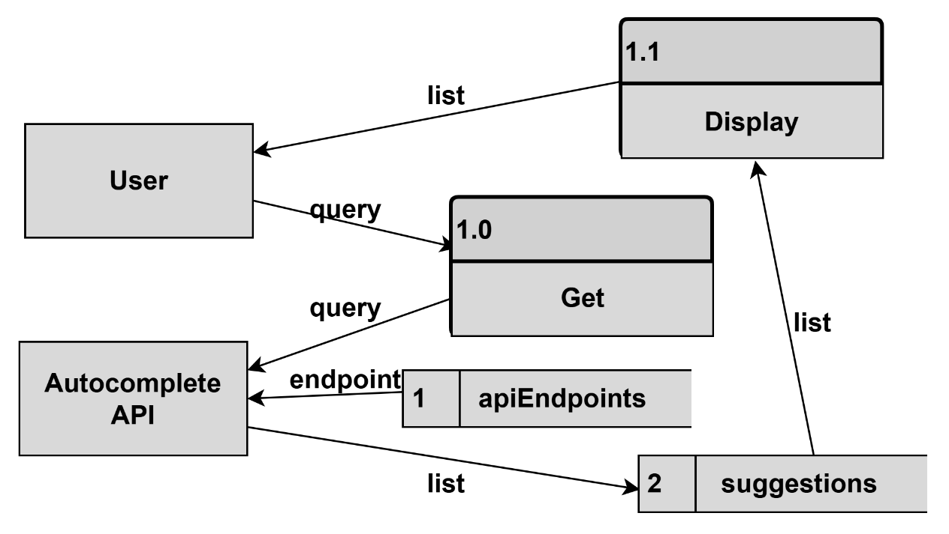

DFD Figure 1.9.0.0.6 – Ranking Results
