Structure Charts — Candidate Search Manager
SC Figure 1.13.2.0.1 — searchCandidates()
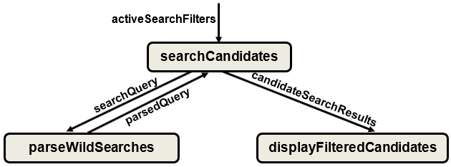

SC Figure 1.13.2.0.2 — autoFillSearchBar()
