DFD Figure 1.10.0.0.8 — News Feed Manager

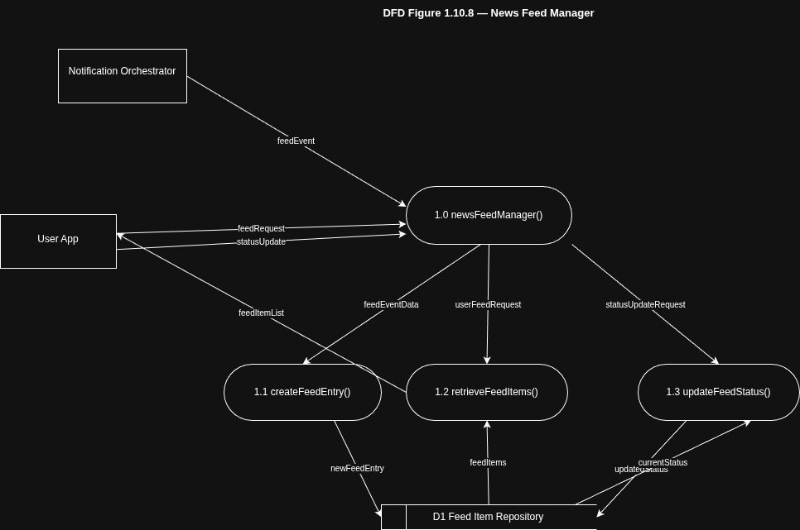

Structure Chart — SC Figure 1.10.0.8

