DFD Figure 1.10.0.0.7 — Push Delivery Component

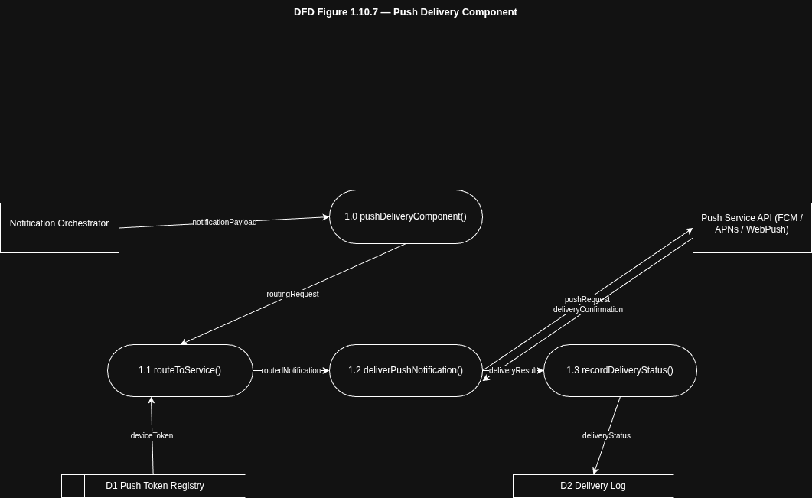

SC Figure 1.10.0.7 Notification Subsystem

