While reviewing your version of the ssd i found only one issue:
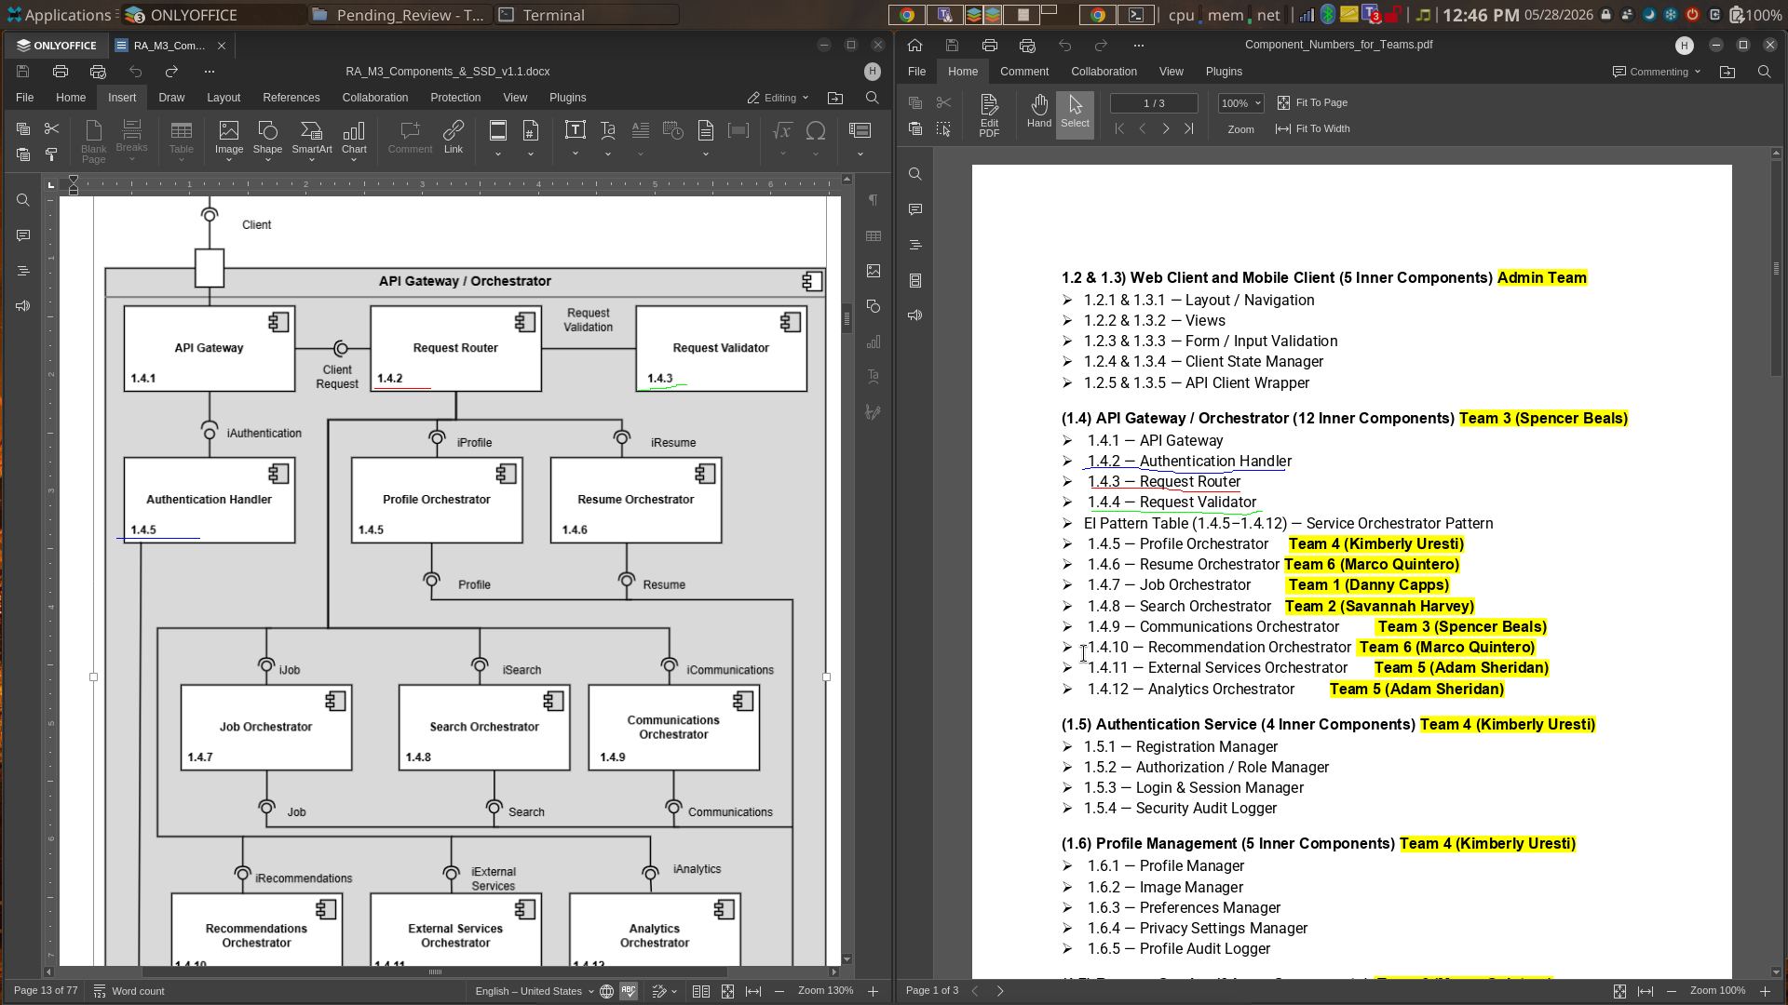
\

Highlighted and color coded in this image is a mismatch in numbering. The figure 1.4 drawio file should be corrected to match the Component_numbers_for_teams document.
In addition to that, just ad your name and revisions to the revisions history table on page 2 and you’re good to go. When you make those changes go ahead and just put it directly in the approved folder.

