#1 Is missing the Design Information Table
#2 Desktop view is too thin and too small to read - needs to be redone, so that it is wide like a desktop view and you are able to see and read the labels, etc. It looks like a mobile view in the center of a Desktop screen and is so long it takes up 2 ½ pages of a Word Document when expanded to the width of the page so that you can see it.
#3 Mobile view and other views need to be place under a heading in a word document as shown below.

UI View 4.4 – Privacy Security Settings

Desktop View – Privacy Security Settings
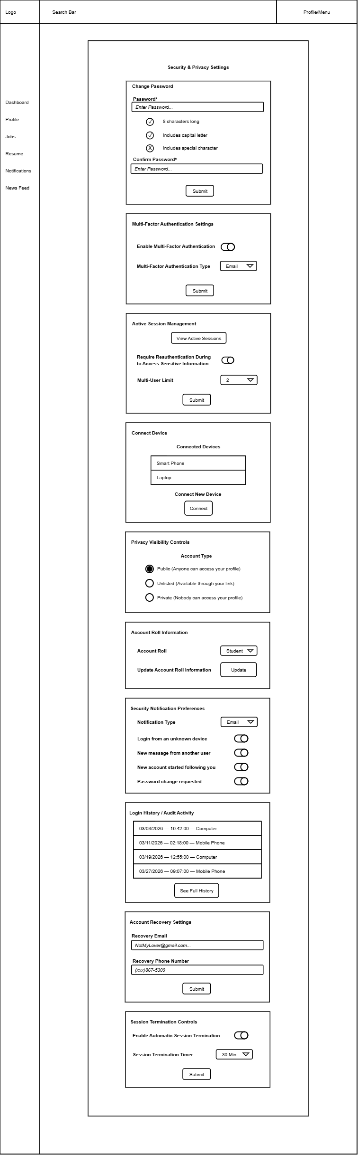

Mobile View – Privacy Security Settings

