1.11.2-ALG calculateCandidateScore() Algorithm
Purpose:
Calculates a candidate ranking score for an employer search or recommendation request by evaluating required filters, skills, experience, profile and resume information, and weighted criteria; returns a bounded score, a score breakdown, and the candidate eligibility status.
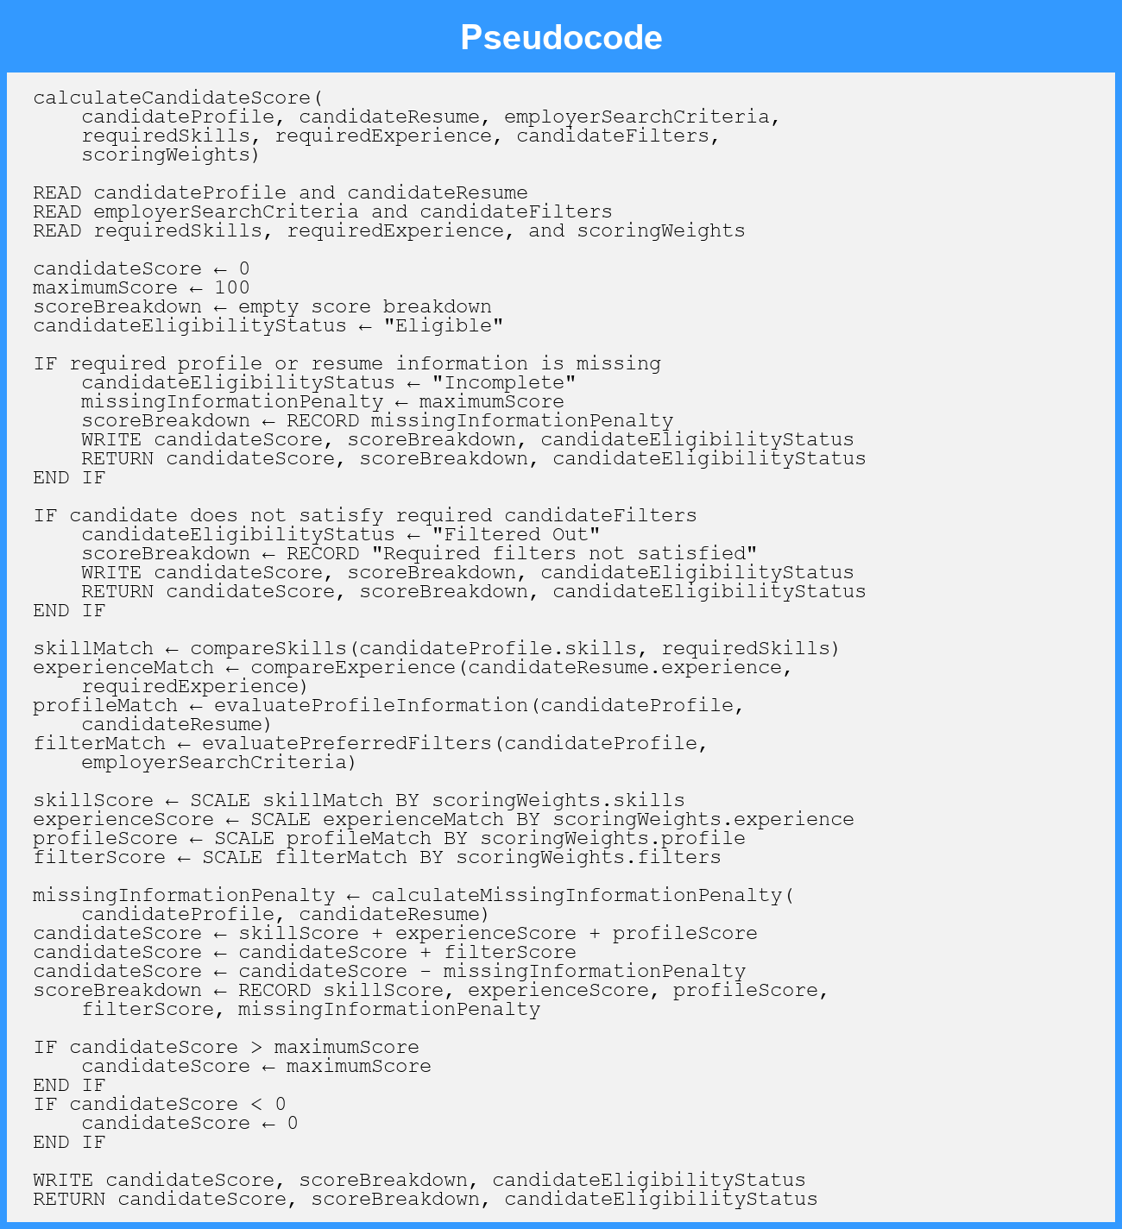
Local Data:
candidateScore : Number
maximumScore : Number
skillMatch : Number
experienceMatch : Number
profileMatch : Number
filterMatch : Number
skillScore : Number
experienceScore : Number
profileScore : Number
filterScore : Number
missingInformationPenalty : Number
scoreBreakdown : ScoreBreakdown
candidateEligibilityStatus : EligibilityStatus

