1.11.5-ALG generateRecommendations() Algorithm
Purpose:
Coordinates the final candidate recommendation process by validating an employer request, retrieving candidate and resume records, applying filters, scoring eligible candidates, ranking matches, limiting results, and returning the recommendation list and summary.
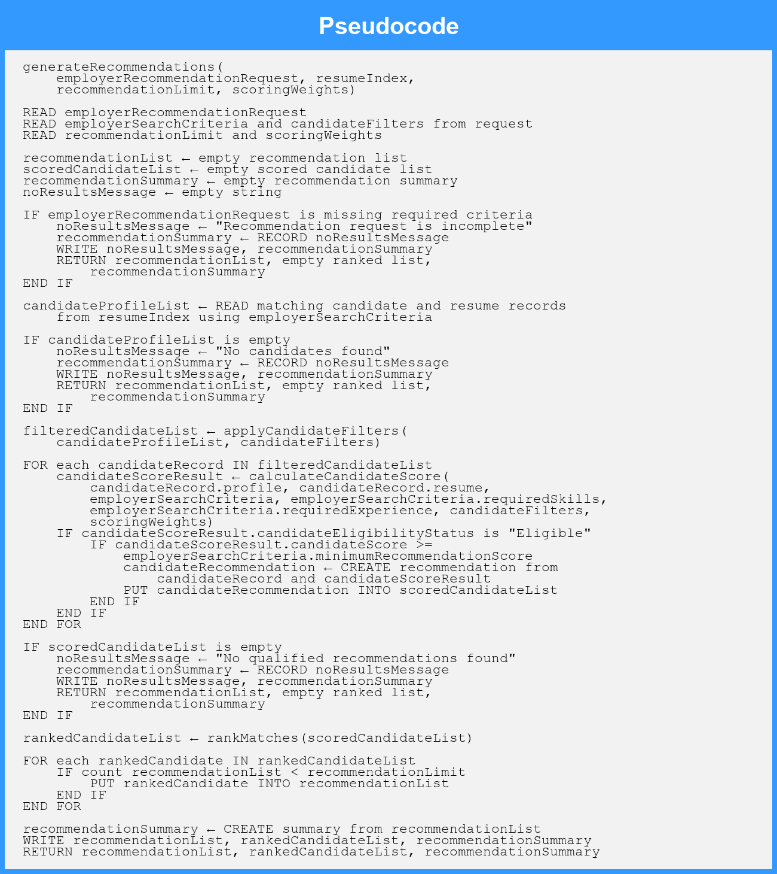
Local Data:
recommendationList : List of CandidateRecommendation
scoredCandidateList : List of CandidateRecommendation
rankedCandidateList : List of CandidateRecommendation
recommendationSummary : RecommendationSummary
noResultsMessage : String
candidateProfileList : List of CandidateRecord
filteredCandidateList : List of CandidateRecord
candidateRecord : CandidateRecord
candidateScoreResult : CandidateScoreResult
candidateRecommendation : CandidateRecommendation

