1.11.2-ALG applyCandidateFilters() Algorithm
Purpose:
Filters searchable student profiles by comparing each candidate against the employer’s selected search criteria and returning only candidates who satisfy the required filters.
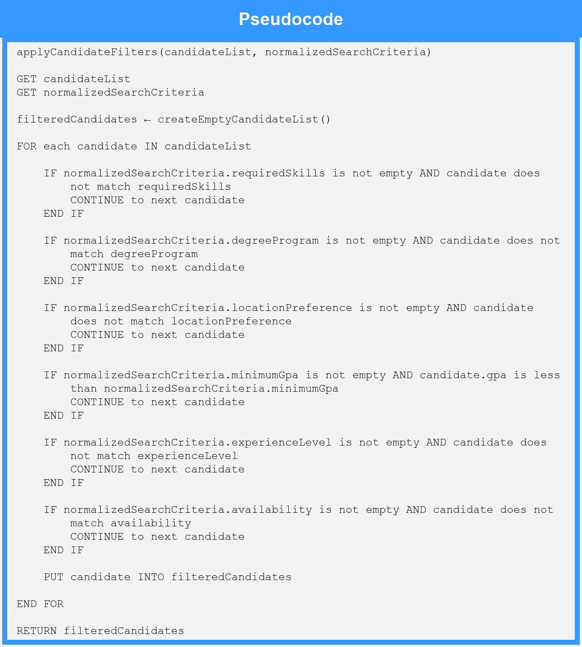
Local Data:
filteredCandidates : List of StudentProfile
candidate : StudentProfile

