1.11.2-ALG recommendCandidates() Algorithm
Purpose:
Recommends qualified student candidates to an employer by validating the candidate search request, applying employer-selected filters, scoring eligible candidates, ranking the results, and returning a ranked recommendation list.
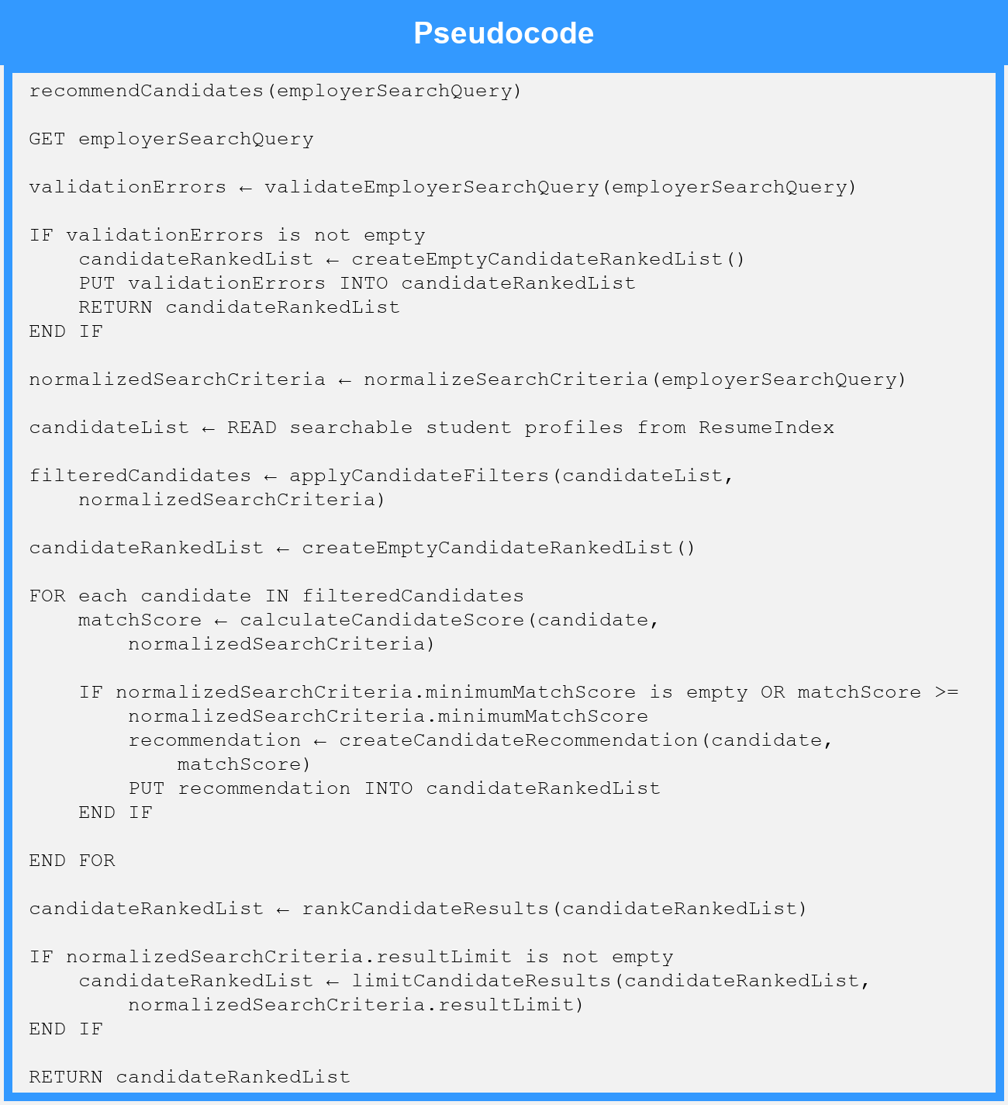
Local Data:
validationErrors : List of String
normalizedSearchCriteria : EmployerSearchQuery
candidateList : List of StudentProfile
filteredCandidates : List of StudentProfile
candidateRankedList : CandidateRankedList
matchScore : Number
recommendation : CandidateRecommendation

