- DATA DESIGN

  - Data Description
The information domain of Career Bound consists of students, companies, resumes, job postings, applications, notifications, search activities, and analytics events. These concepts are transformed into software data structures represented by classes, database records, API messages, and stored files. Each major business entity is assigned a corresponding data structure to support storage, processing, and communication throughout the system.
User account information is managed by the Authentication Service and stored in the primary database. Student and company profile information is managed by the Profile Management Service and stored in the primary database. Resume metadata is stored in the primary database while uploaded resume files are stored in File / Blob Storage. Job postings, applications, notifications, search activity data, and analytics events are similarly managed by their corresponding services and persisted within the system's data stores.
Persistent business data is maintained within the primary database, while binary assets and uploaded documents are maintained within File / Blob Storage. Data exchanged between client applications and backend services is transmitted through REST API messages over the system's communication interfaces.
Data Storage Items:
- Primary Database
- User Accounts
- Student Profiles
- Company Profiles
- Job Postings
- Applications
- Notifications
- Search Activity Data
- Analytics Data

- File / Blob Storage
- Resume Documents
- Profile Images
- Attachments
Career Bound stores data related to user authentication, student profiles, company profiles, resumes, job postings, search activities, notifications, and analytics events.
Persistent data is stored in the system database. Temporary data is exchanged through REST API messages between the client applications and backend services.
  - Data Dictionary
The detailed identification of system entities, functions, data stores, classes, modules, and related data structures is documented within the Entity Identification Tables (EITs) provided throughout Section 3.2 Decomposition Description. The EITs serve as the primary source for entity definitions and provide the foundation for the Class Designs, Database Design, File Format Specifications, and Network Protocol/API Message Specifications described in Sections 4.3 through 4.6.
For convenience, the major business and system data entities within Career Bound are summarized below. The following summary-level data dictionary connects these entities to the component decomposition presented in Section 3.2. Each entity listed below is managed, processed, stored, or exchanged by one or more components identified in Figures 1.2 through 1.15. The Related Component / Figure column provides traceability between the data entities and the architectural components responsible for their creation, management, storage, or use. Infrastructure, routing, presentation, and protocol-related entities are documented within the corresponding EITs and supporting design artifacts but may not be individually represented in this summary table.
Entity | Type | Description | Related Component / Figure
Analytics Event | System Entity | Recorded user activity and system metrics | - Analytics Service — Figure 1.13  - Database — Figure 1.14
Application | Business Entity | Student application submitted for a job posting | - Job Posting Service — Figure 1.8  - Database — Figure 1.14
Company Profile | Business Entity | Company account and profile information | - Profile Management Service — Figure 1.6  - Database — Figure 1.14
Job Posting | Business Entity | Published employment opportunity | - Job Posting Service — Figure 1.8  - Search Service — Figure 1.9; Database — Figure 1.14
Notification | Business Entity | System-generated user notification | - Communication Services — Figure 1.10  - Database — Figure 1.14
Recommendation | System Entity | Job or candidate recommendations generated by the system | - Recommendation Service — Figure 1.11
Resume | Business Entity | Student resume data and associated uploaded files | - Resume Service — Figure 1.7  - File / Blob Storage — Figure 1.15
Student Profile | Business Entity | Student account and profile information | - Profile Management Service — Figure 1.6  - Database — Figure 1.14
User Account | Business Entity | Authenticated user account information | - Authentication Service — Figure 1.5  - Database — Figure 1.14

  - Class Design

Class Diagrams – 1.2 & 1.3 Web & Mobile Client

1.2.1 & 1.3.1–CD Menu Class Diagram
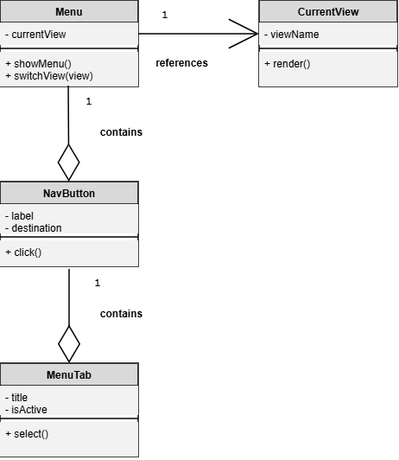

1.2.2 & 1.3.2–CD Navigation Management Class Diagram
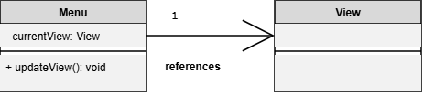

1.2.3 & 1.3.3–CD View Class Diagram
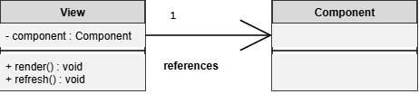

1.2.3 & 1.3.3-CD Form Class Diagram
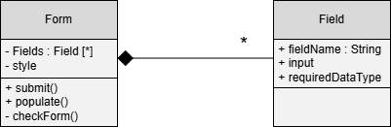

1.2.3 & 1.3.3-CD Form Validation Class Diagram
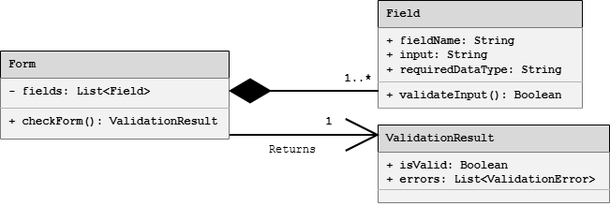

1.2.4 & 1.3.4–CD Localization Class Diagram
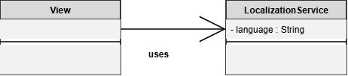

1.2.4 & 1.3.4–CD State Class Diagram
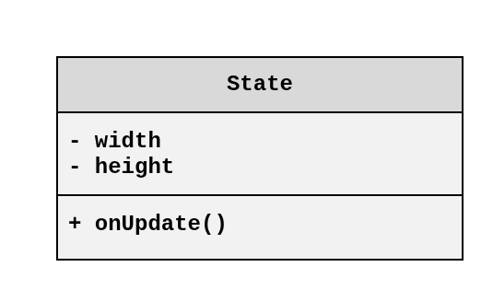

1.2.4 & 1.3.4–CD Dynamic UI Class Diagram
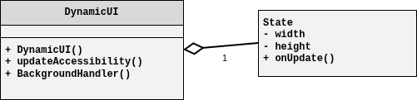

1.2.5 & 1.3.5–CD NetworkConfig Class Diagram
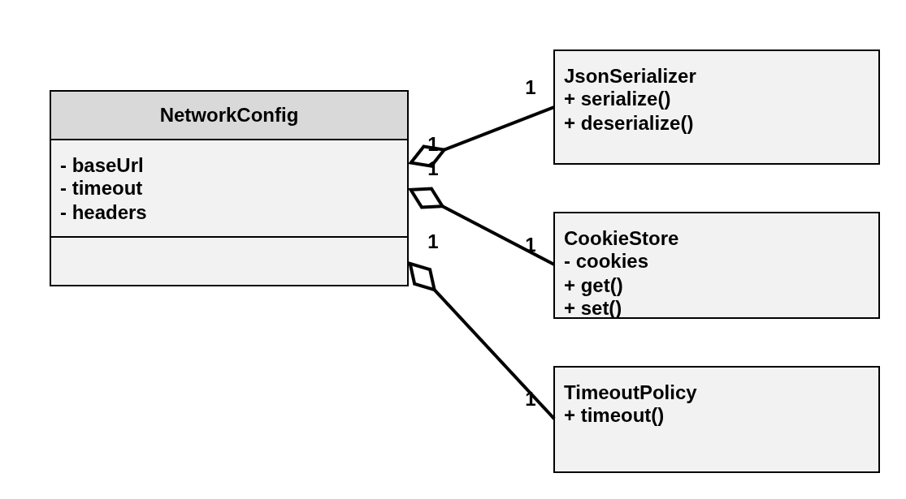

1.2.5 & 1.3.5-CD API Request Processing Class Diagram
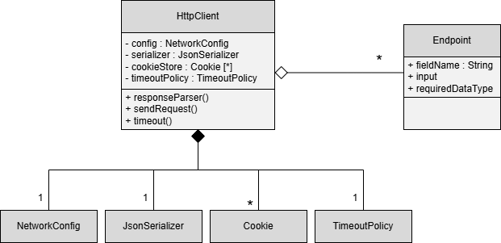

Class Diagrams – 1.4 API Gateway / Orchestrator

1.4.1 – CD API Gateway Class Diagram
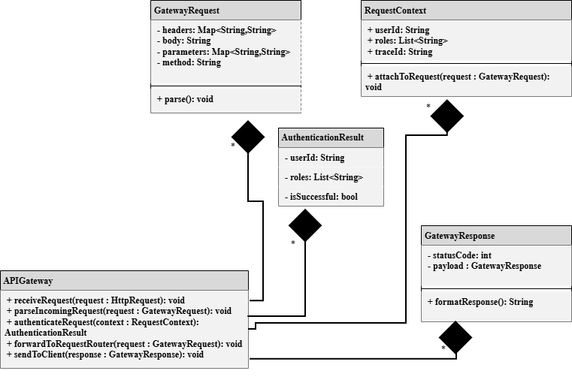

1.4.2 - CD Authentication Handler Class Diagram View
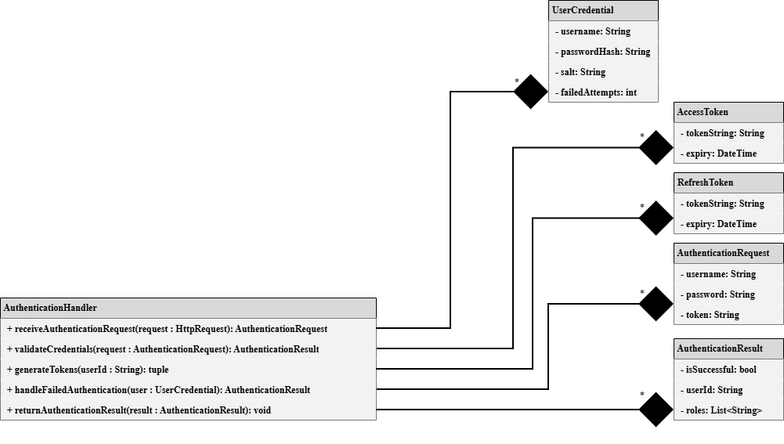

1.4.3-CD Request Router Class Diagram View
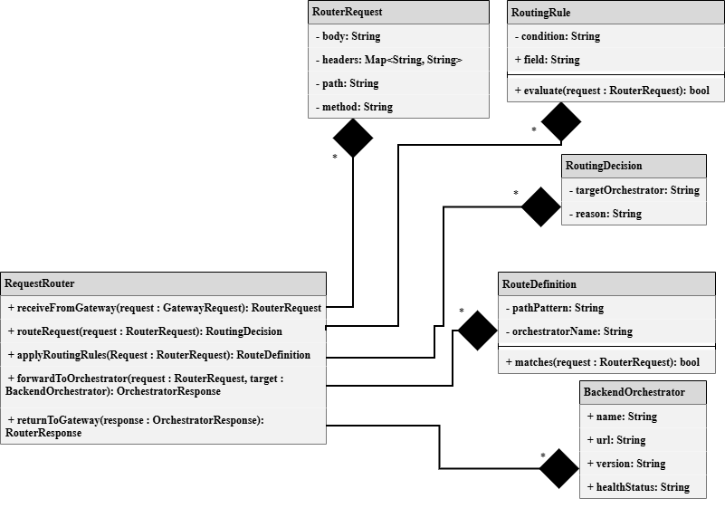

1.4.11–CD ExternalServicesOrchestrator Class Diagram
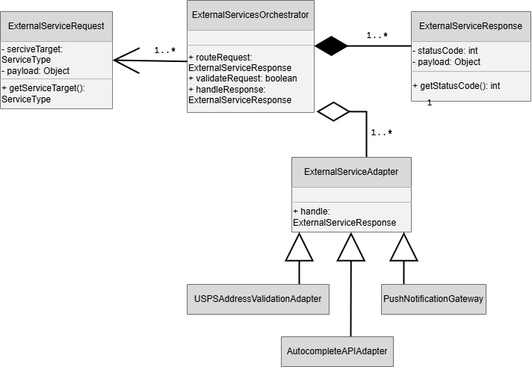

Class Diagrams – 1.5 Authentication Service

1.5.1–CD Registration Manager Class Diagram
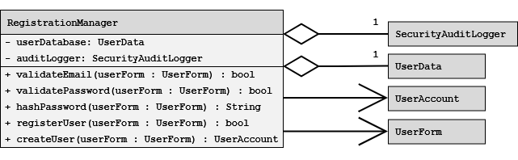

1.5.2-CD UserAccount Class Diagram
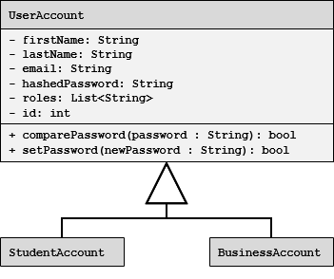

1.5.2–CD Authorization/Role Manager Class Diagram
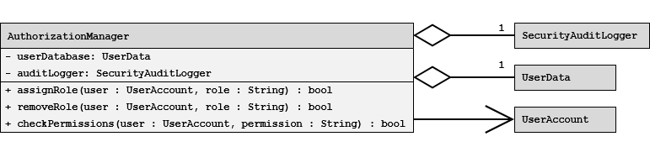

1.5.3-CD Login & Session Manager Class Diagram
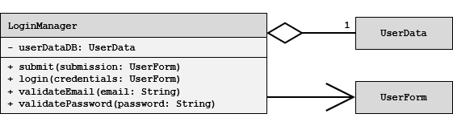

Class Diagrams – 1.6 Profile Management Service

1.6.1-CD User Account Types Class Diagram


1.6.1-CD Accolade Class Diagram
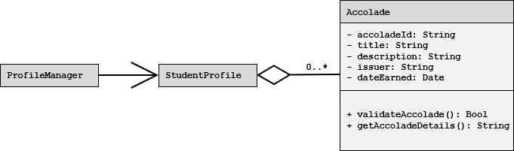

1.6.2-CD Image Manager Class Diagram
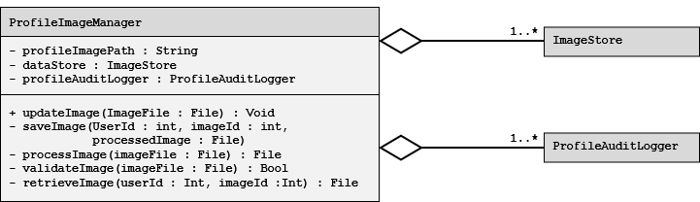

1.6.3-CD Preferences Manager Class Diagram
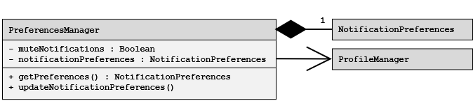

1.6.4-CD Privacy Settings Manager Class Diagram
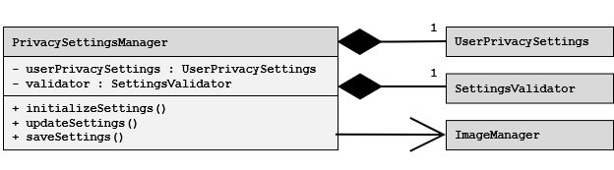

1.6.5-CD Profile Audit Logger Class Diagram
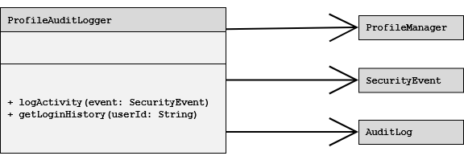

Class Diagrams – 1.7 Resume Service

1.7.1-CD Resume Class Diagram
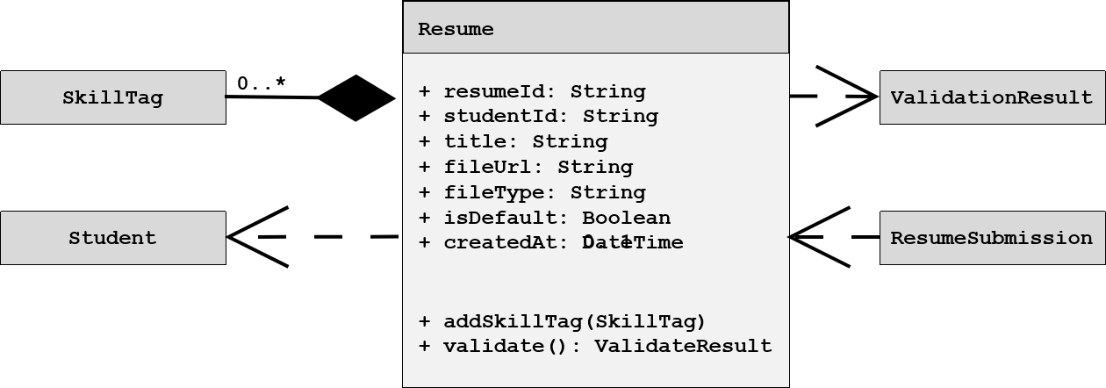

1.7.3-CD ResumeSubmission Class Diagram
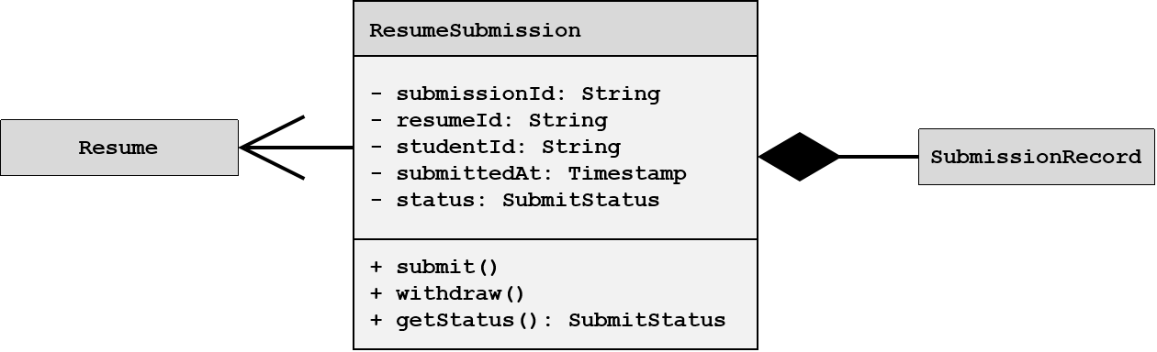

1.7.3-CD Update Resume Request Class Diagram
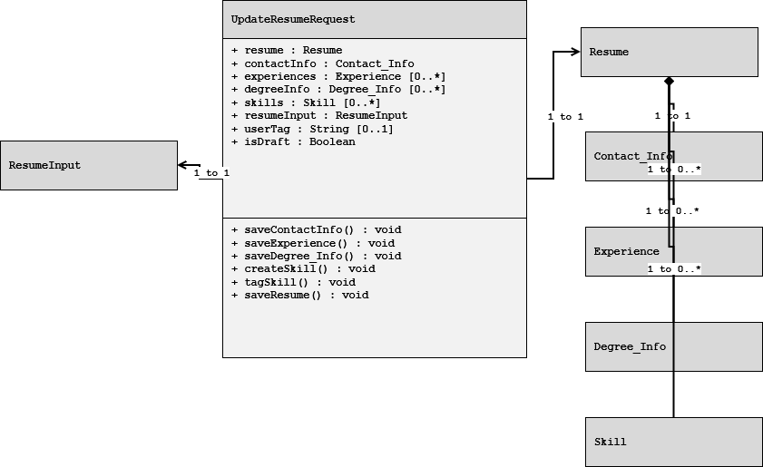

1.7.3-CD Skill Class Diagram
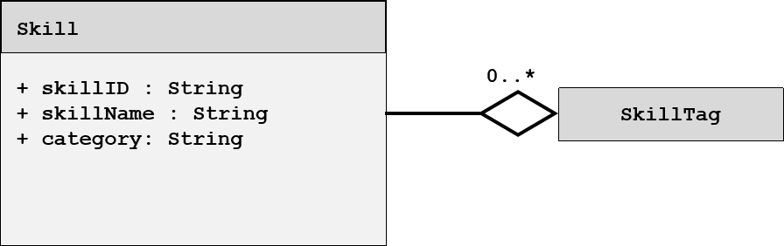

1.7.3-CD SkillTag Class Diagram
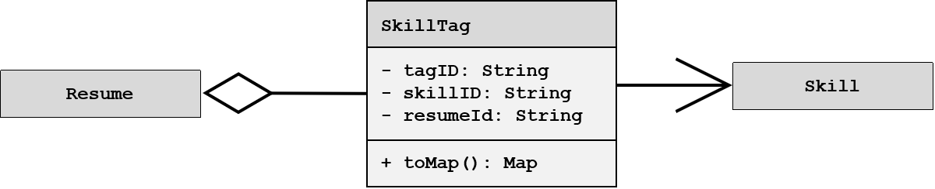

1.7.3-CD Update Resume Response Class Diagram
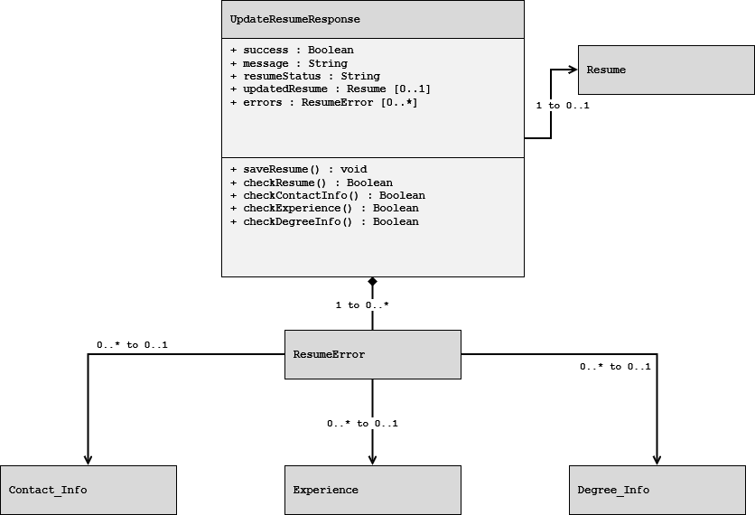

1.7.5-CD ValidationResult Class Diagram
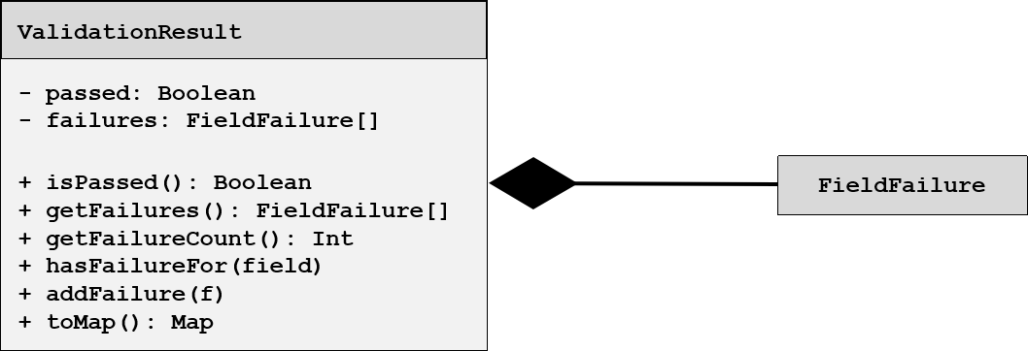

Class Diagrams – 1.9 Search Service

1.9.1-CD SearchController Class Diagram
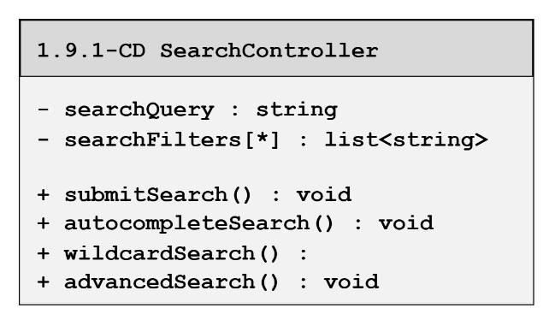

1.9.2-CD CandaditeSearch Class Diagram
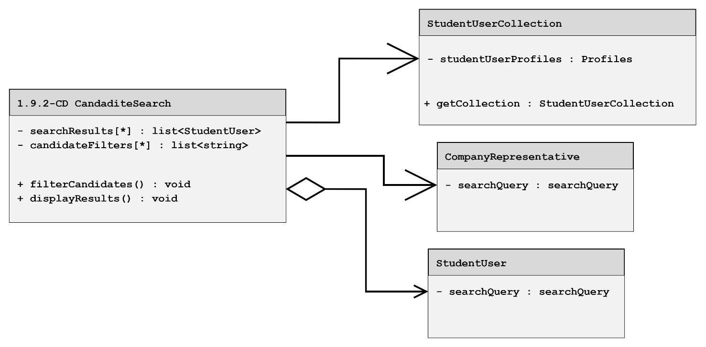

1.9.3-CD JobSearch Class Diagram
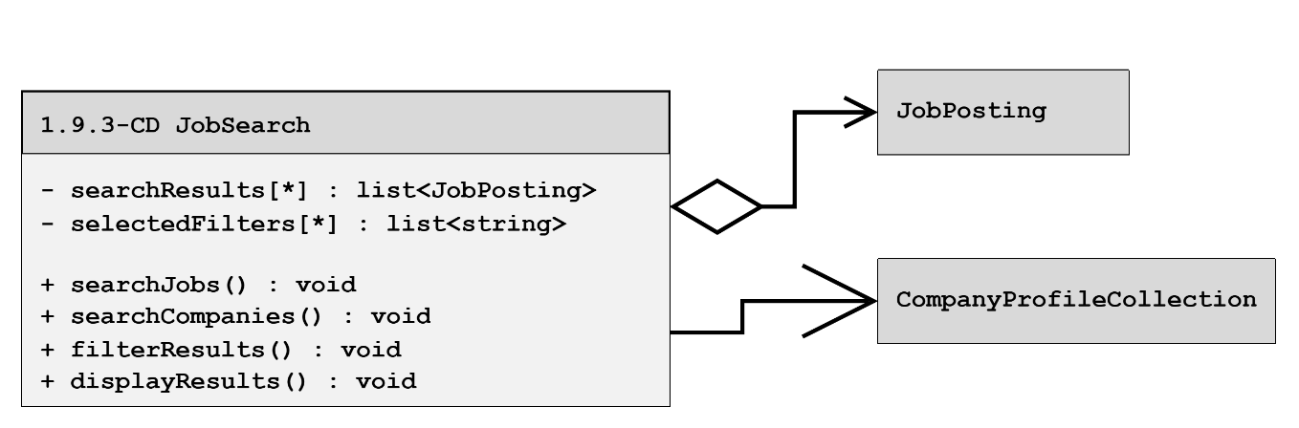

1.9.4-CD CompanySearch Class Diagram
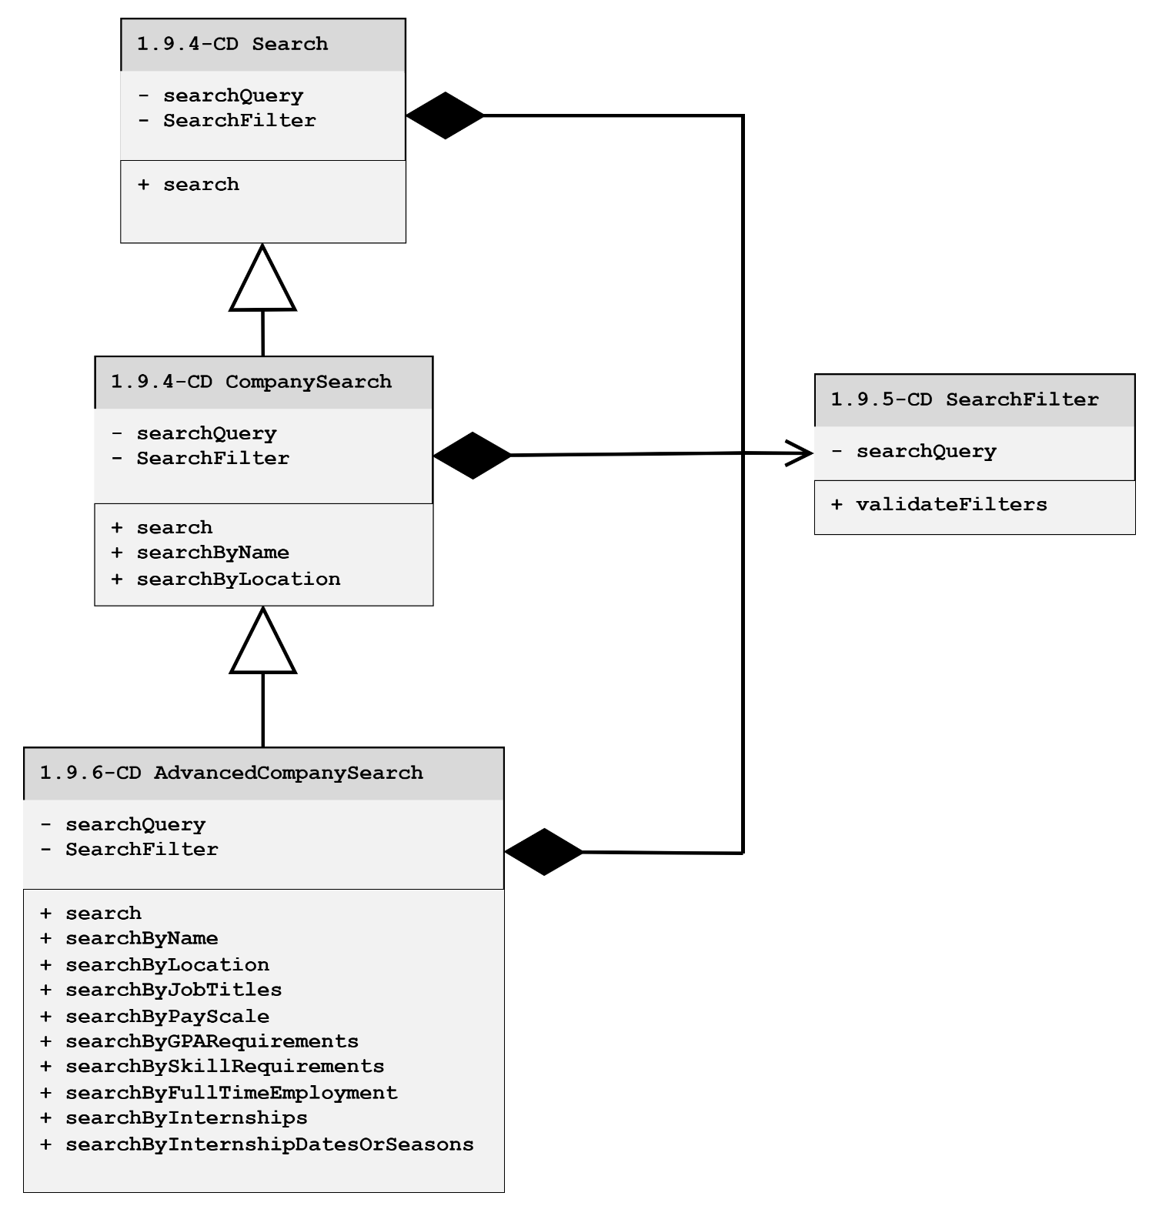

1.9.6 – CD AdvancedCompanySearch Class Diagram
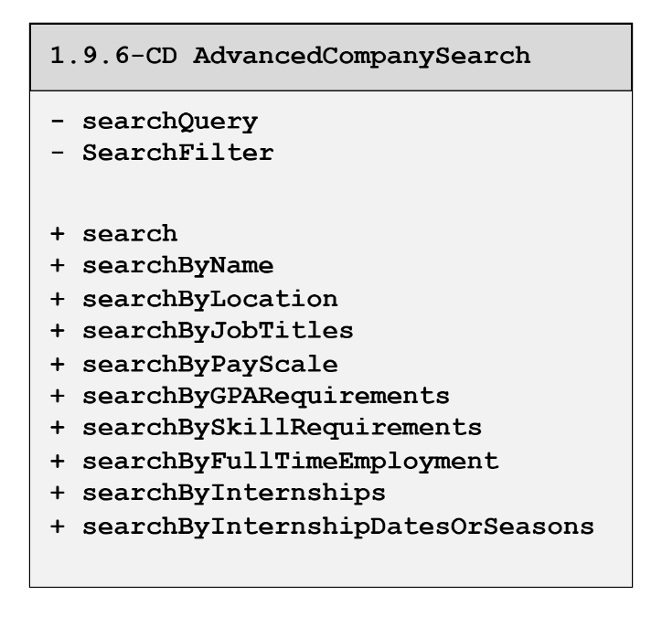

1.9.7-CD WildcardSearch Class Diagram
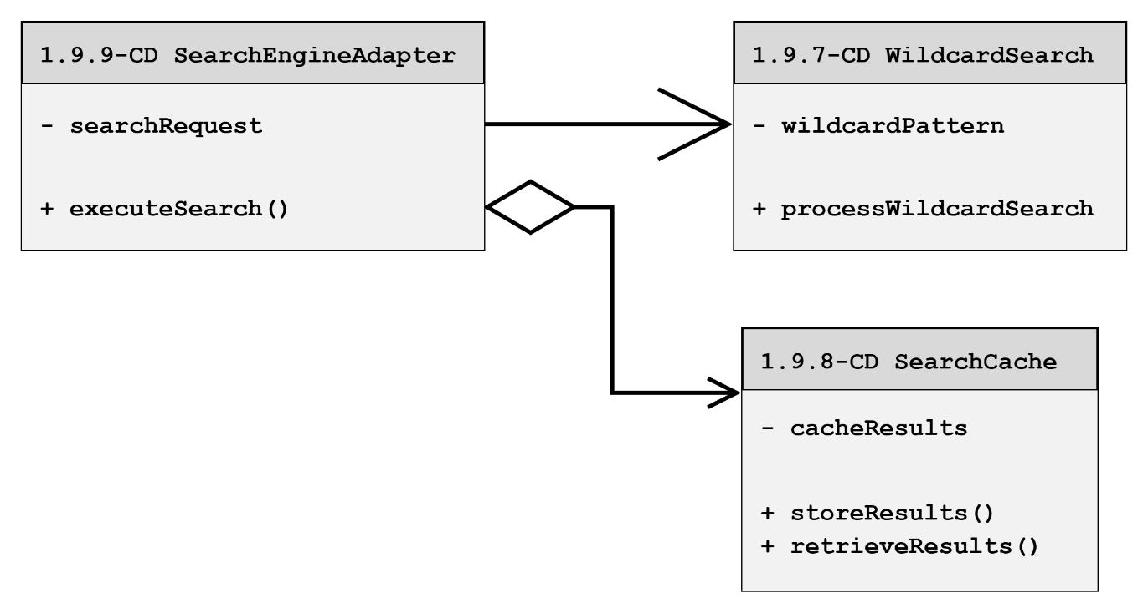

1.9.9-CD SearchEngineAdapter Class Diagram
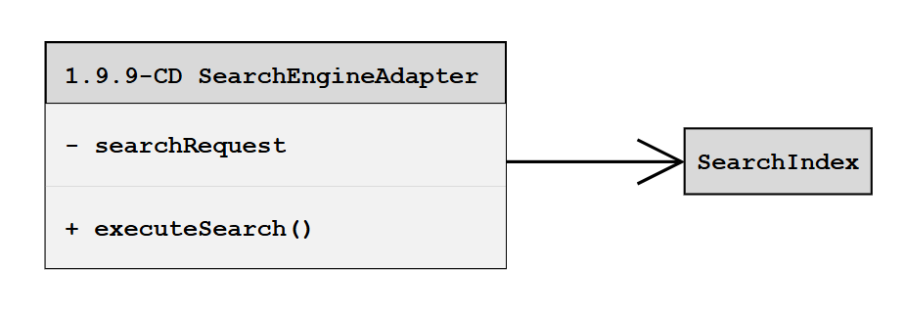

1.9.10-CD SearchEngine Class Diagram
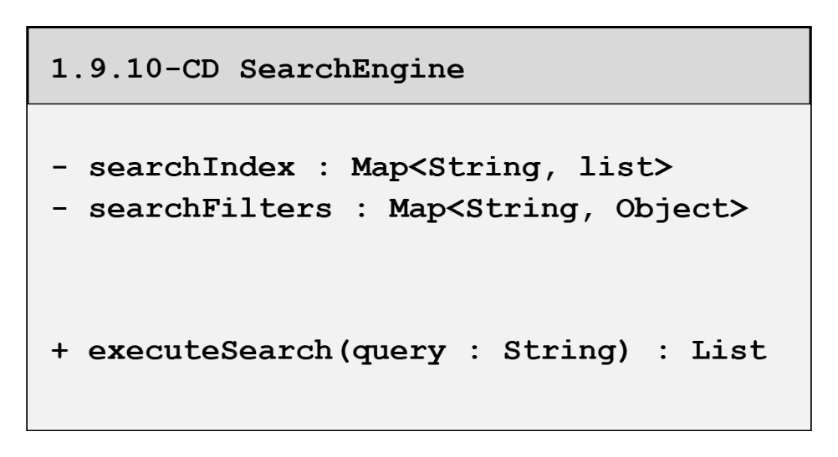

1.9.11-CD Autocomplete Class Diagram
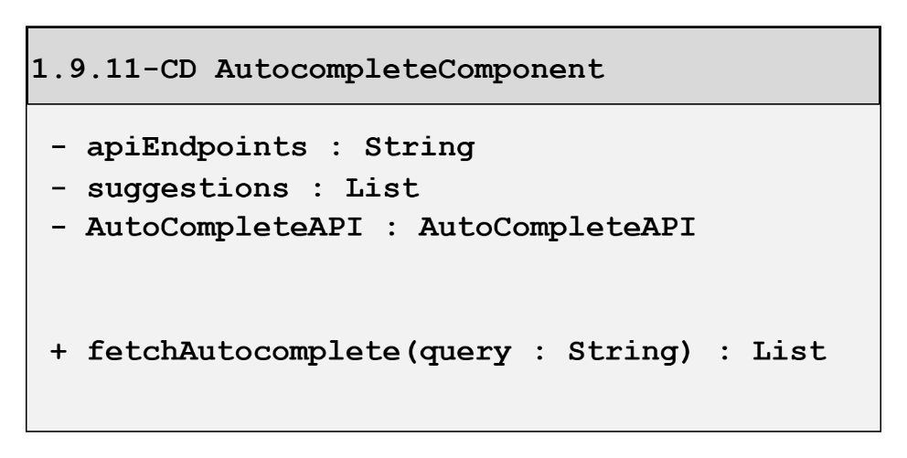

1.9.12-CD ResultsRanker Class Diagram
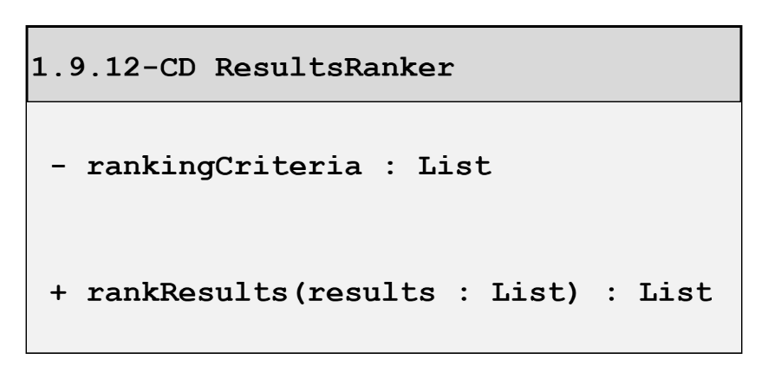

Class Diagrams – 1.10 Communication Services

1.10.1 Event Listener Class Diagram
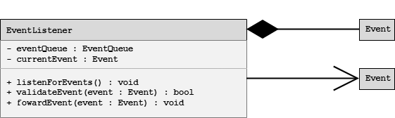

1.10.2 Notification Controller Class Diagram
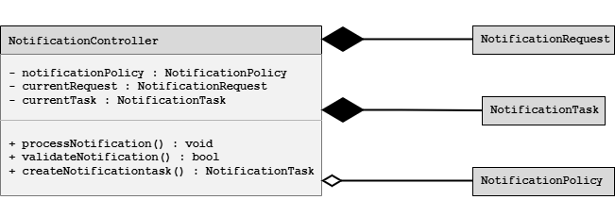

1.10.3 Notification Orchestrator Class Diagram
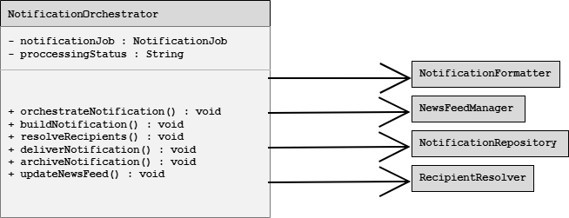

1.10.4-CD Notification Formatter Class Diagram
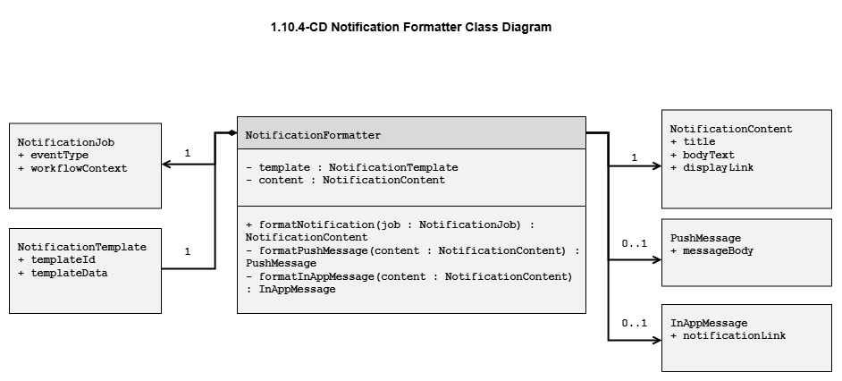

1.10.5-CD Notification Repository Class Diagram
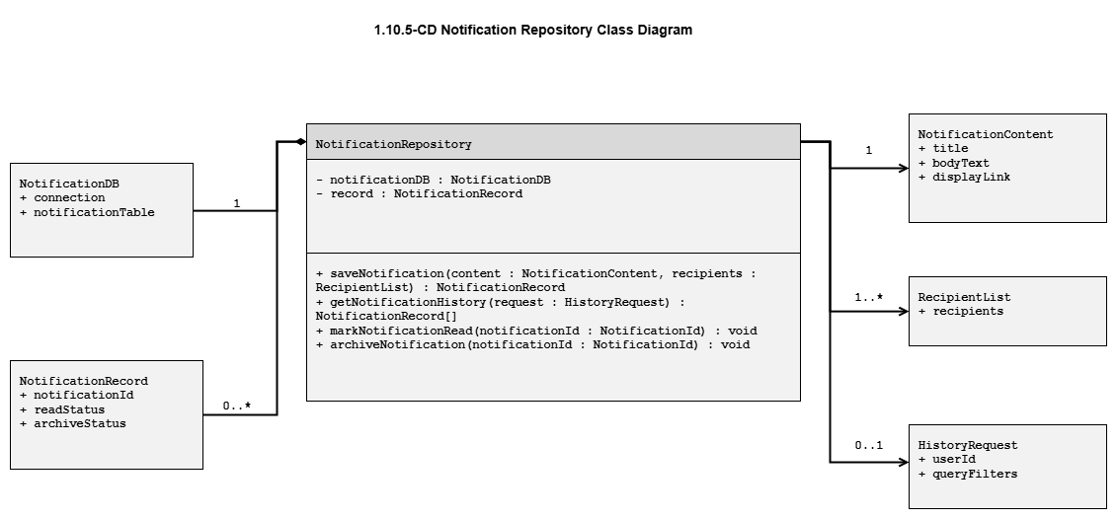

1.10.6-CD Recipient Resolver Class Diagram
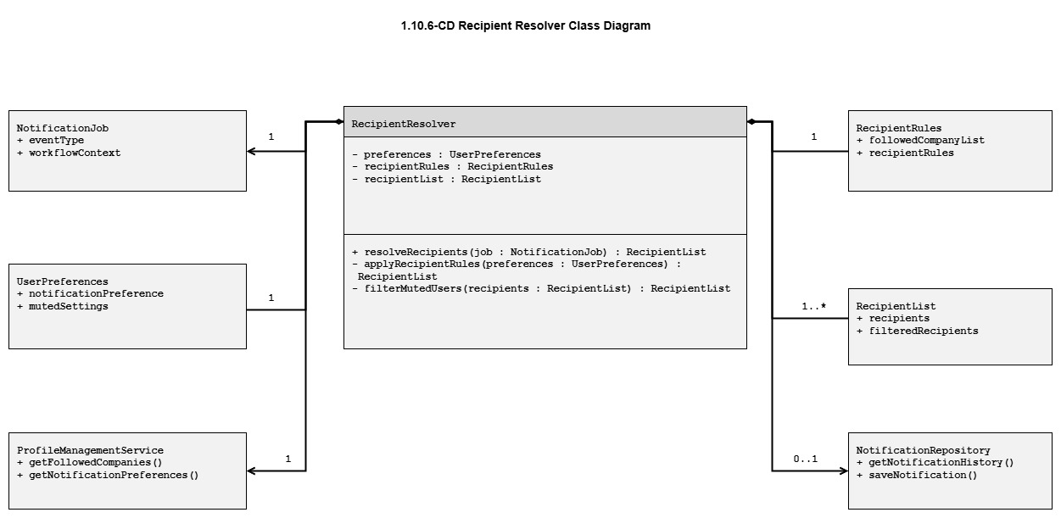

Class Diagrams – 1.11 Recommendation Service

1.11.2-CD CandidateRecommender Class Diagram
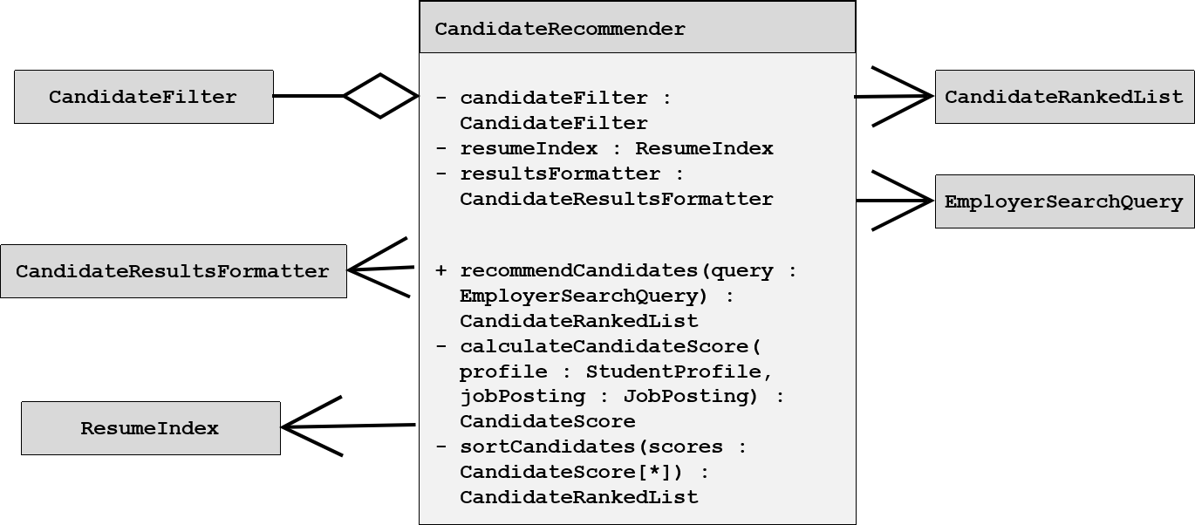

1.11.1-CD JobPosting Class Diagram
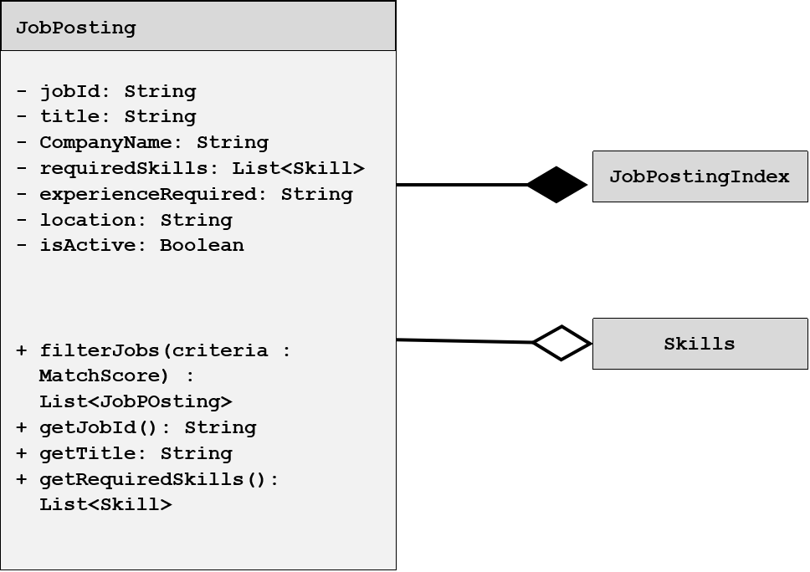

1.11.2-CD CandidateFilter Class Diagram
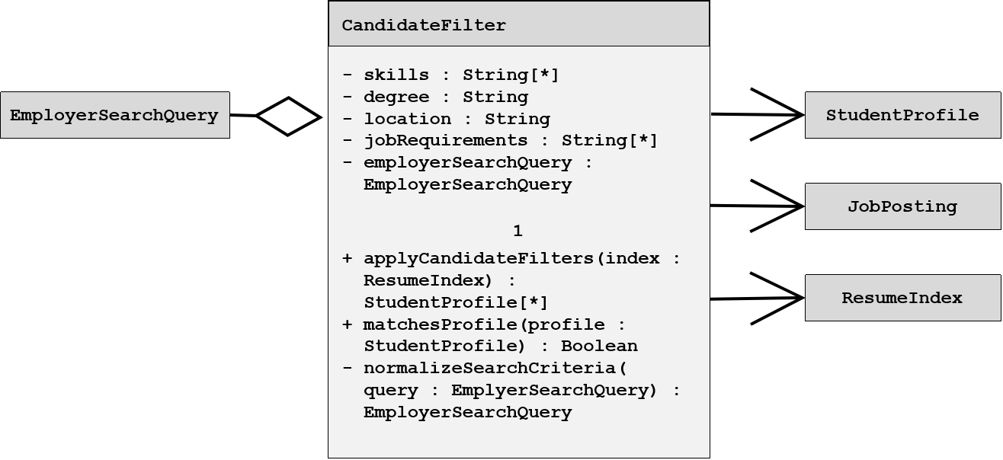

1.11.5-CD Recommendation Class Diagram
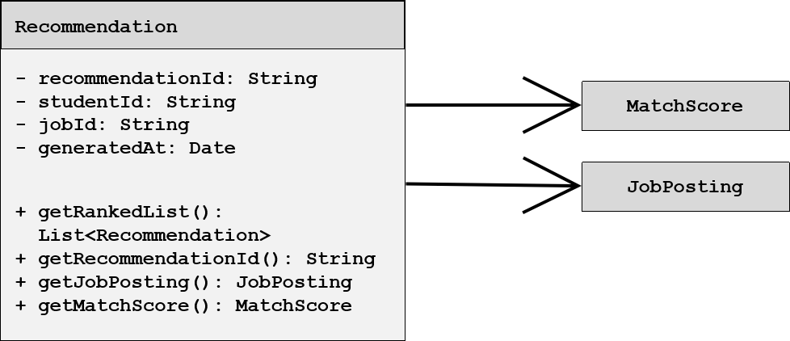

1.11.5-CD StudentProfile Class Diagram
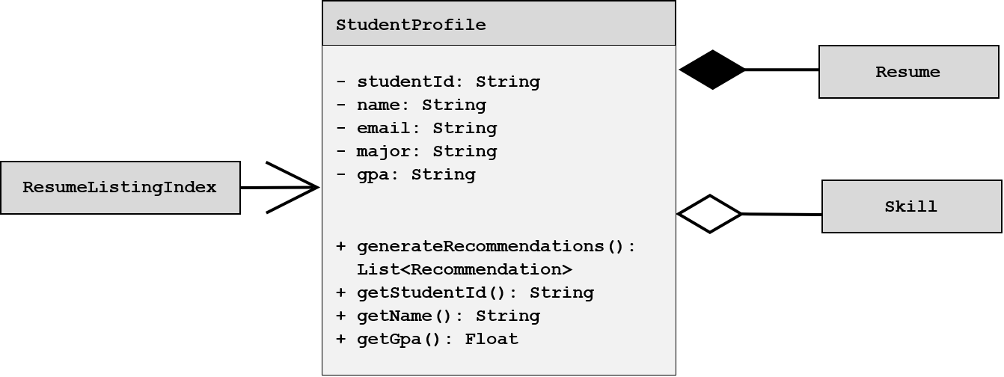

Class Diagrams – 1.12 External Services

1.12-CD External Services Orchestrator Class Diagram


1.12.1-CD USPS Address Validation Adapter Class Diagram
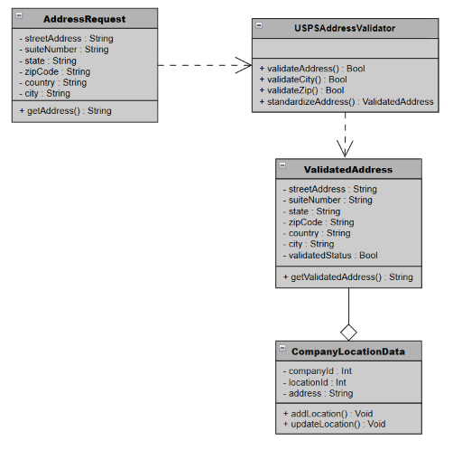

1.12.1-CD Profile and Resume Engagement
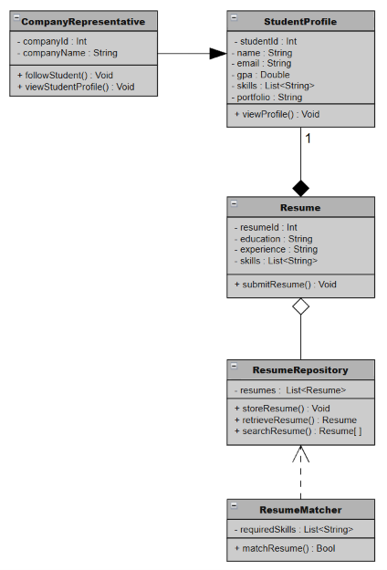

1.12.2-CD Autocomplete API Adapter Class Diagram
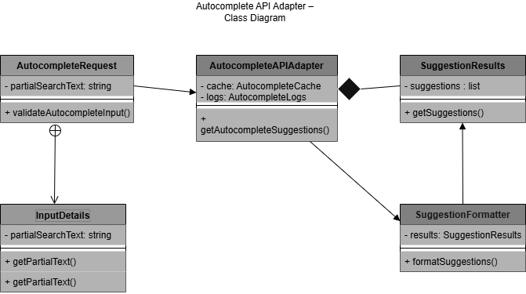

1.12.3-CD Push Notification Gateway
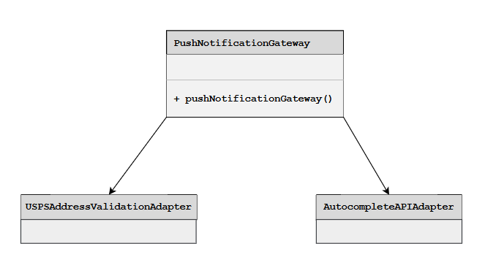

Class Diagrams – 1.13 Analytics Service

1.13-CD Analytics Orchestrator Class Diagram
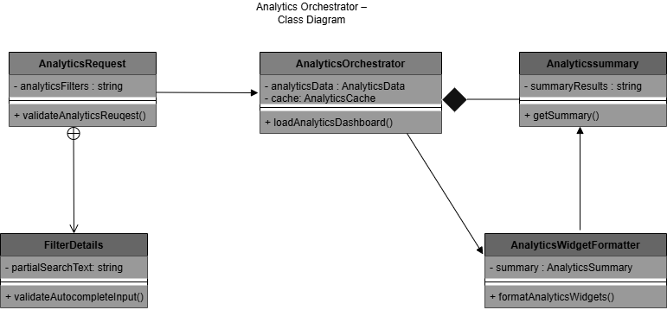

1.13.1-CD JobPostingManager Class Diagram
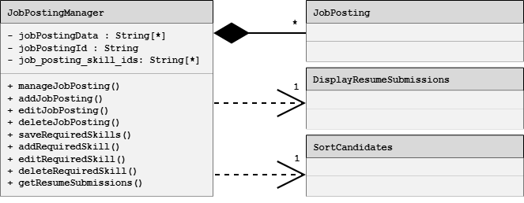

1.13.2-CD CandidateSearchManager Class Diagram
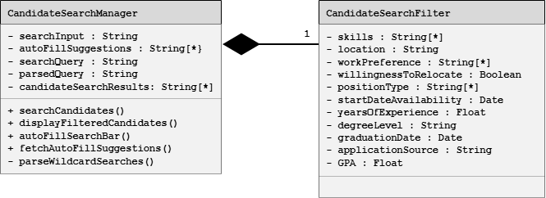

1.13.4-CD Notification and News Feedback Analytics
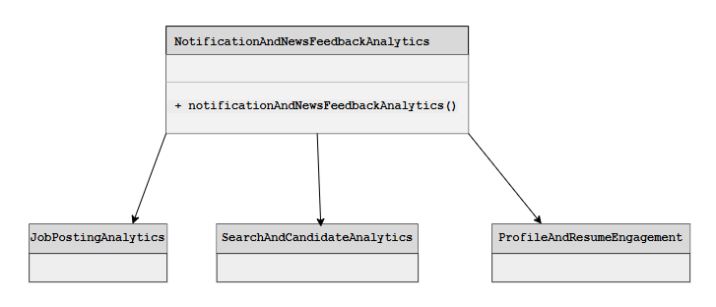

1.13.5-CD Performance Monitor Class Diagram
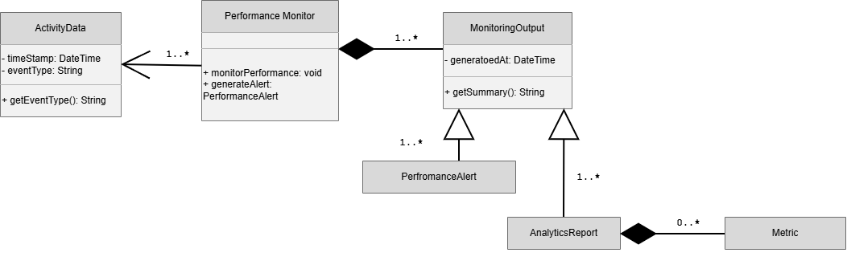

  - Database Design

CreateJobPostingRequest Database Table
Field | Data Type | Required | Description
title | String | Yes | Title of the job posting
companyId | String | Yes | Unique identifier of the company creating the posting
location | String | Yes | Location where the job is based
employmentType | String | Yes | Type of employment (e.g., Full-Time, Part-Time, Internship)
salaryMin | Number | No | Minimum salary or hourly wage offered
salaryMax | Number | No | Maximum salary or hourly wage offered
description | String | Yes | Detailed description of the job responsibilities
requirements | Array of Strings | No | List of qualifications and requirements for applicants
applicationDeadline | Date | No | Final date applications will be accepted
saveAsDraft | Boolean | No | Indicates whether the posting should be saved as a draft instead of published

CreateJobPostingResponse Database Table
Field | Data Type | Required | Description
success | Boolean | Yes | Indicates whether the job posting was created successfully
message | String | Yes | Human-readable status message
jobId | String | Yes | Unique identifier assigned to the new job posting
title | String | Yes | Title of the created job posting
companyId | String | Yes | Identifier of the company associated with the posting
status | String | Yes | Current status of the posting (e.g., Active, Draft)
createdAt | DateTime | Yes | Timestamp indicating when the posting was created

UpdateJobPostingRequest Database Table
Field | Data Type | Required | Description
jobPostingId | Integer | Yes | Identification number in database
companyName | String | No | Official name of the company
jobTitle | String | No | Position title
requiredSkills | String array | No | Skills required for the job
jobDescription | String | No | Information about what the job implies
hours | String | No | Time that has to be devoted to work
positionType | String | No | Type of contract
compensation | String | No | Salary amount
location | String | No | Physical address of the place of work
contactInformation | String | No | Phone numbers and emails to enquire about the job
linksToApply | String | No | Links to apply online

UpdateJobPostingResponse Database Table
Field | Data Type | Required | Description
HTTP Header | String | Yes | Information about the content type, the status code of the update
Response Body | JSON | Yes | It depends on status code and it might include id of the updated record with updated fields. It might also include information modified or generated by the server.

JobSearchRequest Database Table
Field | Data Type | Required | Description
keywords | String | No | Words or phrases entered by the user to search job postings.
location | String | No | City, region, or remote preference used to filter jobs.
category | String | No | Job category or industry filter.
employmentType | String | No | Type of employment such as full-time, part-time, or internship.
salaryMin | Decimal | No | Minimum salary value requested by the user.
salaryMax | Decimal | No | Maximum salary value requested by the user.
pageNumber | Integer | Yes | Page number for paginated search results.
pageSize | Integer | Yes | Number of job results requested per page.
sortBy | String | No | Sort option such as relevance, datePosted, or salary.

JobSearchResponse Database Table
Field | Data Type | Required | Description
searchId | UUID | Yes | Unique identifier for the search transaction.
totalResults | Integer | Yes | Total number of matching job postings found.
pageNumber | Integer | Yes | Current page number returned in the response.
pageSize | Integer | Yes | Number of job postings included in the response page.
jobs | Array<JobSummary> | Yes | List of job postings matching the search criteria.
status | String | Yes | Result status such as success or noResults.
message | String | No | Additional information about the search result.

CandidateSearchRequest Database Table
Field | Data Type | Required | Description
companyId | UUID | Yes | Unique identifier of the company representative initiating the search request.
searchQuery | String | No | Text search term targeting student profiles and resumes.
filters | Object | No | Collection of filters selected by the representative.
filters.skills | Array<String> | No | Technical or soft skills listed on profile.
filters.major | String | No | Major or field of study listed on profile.
filters.gpa | Float | No | Minimum GPA filter listed on profile.
pageNumber | Integer | Yes | Page number for paginated search results.
pageSize | Integer | Yes | Number of student profile results requested per page.

CandidateSearchResponse Database Table
Field | Data Type | Required | Description
searchId | UUID | Yes | Unique identifier for the search transaction.
totalResults | Integer | Yes | Total number of matching student profiles found.
pageNumber | Integer | Yes | Current page number returned in the response.
pageSize | Integer | Yes | Number of student profiles included in the response page.
students | Array<StudentSummary> | Yes | List of student records matching criteria
status | String | Yes | Result status such as success or noResults.
message | String | No | Additional information about the search result.

  - File Format Specifications
This section describes any files the system stores or exchanges.

  - Network Protocol / API Message Specifications
Career Bound uses a RESTful API architecture over HTTPS.

All client-to-server and service-to-service communication is performed using HTTP request and response messages. API payloads are encoded using JSON.

Supported HTTP methods include:
- GET
- POST
- PUT
- DELETE

Authentication tokens are transmitted using HTTPS-secured headers. API responses are encoded using JSON message formats defined in the API Message Specifications that follow.

