1.4.11-CD ExternalServicesOrchestrator Class Diagram

Renamed: 1.12-CD External Services Orchestrator Class Diagram
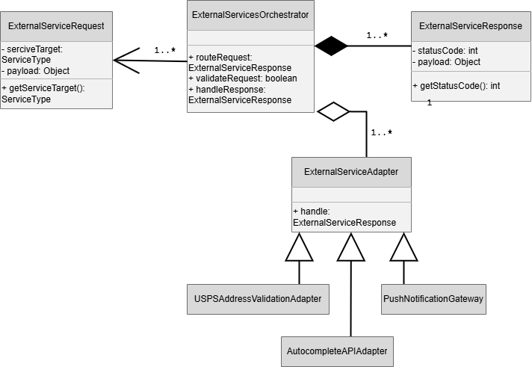

1.13.5-CD Performance Monitor Class Diagram
