1.2.5 & 1.3.5-CD Form / Input Validation
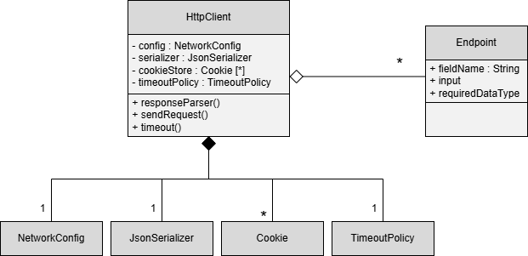
Corrected Heading:
1.2.5 & 1.3.5-CD API Request Processing Class Diagram

