1.2.3 & 1.3.3-CD Form / Input Validation
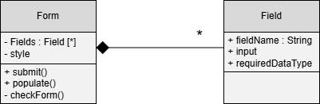
Corrected Heading:

1.2.3 & 1.3.3-CD Form Class Diagram

