2.5.1 – 2.5.9-CD JobPosting Class Diagram
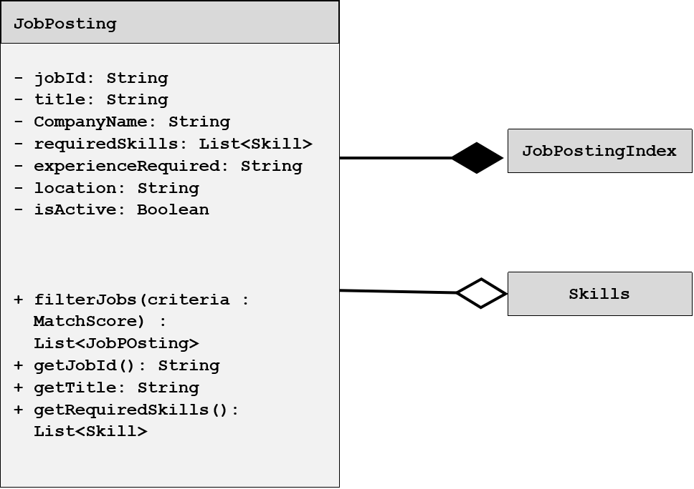

2.3.7, 3.3.3-CD Recommendation Class Diagram

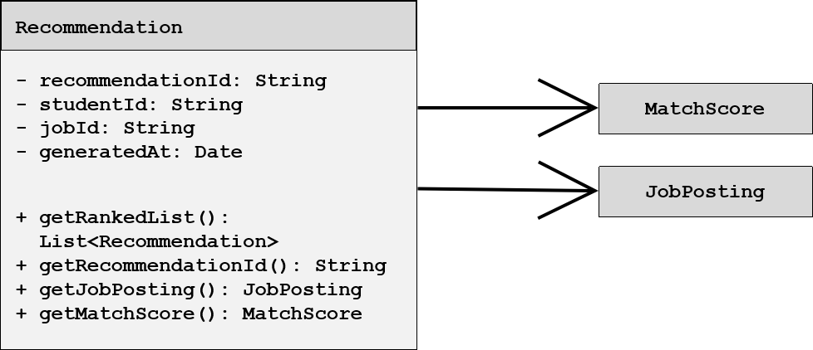

3.1.1 – 3.1.3.4-CD StudentProfile Class Diagram
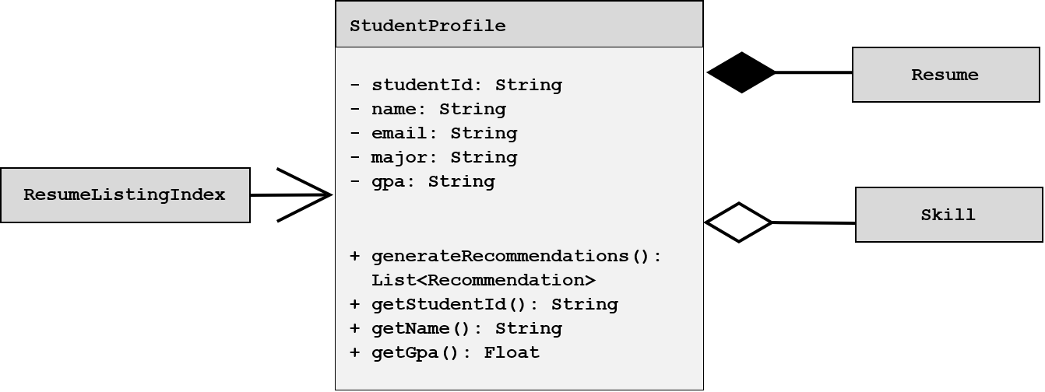

1.7.1-CD Resume Class Diagram

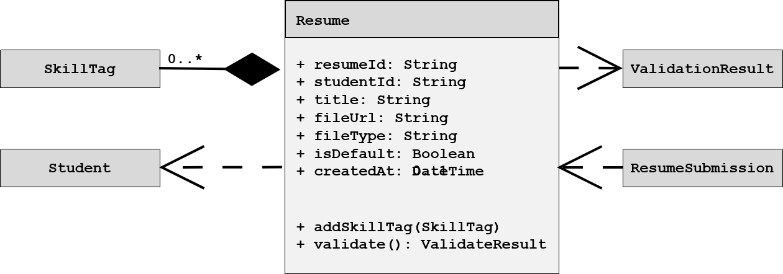

1.7.3-CD Skill Class Diagram

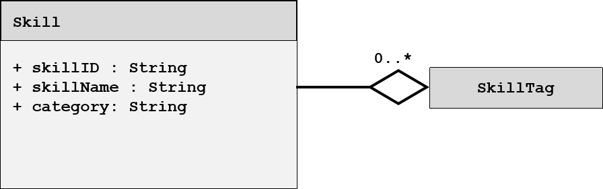

1.7.3-CD SkillTag Class Diagram

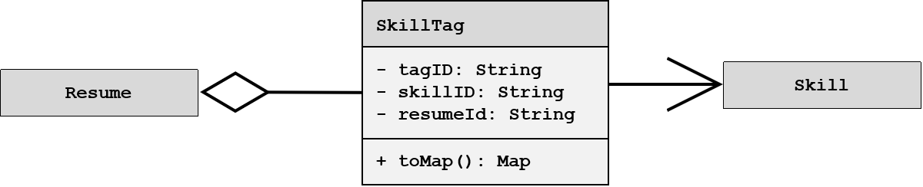

1.7.3-CD ResumeSubmission Class Diagram

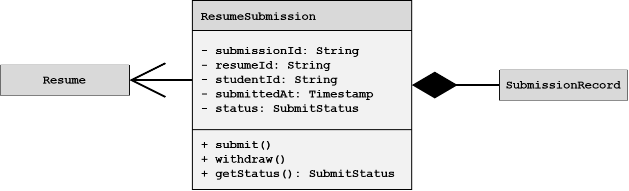

1.7.5-CD ValidationResult Class Diagram

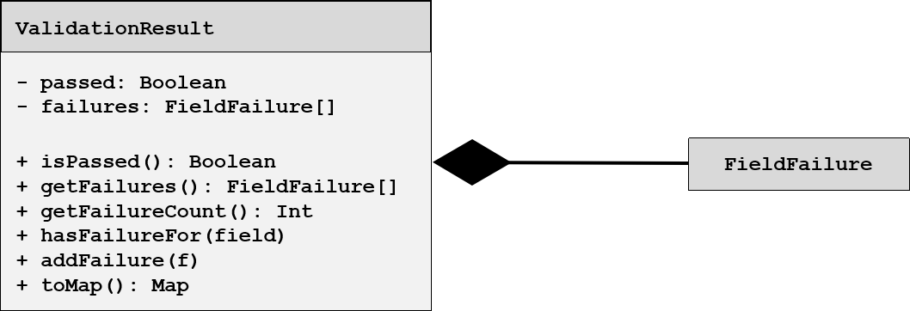

1.11.2-CD CandidateRecommender Class Diagram

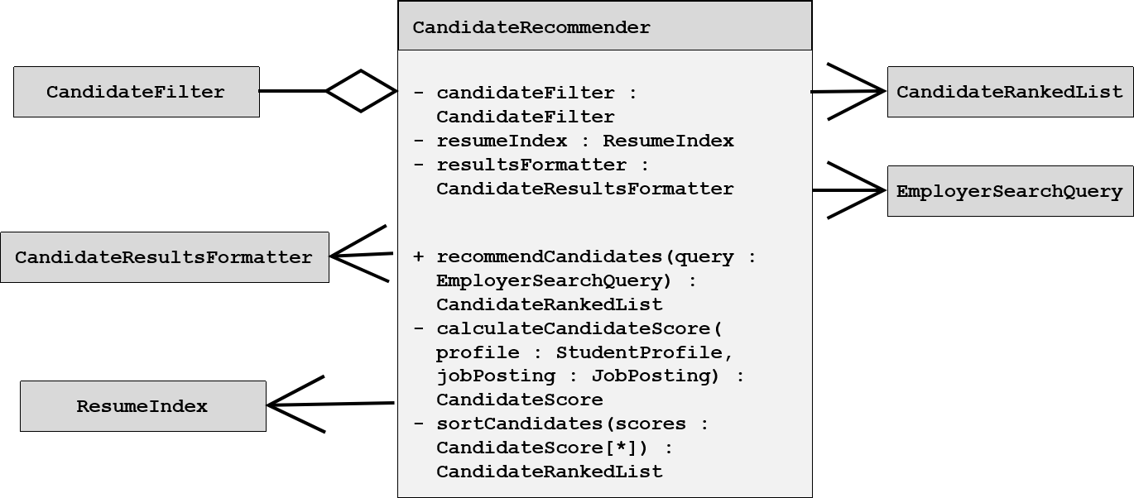

1.11.2-CD CandidateFilter Class Diagram

