1.13.5-ALG PerformanceMonitor() Algorithm
Purpose:
This algorithm reads activity data, analyzes it, and creates a report or an alert for it.

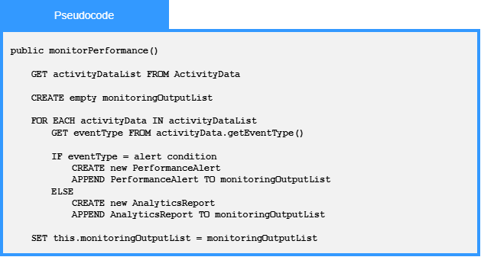

Local Data:
monitoringOutputList : List<MonitoringOutput>
activityData : ActivityData
eventType : String

