1.13.2-ALG parseWildcardSearches() Algorithm
Purpose:
This algorithm parses the searchQuery to make the parsedQuery.

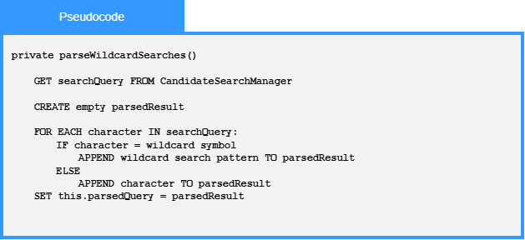

Local Data:
parsedResult : String

