1.13.2-ALG autoFillSearchBar() Algorithm
Purpose:
This algorithm takes the input that the user has typed up and displays a complete suggestion.

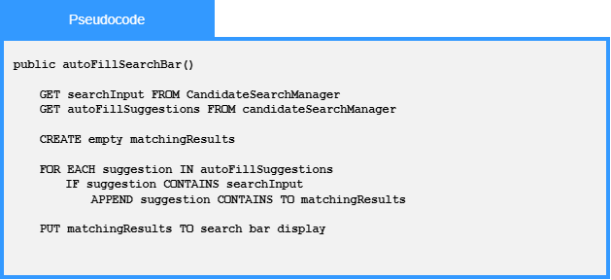

Local Data:
matchingResults : List<string>

