1.10.7-ALG deliverPushNotification() Algorithm
Purpose:
Sends a routed notification to the recipient's device through the push service client. It looks up the device token, attempts delivery with a bounded number of retries, records the outcome in the delivery log, and returns a DeliveryResult describing whether the push succeeded.
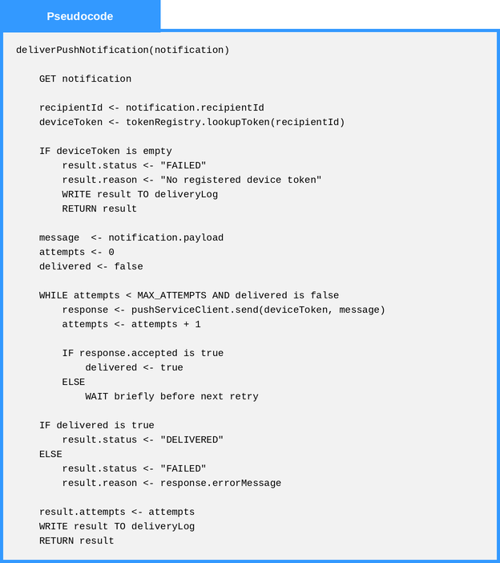
Local Data:
deviceToken : Text
message : NotificationPayload
attempts : Number
delivered : Boolean
result : DeliveryResult

1.10.7-ALG routeToService() Algorithm
Purpose:
Selects the correct delivery channel and service target for an incoming routing request and packages the request into a RoutedNotification. If no channel is requested, it chooses push when notifications are available and falls back to in-app delivery otherwise.
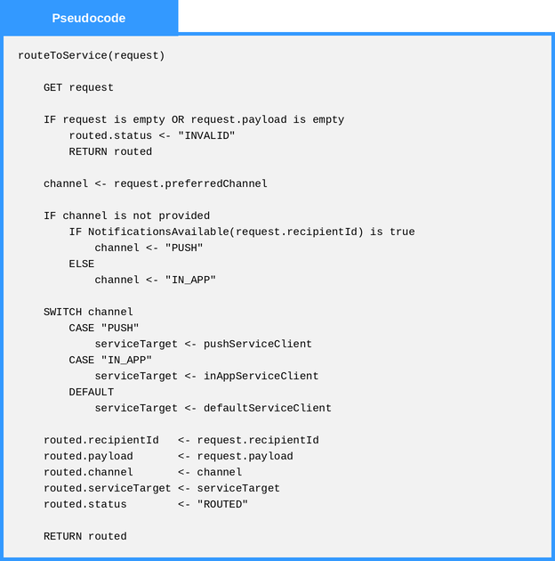
Local Data:
channel : Text
serviceTarget : ServiceClient
routed : RoutedNotification

1.10.8-ALG retrieveFeedItems() Algorithm
Purpose:
Reads a user's feed items from the feed repository, filters them by the category and unread criteria carried on the request, sorts the results newest-first, applies the requested item limit, and returns the assembled FeedItemList.
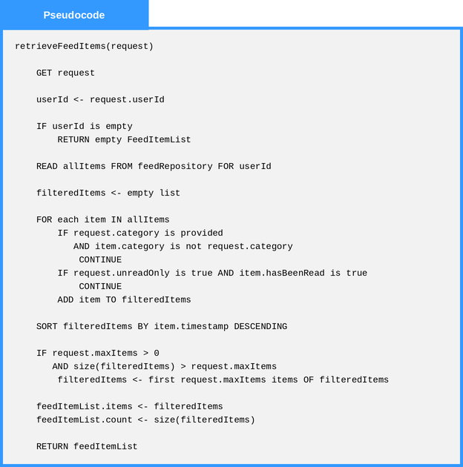
Local Data:
allItems : List of FeedItem
filteredItems : List of FeedItem
feedItemList : FeedItemList

