1.2.1 & 1.3.1-ALG updateView() Algorithm
Purpose:
Determines which view should be shown and updates navigation state.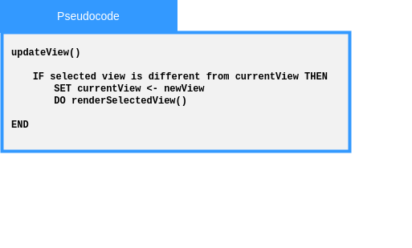

Local Data:
newView : View
currentView : View

1.2.1 & 1.3.1-ALG selectNavigationTarget() Algorithm
Purpose:
Determines the correct target view from a selected menu/button action.
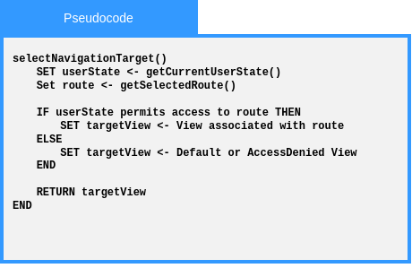
Local Data:
userState : State
route : Route

1.2.2 & 1.3.2-ALG onInit() Algorithm
Purpose:
Performs initial view setup when a page/view loads.
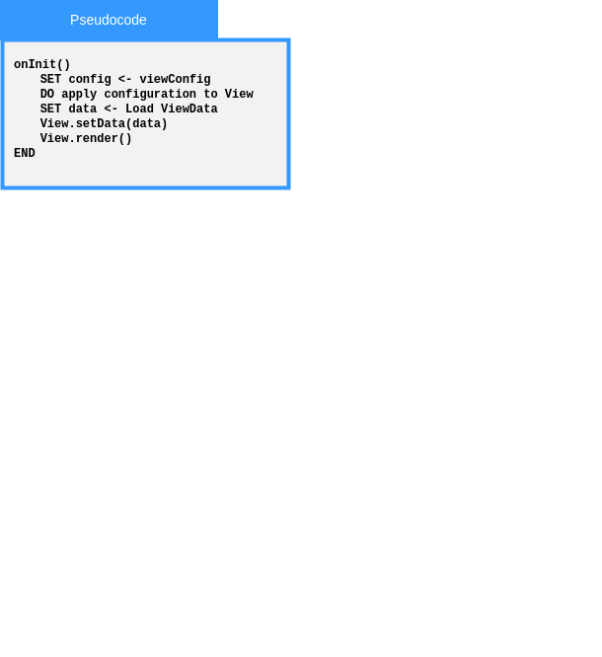
Local Data:
config : Config
data : ViewData

1.2.2 & 1.3.2-ALG renderSelectedView() Algorithm
Purpose:
Coordinates rendering after navigation or state change.

Local Data:

1.2.2 & 1.3.2-ALG render() Algorithm
Purpose:
Displays view content and coordinates rendered UI components.

Local Data:

1.2.3 & 1.3.3-ALG submitForm() Algorithm

Purpose:
Coordinates the full form submission workflow.
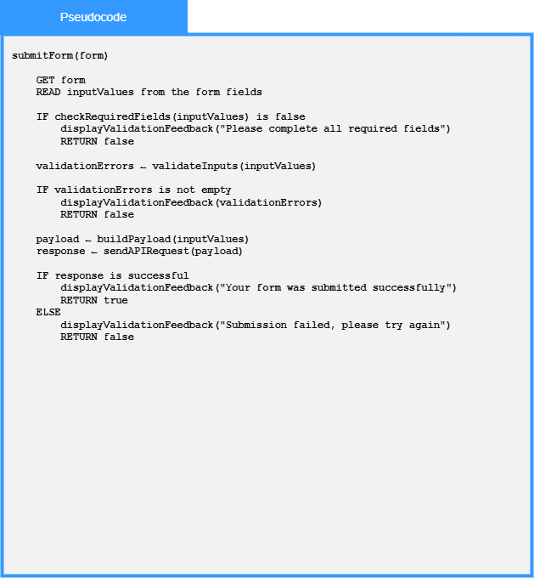
Local Data:
form : HTML DOM Object
inputValues : list of Strings

1.2.3 & 1.3.3-ALG validateInputs() Algorithm
Purpose:
Performs validation across submitted inputs.
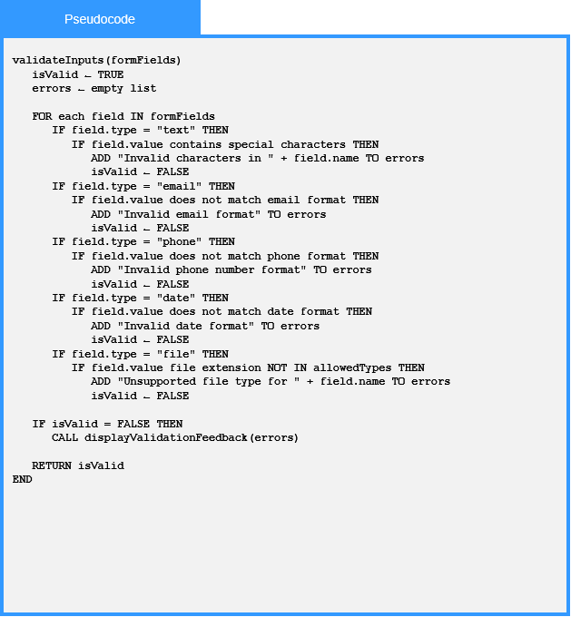
Local Data:
isValid : Boolean
field : HTML DOM Object

1.2.3 & 1.3.3-ALG checkRequiredFields() Algorithm
Purpose:
Checks whether mandatory fields are completed.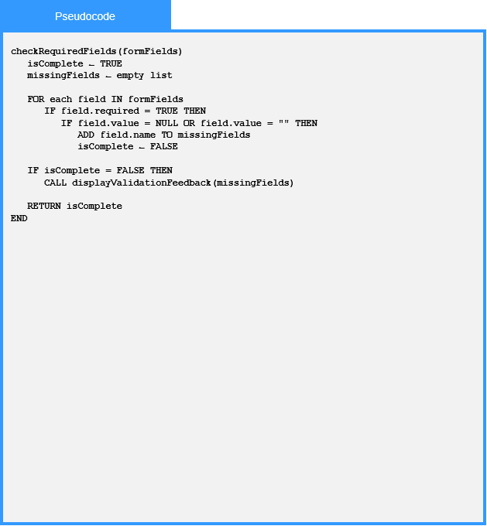

Local Data:
field : HTML DOM Object
isComplete : Boolean

1.2.3 & 1.3.3-ALG buildPayload() Algorithm
Purpose:
Converts form data into a request payload.
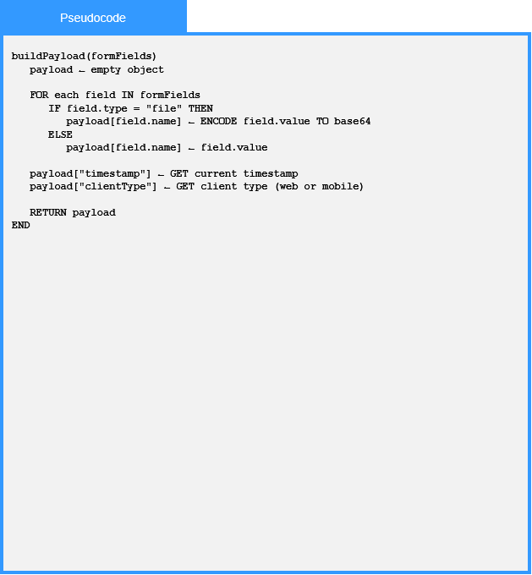
Local Data:
Purpose:
Checks whether mandatory fields are completed.

Local Data:

field : HTML DOM Object

1.2.3 & 1.3.3-ALG displayValidationFeedback() Algorithm
Purpose:
Displays errors or confirmation messages to the user.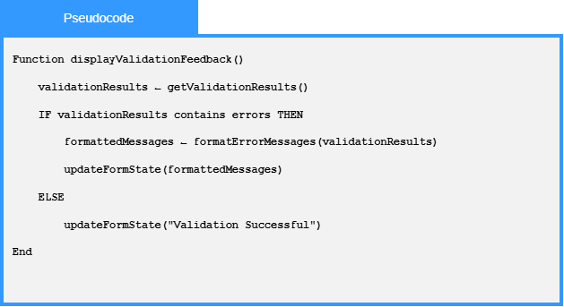
Local Data:
formattedMessages : List of Strings

1.2.4 & 1.3.4-ALG updateClientState() Algorithm
Purpose:
Updates stored client state after layout/accessibility changes.
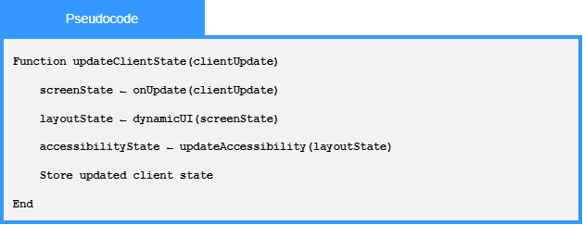
Local Data:
userId : Int
newSettings : Settings
settings : Settings
isValid : Boolean
currentDateTime : DateTime
updateResult : Boolean
errorMessage : String

1.2.4 & 1.3.4-ALG DynamicUI () Algorithm
Purpose:
Determines whether web or mobile layout rules should apply.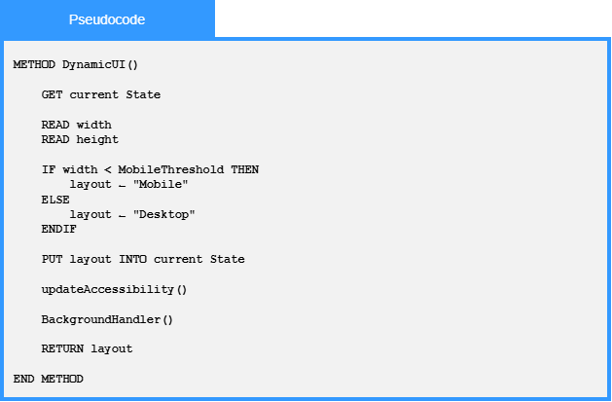Local Data:
currentState : State
width : int
height : int

1.2.4 & 1.3.4-ALG updateAccessibility() Algorithm
Purpose:
Applies accessibility preferences to the client UI. 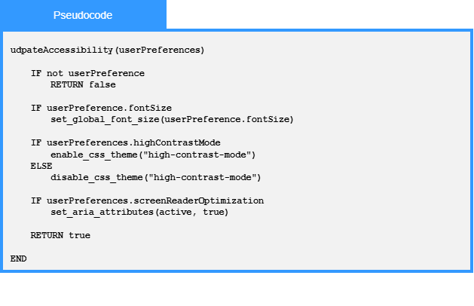Local Data:
userPreferences : Config

1.2.4 & 1.3.4-ALG sendAPIRequest() Algorithm
Purpose:
Coordinates request creation, sending, response parsing, and error handling.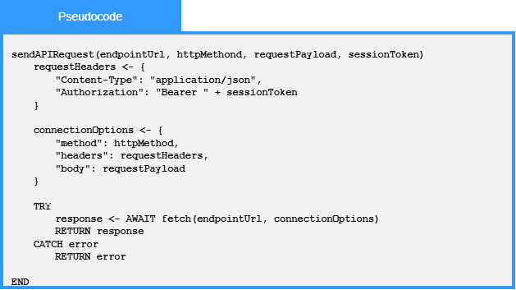Local Data:
requestHeaders : Dictionary
connectionOptions : Dictionary

1.2.4 & 1.3.4-ALG ResponseParser() Algorithm
Purpose:
Interprets API responses and extracts usable data..
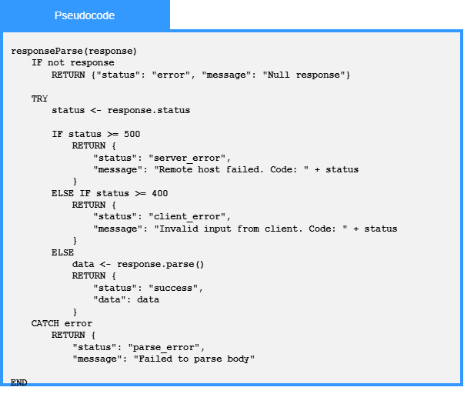
Local Data:
status : int

