1.5.1-ALG registerUser() Algorithm
Purpose:
The algorithm that takes the user input, puts it in a package, and sends it off to the corresponding database. Note: this algorithm DOES NOT verify the data.
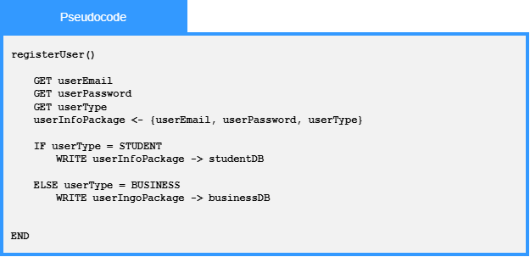

Local Data:
userEmail: string
userPassword: string
userType: enumeration
studentDB: external database connection
businessDB: external database connection

