3.1 Company Dashboard Screen

Desktop View

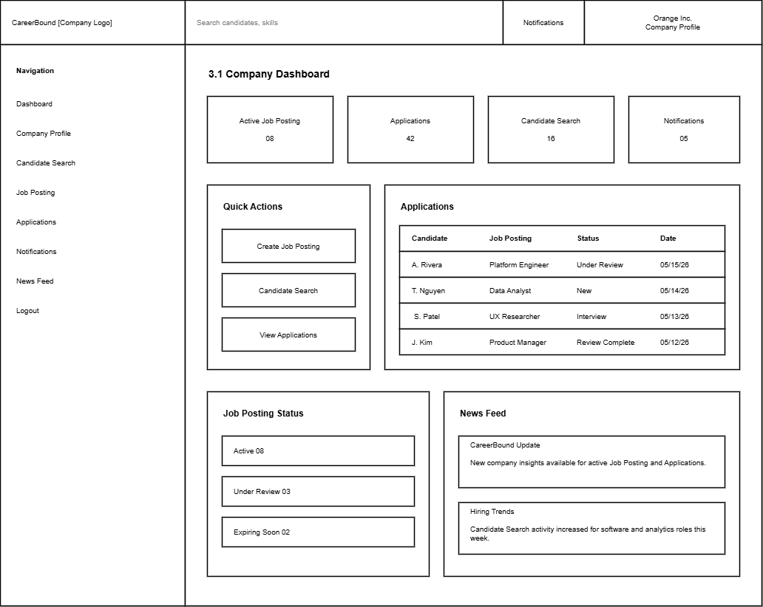
Mobile View – See Next Page

Mobile View


≡
CareerBound
Search Bar
Company Profile

Company Notifications

Search & Filter Features




News Feed


Applications


Job Postings

Design Info Table – See Next Page

Design Information

Field | Description / Purpose
View Name & Number | 3.1 – Company Dashboard Screen
Purpose / Design Concern | Company dashboard to help a company manage recruiting activity from desktop and mobile views.
Description | Provides a desktop and mobile view where company users can review job posting activity, applications, candidate search access, notifications, and company-related updates.
Requirements | Software Requirements Specification (SRS) for CareerBound:  2.1 Company Profile Page, 2.2 Notifications, 2.3 Search Features,  2.4 News Feed, 2.5 Job Postings  Reference: https://content.byui.edu/file/968cdd33-09eb-4430-99a4-131d25e138d4/1/Teach/SRS/430.SRS.CareerBound.pdf
Elements | Navigation menu: provides a company with a list of options to select from.
 | Search bar: provides a company the ability to search.
 | Company Profile area: provides a company with access to all company profile data.
 | Notifications area: provides a company with access to company notifications.
 | Candidate Search feature: provides a company the ability to search or filter job candidates.
 | Job Posting area: provides a company access to job postings.
 | Applications section: provides a company access to a list of candidates who have submitted job applications.
 | News Feed section: provides a company access to news feed options
 | Login / Logout: clicking the company logo provides a company with the ability to login or logout.
Inputs | Search query text, clicks on navigation items, clicks on quick action buttons, and selections related to applications or job postings.
Outputs | Company dashboard metrics, application status information, job posting status information, notifications, and news feed updates.
Navigation / References | 1.1 Login / Logout, 3.2 Candidate Search, 3.3 Job Posting Creation, 4.1 Notifications, 4.2 News Feed
Viewpoint | UI Wireframe / Mockup (Desktop & Mobile)

