1.1 Login / Logout Screen
Desktop View
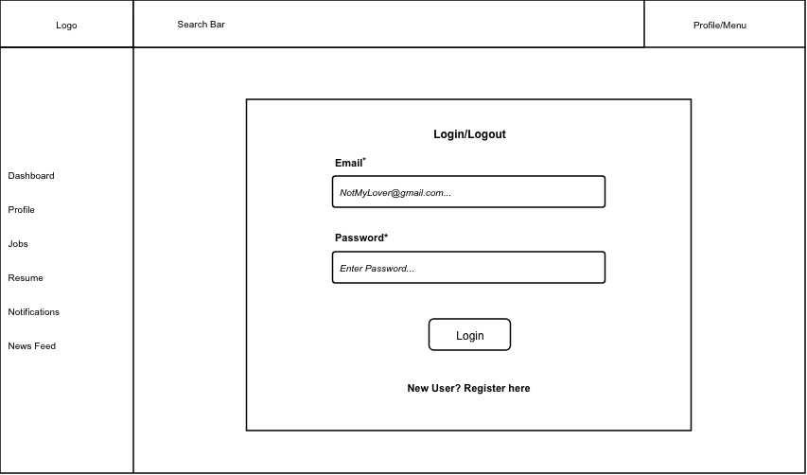

Mobile View
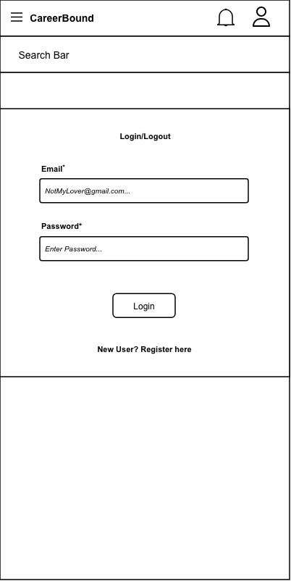
Design Information
Field | Description / Purpose
View Name & Number |  | 1.1 Login / Logout Screen
Purpose / Design Concern |  | Provides a way for students and companies to log into their profiles.
Description |  | A website page which displays a log in field for the user to input their email and password to authenticate themselves.
Requirements |  | Authentication requirements supporting all protected system functionality under Sections 2.x and 3.x
Elements |  | Email Field
 |  | Password Field
 |  | Login Button
 |  | Invalid Login Information Field
 |  | Registration Redirect Button
Inputs |  | Email and Password fields, Login button click, Register link click, Forgot Password link click.
Outputs |  | Redirect to Dashboard (2.1 for students, 3.1 for companies) if user log in was successful. Displays an error message if invalid credentials were provided.
Navigation / References |  | Student Dashboard 2.1, Company Dashboard 3.1, Registration 1.2
Viewpoint |  | UI Wireframe / Mockup (Desktop & Mobile).

