1.2 Registration Screen
Desktop View
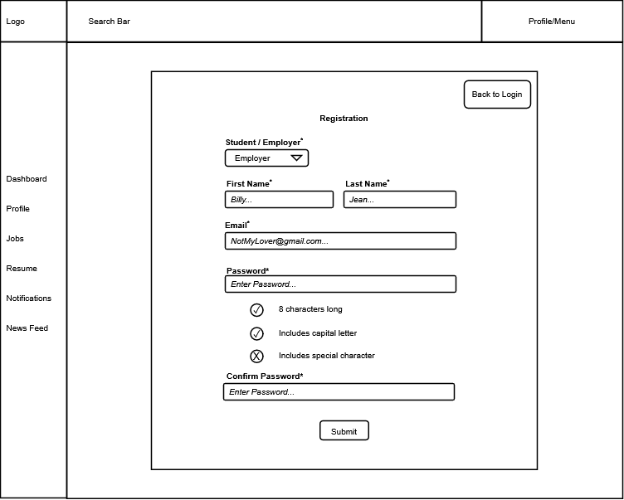

Mobile View
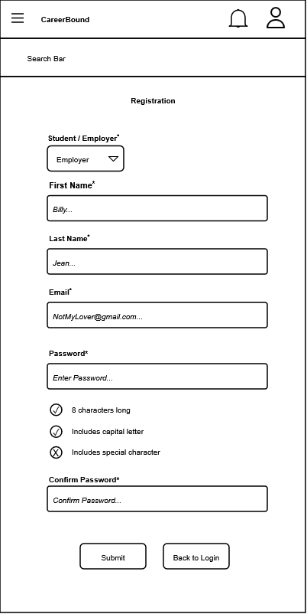
Design Information
Field | Description / Purpose
View Name & Number | 1.2 Registration
Purpose / Design Concern | Facilitates user account creation and role selection for new users.
Description | Displays a registration form allowing a user to select their role and establish account credentials.
Requirements | SRS 2.1 Company Profile Page, 3.1 Student User Profile
Elements | Back to Login button
 | Student / Employer role selection dropdown
 | Text fields
 | Password validation checklist
 | Submit button
Inputs | Role selection, First Name string, Last Name string, Email string, Password string, Confirm Password string, Submit action.
Outputs | Visual feedback on password requirement validation (status icons for "8 characters long", "Includes capital letter", and "Includes special character").
Navigation / References | 1.1 Login / Logout (accessed via "Back to Login" button).  2.1 Student Dashboard or 3.1 Company Dashboard upon successful submission.
Viewpoint | UI Wireframe / Mockup (Desktop & Mobile).

