For a Reference of where this is going you can see the SWDD-template_v2 document in the 01_Standards/Templates folder.

Starting Requirements Tracing
The following table provides a cross-reference that traces each major component in the system architecture to the specific SRS requirements it fulfills.

SRS Requirements Mapping Table

Component | SRS Sections / Requirements It Directly Supports
Client Applications  (Parent) | • 1.2 Application Scope (web and mobile interfaces that share the same features)  • Overall client-side architecture, shared UI patterns, role-based views, and coordination between web and mobile clients
Web Client | • Primary web-based user interface (browser UI)  • Implements all web UI elements for Company and Student features (sections 2.x and 3.x)  • Profile pages, search bar, forms, news feed display, notifications display, resume form, job browsing, etc. (1.2.1)
Mobile Client | • Mobile application user interface  • Implements the same features and characteristics as the Web Client (per SRS 1.2.1)  • Mobile-optimized UI for all features in sections 2.x and 3.x (profiles, search, news feed, notifications, resume form, job browsing, etc.)
API Gateway / Orchestrator | • Cross-cutting orchestration for all client–service communication (implicit in 1.2 and all functional requirements in 2.x / 3.x)
Authentication Service | • Foundational requirement for all logged-in features (profiles, following, notifications, job postings, resume access, etc.)  • Required for every section under 2.x and 3.x
Profile Management Service | • 2.1 Company Profile Page (2.1.1–2.1.3.10)  • 3.1 Student User Profile (3.1.1–3.1.3.3)
Resume Service | • 3.5 Resume (3.5.1–3.5.5.2)  • Referenced in 2.1.2, 2.2.5, 2.3.3, 2.3.5, 2.5.6, 3.1.3.1–3.1.3.3
Job Posting Service | • 2.5 Job Postings (2.5.1–2.5.7)  • Referenced in 3.3.1, 3.4.1, 2.2.5
Search Service | • 2.3 Search Features (2.3.1–2.3.8)  • 3.3 Search Features (3.3.1–3.3.2)
Communication Services (Notifications + News Feed) | • 2.2 Notifications (2.2.1–2.2.5)  • 2.4 News Feed (2.4.1–2.4.6)  • 3.2 Notifications (3.2.1–3.2.7)  • 3.4 News Feed (3.4.1–3.4.2)
Recommendation Service | • Job and candidate recommendations based on profiles, resumes, and job postings  • Supports 2.3 Search Features, 2.5 Job Postings, 3.3 Search Features, and 3.1/3.5 profile/resume data
External Services | • External integrations (USPS address validation in 2.1.3.9, autocomplete API in 2.3.6, push notification services in 2.2, etc.)  • Any third-party APIs referenced throughout the SRS

Requirements Matrix Example
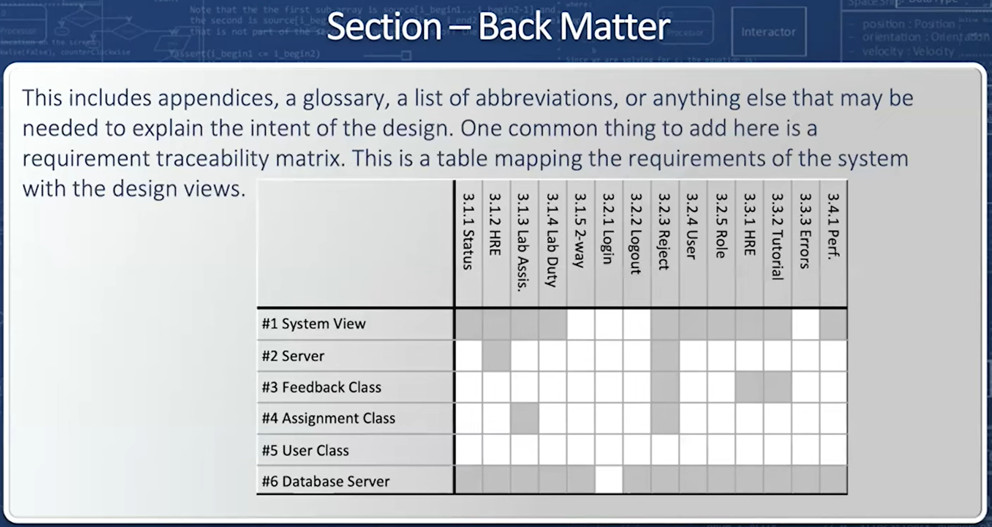
We need to make sure that every requirement in the 430.SRS.CareerBound document found in the 01_Standards folder is fulfilled. Making one table with all of the requirements would be unreadable, so I suggest something like the following:

7.0 REQUIREMENTS MATRIX (Suggested Layout)

7.1 Company Features Requirements Matrix
Component 2.1.1 | 2.1.2 | 2.1.3.1 | 2.1.3.2 | 2.1.3.3 | etc.

7.2 Notification Requirements Matrix
Component 2.2.1 | 2.2.2 | 2.2.3 | 2.2.4 | 2.2.5 | etc.

7.3 Search Requirements Matrix
Component 2.3.1 | 2.3.2 | 2.3.3 | 2.3.4 | 2.3.5 | etc.

7.4 Student Profile Requirements Matrix
Component 3.1.1 | 3.1.2 | 3.1.3.1 | 3.1.3.2 | 3.1.3.3 | etc.

7.# . . . and so on to the end

Major Subsystems
The architecture includes the following major subsystems and components:
Component | Responsibility
Client Applications (Parent) | Parent component representing all user-facing client interfaces including the Web Client and Mobile Client.
Web Client | Browser-based user interface providing access to all CareerBound functionality through desktop and laptop web browsers.
Mobile Client | Mobile-optimized user interface providing responsive access to CareerBound functionality on smartphones and tablets.
API Gateway / Orchestrator | Central communication layer that manages and routes requests between client applications and backend services.
Authentication Service | Handles login, logout, registration, session management, and user authentication/security operations.
Profile Management Service | Manages company and student profile information, profile editing, following relationships, and related user data.
Resume Service | Handles resume creation, editing, storage, submission, retrieval, and resume-related access control.
Job Posting Service | Manages job posting creation, editing, deletion, candidate application tracking, and job-related data.
Search Service | Provides candidate and job search functionality including filters, ranking, autocomplete, and wildcard searching.
Communication Services (Notifications + News Feed) | Manages notifications, messaging, news feed updates, social interactions, and communication-related features.
Recommendation Service | Generates job and candidate recommendations using profile, resume, search, and job posting data.
External Services | Integrates third-party APIs and external systems such as USPS address validation, autocomplete APIs, and push notification providers.
Analytics Service | Provides reporting, monitoring, usage analytics, performance tracking, and system metrics.
Data Storage Layer (Parent) | Parent storage component responsible for centralized persistent data management and coordination between storage subsystems.
Database | Stores structured system data including accounts, profiles, resumes metadata, job postings, notifications, and application data.
File / Blob Storage | Stores uploaded resumes, profile images, attachments, and other binary or file-based content.

7.0 REQUIREMENTS MATRIX (Tables)

7.1 Company Profile Requirements Matrix (SRS 2.1)

Table Format Template
Component | 2.1.1 Profile | 2.1.2 Resume | 2.1.3.1 Contact | 2.1.3.2 Location | 2.1.3.3 Skills | 2.1.3.4 Following | 2.1.3.5 Posting | 2.1.3.6 Analytics | 2.1.3.7 Messaging | 2.1.3.8 Search | 2.1.3.9 Validation | 2.1.3.10 Security
Web Client | X | X | X | X | X | X | X | X | X | X | X | X
Mobile Client | X | X | X | X | X | X | X | X | X | X | X | X
API Gateway / Orchestrator | X | X | X | X | X | X | X | X | X | X | X | X
Authentication Service | X | X | X | X | X | X | X | X | X | X | X | X
Profile Management Service | X | X | X | X | X | X | X | X | X | X | X | X
Resume Service |  | X |  |  | X |  |  | X
Job Posting Service |  |  |  | X |  | X
Search Service |  | X |  |  |  | X |  |  |  | X | X
Communication Services |  |  | X |  |  | X |  |  | X
Recommendation Service |  | X |  |  |  | X |  |  |  | X
External Services |  |  |  |  |  |  |  |  |  |  | X
Analytics Service |  | X |  | X | X | X |  |  | X
Database | X | X | X | X | X | X | X | X | X | X | X | X
File / Blob Storage |  | X |  |  |  | X

7.2 Notification Requirements Matrix (SRS 2.2)

Component | 2.2.1 Alerts | 2.2.2 Updates | 2.2.3 Push | 2.2.4 Delivery | 2.2.5 Preferences
Web Client | X | X | X | X | X
Mobile Client | X | X | X | X | X
API Gateway / Orchestrator | X | X | X | X | X
Authentication Service | X | X | X | X | X
Profile Management Service
Resume Service
Job Posting Service
Search Service
Communication Services | X | X | X | X | X
Recommendation Service
External Services |  |  | X | X
Analytics Service | X | X | X | X | X
Database | X | X | X | X | X
File / Blob Storage

7.3 Search Requirements Matrix (SRS 2.3)
Component | 2.3.1 Candidate | 2.3.2 Company | 2.3.3 Filters | 2.3.4 Wildcards | 2.3.5 Performance | 2.3.6 Autocomplete | 2.3.7 Ranking | 2.3.8 Resume
Web Client | X | X | X | X | X | X | X | X
Mobile Client | X | X | X | X | X | X | X | X
API Gateway / Orchestrator | X | X | X | X | X | X | X | X
Authentication Service | X | X | X | X | X | X | X | X
Profile Management Service |  | X | X
Resume Service |  |  | X
Job Posting Service | X | X | X | X | X
Search Service | X | X | X | X | X | X | X | X
Communication Services
Recommendation Service |  | X | X | X |  |  | X | X
External Services |  |  |  |  |  | X | X
Analytics Service | X | X | X | X | X | X | X | X
Database | X | X | X | X | X | X | X | X
File / Blob Storage

7.4 News Feed Requirements Matrix (SRS 2.4)

Component | 2.4.1 Posts | 2.4.2 Updates | 2.4.3 Media | 2.4.4 Comments | 2.4.5 Reactions | 2.4.6 Feed
Web Client | X | X | X | X | X | X
Mobile Client | X | X | X | X | X | X
API Gateway / Orchestrator | X | X | X | X | X | X
Authentication Service | X | X | X | X | X | X
Profile Management Service
Resume Service
Job Posting Service
Search Service
Communication Services | X | X | X | X | X | X
Recommendation Service
External Services
Analytics Service | X | X | X | X | X | X
Database | X | X | X | X | X | X
File / Blob Storage |  |  | X

7.5 Job Posting Requirements Matrix (SRS 2.5)
Component | 2.5.1 Create | 2.5.2 Edit | 2.5.3 Delete | 2.5.4 Skills | 2.5.5 Details | 2.5.6 Apply | 2.5.7 Status | 2.5.8 Filters | 2.5.9 Data
Web Client | X | X | X | X | X | X | X | X | X
Mobile Client | X | X | X | X | X | X | X | X | X
API Gateway / Orchestrator | X | X | X | X | X | X | X | X | X
Authentication Service | X | X | X | X | X | X | X | X | X
Profile Management Service
Resume Service |  |  |  |  |  | X | X | X
Job Posting Service | X | X | X | X | X | X | X | X | X
Search Service | X | X | X | X |  |  | X | X | X
Communication Services
Recommendation Service | X | X | X | X | X | X | X | X | X
External Services
Analytics Service | X | X | X | X | X | X | X | X | X
Database | X | X | X | X | X | X | X | X | X
File / Blob Storage |  |  | X

7.6 Student Profile Requirements Matrix (SRS 3.1)
Component | 3.1.1 Student | 3.1.2 Accolades | 3.1.3.1 GPA | 3.1.3.2 Skills | 3.1.3.3 Experience | 3.1.3.4 Resume
Web Client | X | X | X | X | X | X
Mobile Client | X | X | X | X | X | X
API Gateway / Orchestrator | X | X | X | X | X | X
Authentication Service | X | X | X | X | X | X
Profile Management Service | X | X | X | X | X | X
Resume Service |  |  | X | X | X | X
Job Posting Service
Search Service
Communication Services
Recommendation Service |  | X | X | X | X | X
External Services
Analytics Service | X | X | X | X | X | X
Database | X | X | X | X | X | X
File / Blob Storage |  |  | X | X |  | X

7.7 Shared Notification Requirements Matrix (SRS 3.2)
Component | 3.2.1 Alerts | 3.2.2 Messages | 3.2.3 Push | 3.2.4 Delivery | 3.2.5 Tracking | 3.2.6 Preferences | 3.2.7 History
Web Client | X | X | X | X | X | X | X
Mobile Client | X | X | X | X | X | X | X
API Gateway / Orchestrator | X | X | X | X | X | X | X
Authentication Service
Profile Management Service
Resume Service
Job Posting Service
Search Service
Communication Services | X | X | X | X | X | X | X
Recommendation Service
External Services |  |  | X | X |  | X
Analytics Service | X | X | X | X | X | X | X
Database | X | X | X | X | X | X | X
File / Blob Storage

7.8 Student Search Requirements Matrix (SRS 3.3)
Component | 3.3.1 Jobs | 3.3.2 Companies | 3.3.3 Matches | 3.3.4 Filters
Web Client | X | X | X | X
Mobile Client | X | X | X | X
API Gateway / Orchestrator | X | X | X | X
Authentication Service
Profile Management Service |  | X |  | X
Resume Service
Job Posting Service | X |  | X
Search Service | X | X | X | X
Communication Services
Recommendation Service | X | X | X | X
External Services
Analytics Service | X | X | X | X
Database | X | X | X | X
File / Blob Storage

7.9 Shared News Feed Requirements Matrix (SRS 3.4)
Component | 3.4.1 Feed | 3.4.2 Updates
Web Client | X | X
Mobile Client | X | X
API Gateway / Orchestrator | X | X
Authentication Service
Profile Management Service
Resume Service
Job Posting Service
Search Service
Communication Services | X | X
Recommendation Service
External Services
Analytics Service | X | X
Database | X | X
File / Blob Storage

7.10 Resume Requirements Matrix (SRS 3.5)
Component | 3.5.1 Builder | 3.5.2 Upload | 3.5.3 Storage | 3.5.4.1 Fields | 3.5.4.2 Help | 3.5.5.1 Submit | 3.5.5.2 Review | 3.5.5.3 Required
Web Client | X | X | X | X | X | X | X | X
Mobile Client | X | X | X | X | X | X | X | X
API Gateway / Orchestrator | X | X | X | X | X | X | X | X
Authentication Service | X | X | X | X | X | X | X | X
Profile Management Service |  |  | X |  |  |  | X
Resume Service | X | X | X | X | X | X | X | X
Job Posting Service
Search Service
Communication Services
Recommendation Service |  | X | X |  |  |  | X
External Services
Analytics Service | X | X | X | X | X | X | X | X
Database | X | X | X | X | X | X | X | X
File / Blob Storage | X | X | X |  |  | X | X

7.11 Hardware Requirements Matrix (SRS 4.0)
Component | 2.1.1 Profile | 2.1.2 Resume | 2.1.3.1 Contact | 2.1.3.2 Location
Web Client | X | X | X | X
Mobile Client | X | X | X | X
API Gateway / Orchestrator | X
Authentication Service | X
Profile Management Service | X
Resume Service | X
Job Posting Service | X
Search Service | X
Communication Services | X
Recommendation Service | X
External Services |  |  | X | X
Analytics Service | X
Database | X
File / Blob Storage | X

