1.8.1-ALG isAuthorized() Algorithm
Purpose:
isAuthorized checks if a user has the overall permission/role required to perform job posting actions like creating or editing.

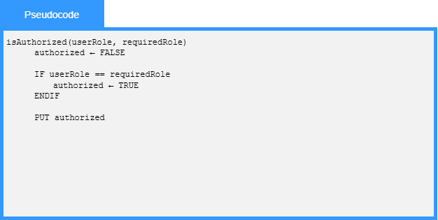

1.8.1-ALG verifyOwner() Algorithm
Purpose:
verifyOwner checks if the current user ID matches the owner ID of the specific job listing being modified.

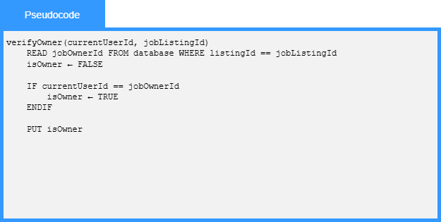

1.8.2-ALG createPost() Algorithm
Purpose:
The algorithm validates the data, checks if such a record already exists and if data are valid and such a record does not exist then it writes the data to the database as a new post record.
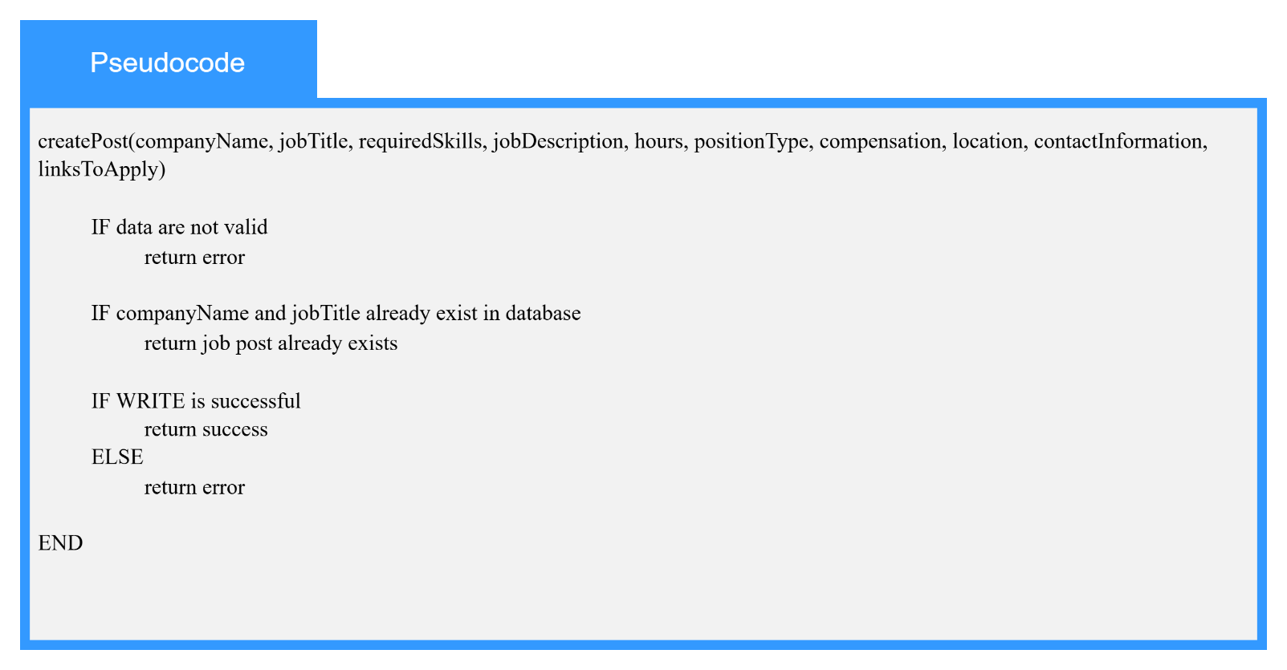

1.8.2-ALG modifyPost() Algorithm
Purpose:
The algorithm validates the data and if data are valid then it updates the record that has the same id.
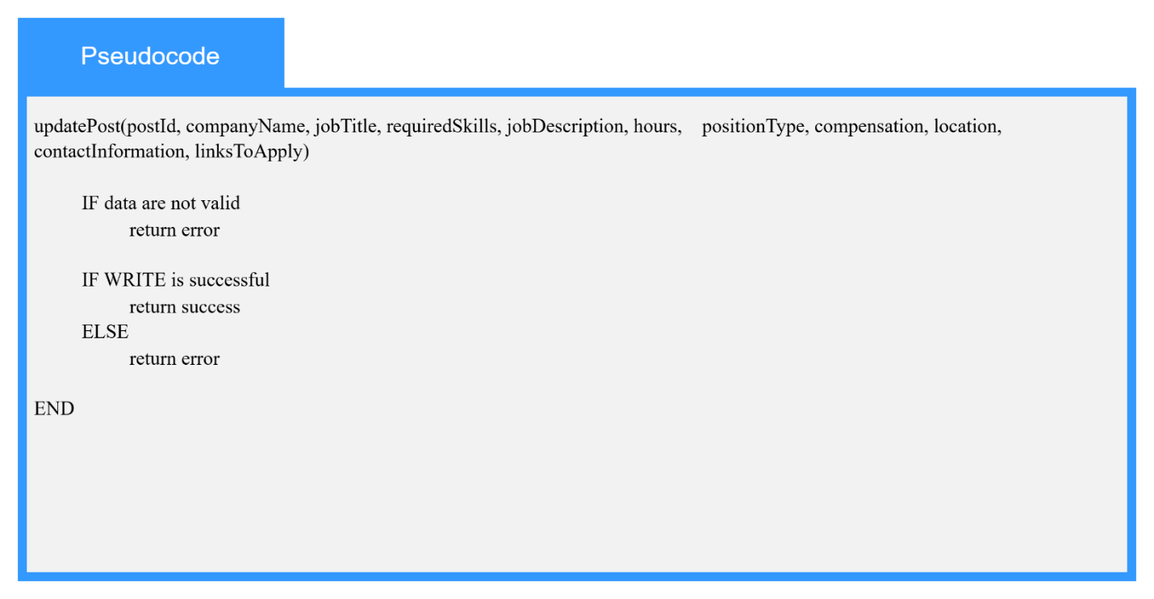

1.8.3-ALG validate() Algorithm
Purpose:
Brief sentence explaining what the algorithm does.
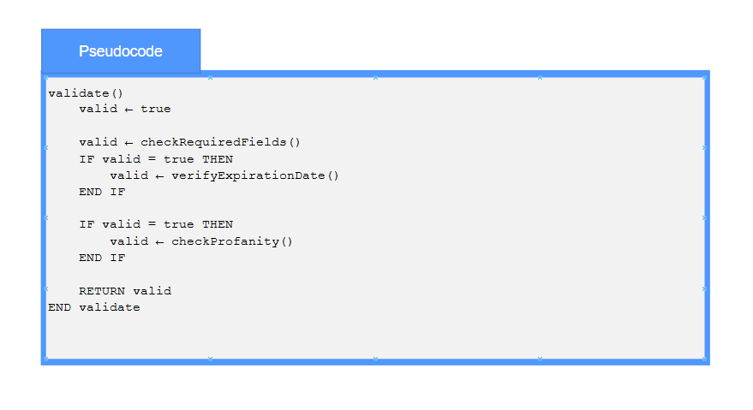

1.8.3-ALG checkProfanity() Algorithm
Purpose:
Brief sentence explaining what the algorithm does.
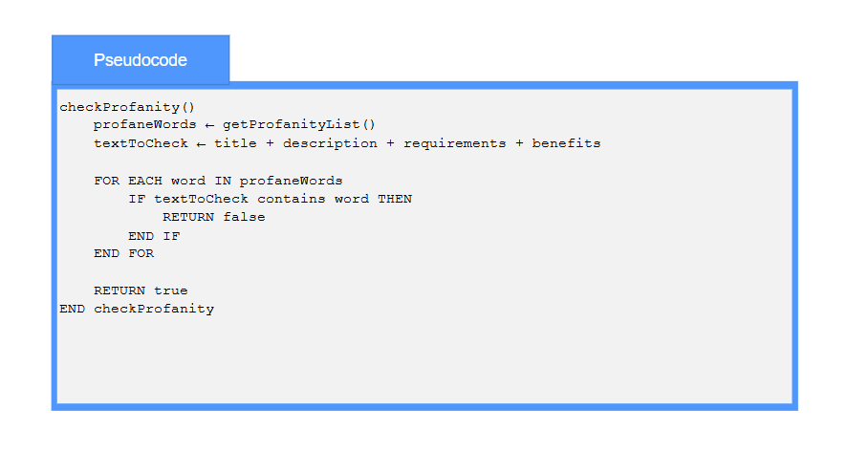

1.9.1-ALG submitSearch() Algorithm
Purpose:
Brief sentence explaining what the algorithm does.

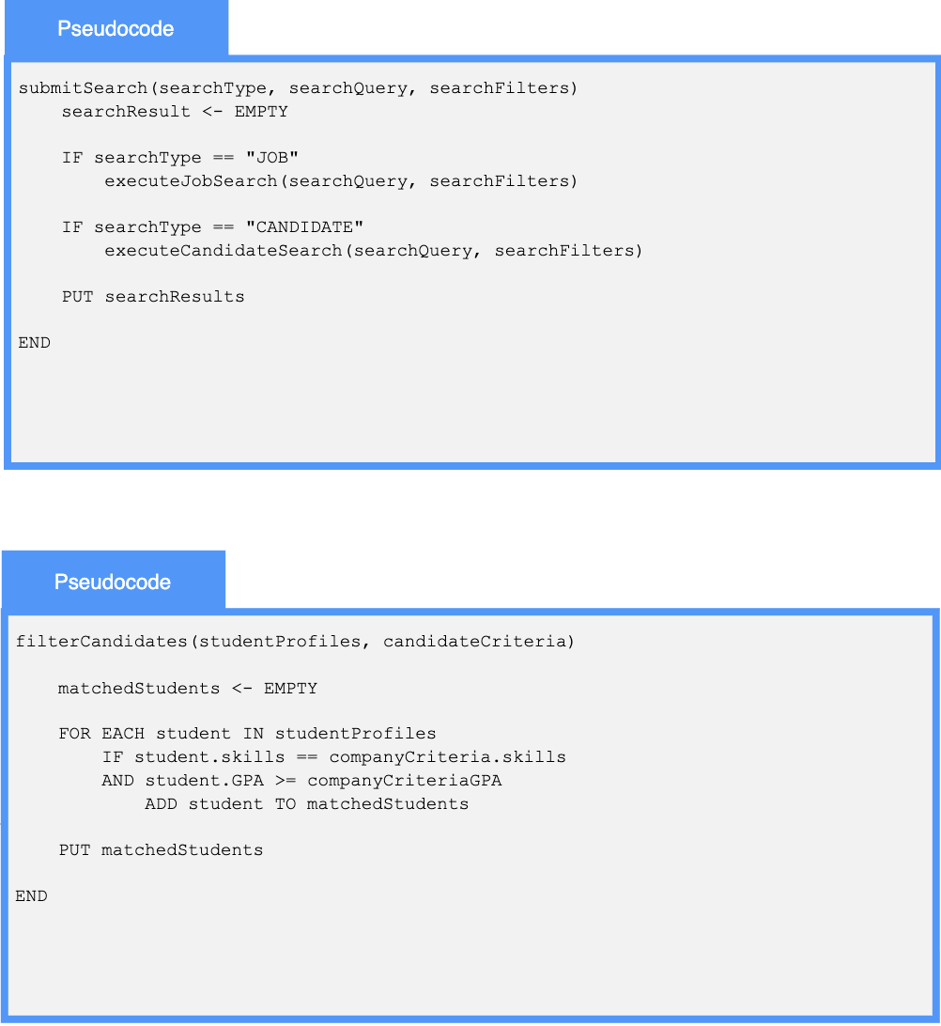

1.9.2-ALG filterCandidates() Algorithm
Purpose:
Brief sentence explaining what the algorithm does.



