1.8.1-CD AuthorizationService Class Diagram
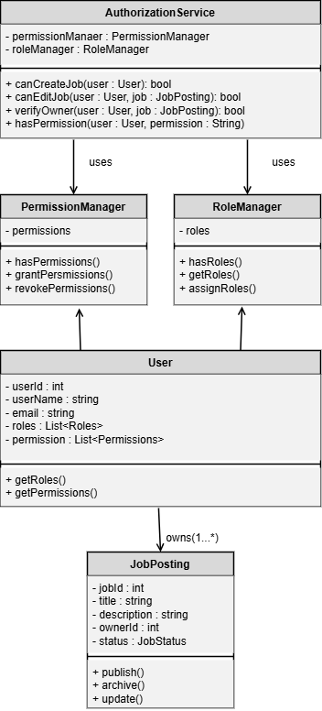

1.8.1-CD PermissionManager Class Diagram
